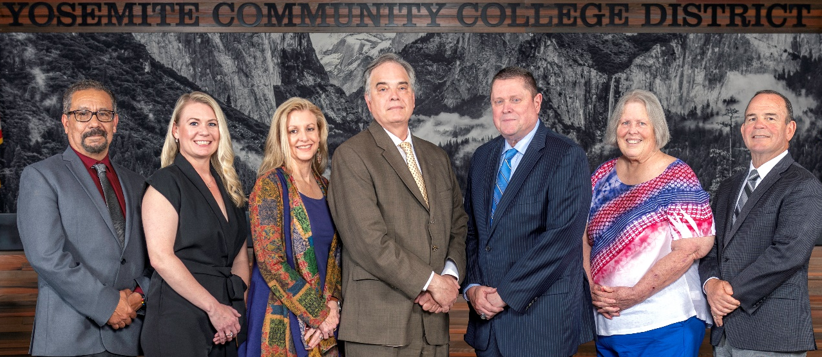
Board Meeting Highlights
November 12, 2025
Regular Board Meeting

Report Out from Closed Session
There was no report out from Closed Session.
Board Committee Report: Board Policy Committee Report
Trustee Leslie Beggs provided the Board of Trustees with an update from the Board Policy Committee.
Board Committee Report: Modesto Junior College Foundation Report
Trustee Leslie Beggs provided the Board of Trustees with an update from the Modesto Junior College Foundation.
Board Committee Report: Columbia College Foundation Report
Trustee Don Davis provided the Board of Trustees with an update from the Columbia College Foundation.
Board Committee Report: Association of Stanislaus County School Boards Report
Trustee Don Davis provided the Board of Trustees with an update from the Association of Stanislaus County School Boards.

Presentation: Modesto Junior College and Columbia College Student Equity Plan
Jose Rocha, MJC Dean of Special Programs; Caterina Grossi, MJC Director of College Research and Planning; Dr. Melissa Raby, Columbia College Vice President of Student Services; and Michael Igoe, Columbia College Dean of Student Services, presented the 2025-2028 Student Equity Plan for their respective college to the Board of Trustees.
Interim Chancellor Update
Interim Chancellor Tran recognized and commended Columbia College for their warm hospitality in hosting the November Board Meeting. She also recognized Dr. Chad Redwing for revitalizing the look in the President’s Office.
Finally, Dr. Tran invited Dr. Sanders and Dr. Redwing to provide the Board of Trustees with an update from their respective colleges.
Modesto Junior College Proposed Curriculum Changes
The Board of Trustees approved the curriculum additions, deletions, and modifications as indicated on the Proposed Curriculum Changes Report of the September 23, 2025, Curriculum Committee meeting.
YCCD Personnel Transaction
The Board of Trustees acknowledged and commended the following retiree(s) for their years of service to the District:
o James Sahlman, Interim Director of Strategic Initiatives/Professor of Speech Communication (26 years)
o Cheryl Youngman, Financial Aid Specialist, Lead (33 years)
Board Policy – 1st Reading
The Board of Trustees conducted a 1st reading on the following YCCD policies. All of the policies will be presented to the Board for a 2nd reading at the December 12, 2025, Board Meeting.
o 4010 – Academic Calendars
o 4020 – Program, Curriculum, and Course Development
o 4025 – Philosophy and Criteria for Associate Degree and General Education
o 4100 – Graduation Requirements for Degrees and Certificates
o 4103 – Work Experience
o 4105 – Distance Education
o 4227 – Repeatable Courses
o 5050 – Student Success and Support Program
o 7342 – Holidays
Acceptance of Administrative Procedures
The Board of Trustees accepted the final recommendation from the Board Policy Committee and directed the Interim Chancellor to revise the following administrative procedure(s) to align with the corresponding Board policy.
o 4105 – Distance Education

Academic Calendars for 2026-2027 and 2027-2028
The Board of Trustees adopted the 2026-2027 Academic Calendar for Columbia College and Modesto Junior College and tentatively adopted the 2027-2028 Academic Calendar.
District Administrative Services, Quarterly Report on the District’s Financial Condition
The Board of Trustees reviewed the District’s financial report for the quarter ended September 30, 2025, and directed staff to submit a copy of the required report to the California Community Colleges Chancellor’s Office.
Personnel – Negotiations – YFA/YCCD/Public Hearing on Proposal Reopeners
The Board of Trustees held a public comment period regarding the Bargaining Proposal Reopeners submitted by YFA and the District. The Board of Trustees approved the District reopeners.
Modesto Junior College, 2025-2028 Student Equity Plan
The Board of Trustees approved the Modesto Junior College 2025-2028 Student Equity Plan.
Columbia College, 2025-2028 Student Equity Plan
The Board of Trustees approved the Columbia College 2025-2028 Student Equity Plan.
Modesto Junior College Educational Master Plan
The Board of Trustees approved the Modesto Junior College Educational Master Plan.
CDSS-CCTR Authorizing Continued Funding Application
The Board of Trustees adopted the CDSS-CCTR Authorizing Continued Funding Application for the Columbia College Child Care Center.
Next Meetings
The next regular meeting of the Board of Trustees will be held on Friday, December 12, 2025. Closed Session will begin at 3:00 p.m. and Open Session at 5:30 p.m. in the Yosemite Community College District Board Room, 2201 Blue Gum Avenue, Modesto, California.

All Board action is available on BoardDocs following the meeting at this link: https://go.boarddocs.com/ca/yosemite/Board.nsf/vpublic?open

