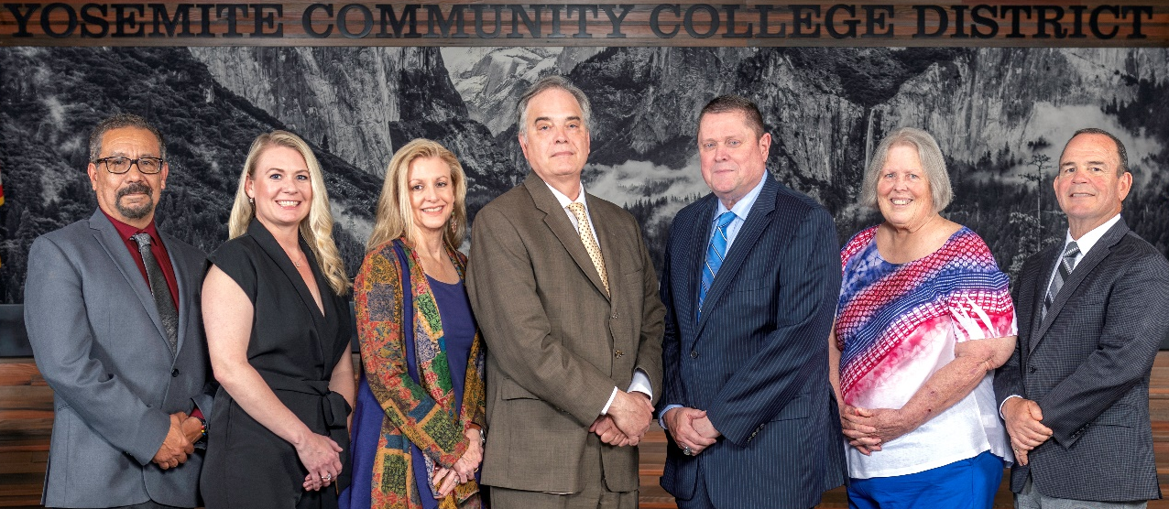
Board Meeting Highlights
May 13, 2026
Regular Board Meeting

Report Out from Closed Session
There was no report out from Closed Session.
Board Committee Report: Board Finance Committee Report
Trustee Darin Gharat provided the Board of Trustees with an update from the Board Finance Committee.
Board Committee Report: Board Policy Committee Report
Trustee Leslie Beggs provided the Board of Trustees with an update from the Board Policy Committee.
Board Committee Report: Modesto Junior College Foundation Report
Trustee Leslie Beggs provided the Board of Trustees with an update from the Modesto Junior College Foundation.
Board Committee Report: Columbia College Foundation Report
Trustee Don Davis provided the Board of Trustees with an update from the Columbia College Foundation.
Interim Chancellor Update
Interim Chancellor Tran invited Harry Davis, Interim Director of Campus Safety, to provide an update on the recent events on MJC East Campus. Dr. Tran also recognized and congratulated Celeste Randolph and Matthew Gutierrez for their service to the District and extended her best wishes as they move forward in their future endeavors.

Interim Chancellor Update Continued
She further expressed her appreciation to the faculty, staff, administrators, and volunteers at both colleges for their efforts in holding successful commencement ceremonies.
In response to the Nursing Program’s presentation to the Board, Dr. Tran reminded the program to send over the resumes of the recently graduated Nursing students who were still seeking employment. She also reminded everyone that, in appreciation of Classified School Employees’ Week, the District will host celebrations honoring our classified professionals. The events will be held on the following dates, times, and locations:
o Monday, May 18, 11:30 am-12:30 pm, District Office/Modesto Junior College, West Campus
o Wednesday, May 20, 8:30 am-9:30 am, Modesto Junior College, East Campus
o Wednesday, May 20, 8:30 pm, Custodial Break Room and Security Break Room, East & West
o Thursday, May 21, 12:00 pm-1:00 pm, Columbia College
Finally, Dr. Tran invited Dr. Redwing to provide the Board of Trustees with an update from Columbia College.
2026 YCCD Classified Employee of the Year
With deep respect and heartfelt appreciation, the YCCD Board of Trustees nominated Ashorina Yadegar for posthumous recognition as the District’s official submission to the California Community Colleges Board of Governors and the Foundation for California Community Colleges for the Classified Employee of the Year Award. Additionally, the Board honored Ashorina’s family with a special award presentation, commemorating her posthumous recognition as the 2026 YCCD Classified Employee of the Year and celebrating the enduring impact of her service to the District.
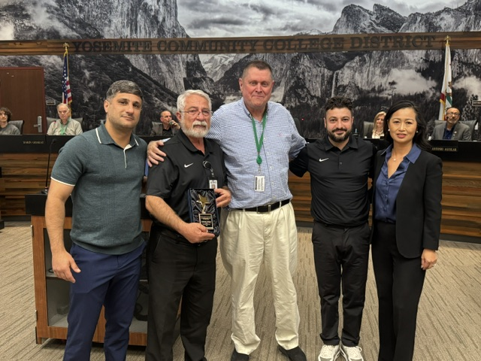
(pictured left to right: Bonipal Yadegar, Sargon Yadegar, Board President Richards, Giwargis Yadegar, and Interim Chancellor Tran)

2025-2026 Student Trustee Recognition
The Board of Trustees recognized Matthew Gutierrez for his service as 2025-2026 Student Trustee of the Yosemite Community College District.
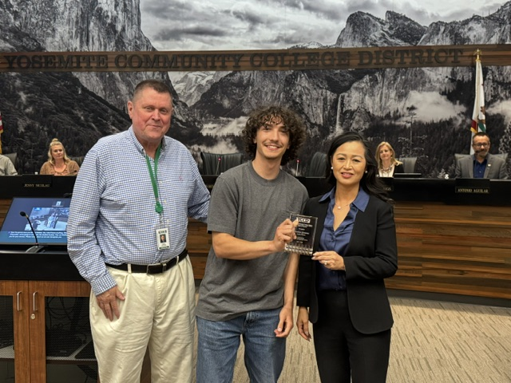
(pictured left to right: Board President Richards, Matthew Gutierrez, and Interim Chancellor Tran)
Presentation: Modesto Junior College Nursing Program
MJC Nursing Faculty, Patti Hall and Allison Sampson, along with recently graduated and former MJC Nursing students, Mary Leonard and Deanna Blum, presented to the Board of Trustees on how the Modesto Junior College Associate Degree Nursing (AND) program continues to effectively prepare workforce-ready registered nurses, with strong outcomes in retention, completion, and licensure.
Modesto Junior College Proposed Curriculum Changes
The Board of Trustees approved the curriculum additions, deletions, and modifications as indicated on the Proposed Curriculum Changes Report for the March 24, 2026, Curriculum Committee meeting.
Columbia College Proposed Curriculum Changes
The Board of Trustees approved the curriculum additions, deletions, and modifications as indicated on the Proposed Curriculum Changes Report for the period of March 17, 2026, to April 7, 2026.

YCCD Personnel Transaction
The Board of Trustees acknowledged and commended the following retiree(s) for their years of service to the District:
o Deborah Barr, Professor of Art (22 years)
o Craig Johnston, Professor of English (20 years)
o Dorothy Peek, Instructional Support Assistant (12 years)
o Brian Sinclair, Professor of Computer Graphics (21 years)
Governing Board Member Election - YCCD Resolution No. 25-26.17, No.25-26.21, and No. 25-26.22
The Board of Trustees adopted the following resolutions calling for a District election and directing that these be filed with the respective agencies:
o YCCD Resolution No. 25-26.21 calling General District Election within Calaveras County;
o YCCD Resolution No. 25-26.22 calling General District Election within Merced County; and
o YCCD Resolution No. 25-26.17 ordering an election to be conducted on November 3, 2026, in the Yosemite Community College District and direct that the adopted resolutions be filed with the Stanislaus Superintendent of Schools prior to June 22, 2026.
Board Policy – 2nd Reading
The Board of Trustees conducted a 2nd reading on the following YCCD policies and approved said policies.
o 2015 – Student Member
o 2110 – Vacancies on the Board
o 2310 – Regular Meetings of the Board
o 2340 – Agendas
o 2355 – Decorum
o 2410 – Board Policies and Administrative Procedures
o 6-8013 – Control of Fixed Assets
o 7150 – Evaluations
o 7340 – Leaves
o 7400 – Travel
YCCD Resolution No.25-26.15 – Trustee Absence from Board Meeting
The Board of Trustees adopted YCCD Resolution No. 25-26.15, in the matter of Trustee Hinton’s absence from the Board Regular Meeting.
YCCD Resolution No.25-26.16 – Trustee Absence from Board Meeting
The Board of Trustees adopted YCCD Resolution No. 25-26.16, in the matter of Trustee Aguilar’s absence from the Board Regular Meeting.
Next Meetings
The next regular meeting of the Board of Trustees will be held on Wednesday, June 10, 2026. Closed Session will begin at 3:00 p.m. and Open Session at 5:30 p.m. in the Yosemite Community College District Board Room, 2201 Blue Gum Avenue, Modesto, California.

All Board action is available on BoardDocs following the meeting at this link: https://go.boarddocs.com/ca/yosemite/Board.nsf/vpublic?open

