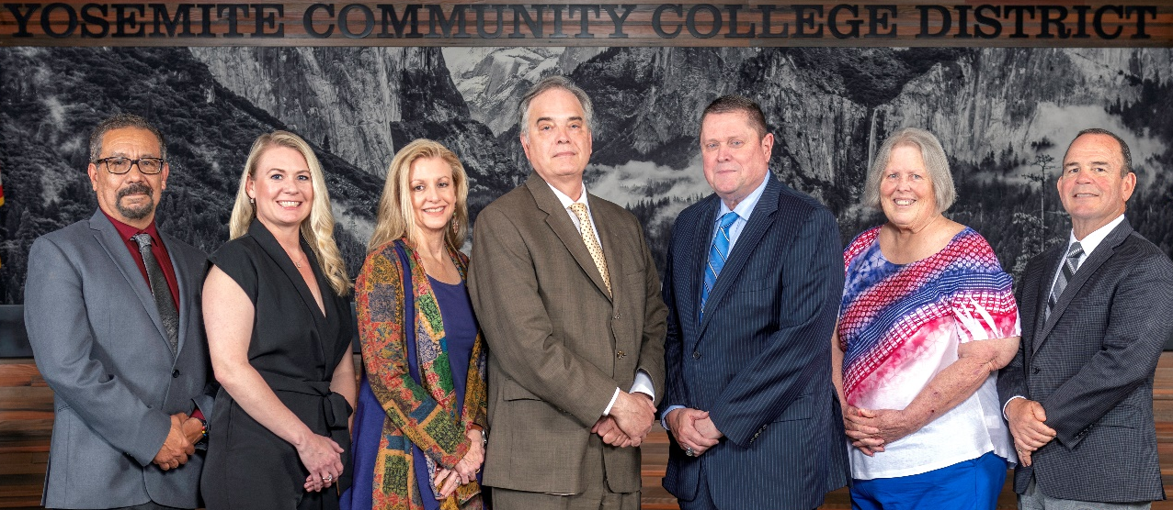
Board Meeting Highlights
November 12, 2025
Regular Board Meeting

Open Session – Annual Organizational Meeting
Education Code Section 72000 requires that the annual organizational meeting of the Board of Trustees be conducted. In compliance with this code section, the Board of Trustees elected Dr. Milton Richards (Area 3) as Board President and Dr. Don Davis (Area 1) as Vice-President.
Additionally, Antonio Aguilar was appointed as the member to serve on the Association of Stanislaus County School Boards and voting representative to attend the Stanislaus County annual meeting; Darin Gharat was appointed as the member to serve on the Valley Insurance Program/Joint Powers Agency Board of Directors; Antonio Aguilar, Dr. Don Davis, and Darin Gharat were appointed to serve on the Finance Standing Committee; Leslie Beggs, Nancy Hinton, and Jenny Nicolau were appointed to serve on the Policy Standing Committee; Leslie Beggs was appointed as the member to serve on the Modesto Junior College Foundation Board; and Dr. Don Davis was appointed as the member to serve on the Columbia College Foundation Board.
Report Out from Closed Session
There was no report out from Closed Session.
Board Committee Report: Board Finance Committee Report
Trustee Darin Gharat provided the Board of Trustees with an update from the Board Finance Committee.
Board Committee Report: Modesto Junior College Foundation Report
Trustee Leslie Beggs provided the Board of Trustees with an update from the Modesto Junior College Foundation.

Board Committee Report: Columbia College Foundation Report
Trustee Don Davis provided the Board of Trustees with an update from the Columbia College Foundation.
Board Committee Report: Association of Stanislaus County School Boards Report
Trustee Don Davis provided the Board of Trustees with an update from the Association of Stanislaus County School Boards.
Interim Chancellor Update
Interim Chancellor Tran congratulated Celeste Randolph on her election as the new ASMJC President and thanked Sabino Salas for his dedicated service during his term as CSEA President.
Dr. Tran then shared a holiday greeting by playing the YCCD Seasons Greetings video, noting that she would also be sharing the video with CEOs across the state.
Following the video presentation, Dr. Tran invited Dr. Sanders and Dr. Redwing to provide the Board of Trustees with updates from their respective colleges.
Dr. Tran concluded by recognizing and thanking Dr. Milton Richards for his service as Board President for the 2024–2025 year.
Modesto Junior College Proposed Curriculum Changes
The Board of Trustees approved the curriculum additions, deletions, and modifications as indicated in the Proposed Curriculum Changes Reports from the October 14, 2025, and October 28, 2025, Curriculum Committee meetings.
Columbia College Proposed Curriculum Changes
The Board of Trustees approved the curriculum additions, deletions, and modifications as indicated on the Proposed Curriculum Changes Reports for the period of October 14, 2025, to November 4, 2025.
Modesto Junior College Sabbatical Leave Report
The Board of Trustees approved the 2024-2025 Sabbatical Leave report from the following Modesto Junior College faculty member:
o Alejandro Sabre – Spring 2025
2026 Summer Schedule
The Board of Trustees authorized the use of the 4/10 workweek for the Summer 2026 period beginning May 4, 2026, and ending August 14, 2026.

YCCD Personnel Transaction
The Board of Trustees acknowledged and commended the following retiree(s) for their years of service to the District:
o Darin Blume, Maintenance Technician 50%/Maintenance Specialist - Access Controls/Locksmith 50% (25 years)
o Melissa Clark, Scholarship Specialist (27 years)
o Martha Robles, Dean of Instruction, School of Health Professions (40 years)
o Cheryl Williams-Jackson, Professor of Child Development (20.5 years)
Board Policy 2725 Board Member Compensation
The Board of Trustees approved a 5% increase in Board Members' compensation, as specified in Education Code Section 72024, and adopted the new rate of $536.04.
Out of Country Travel – Modesto Junior College – All African Diaspora Education Summit (ADES), Ghana, Africa
The Board of Trustees approved the out of the country travel for six Modesto Junior College faculty/staff/administrators attending the All-African Diaspora Education Summit (ADES), September 24, 2026 – October 3, 2026 in Ghana, Africa.
YCCD Resolution No. 25-26.04 – Withdrawing from Membership in the Schools Excess Liability Fund Joint Powers Authority (SELF)
The Board of Trustees adopted YCCD Resolution No. 25-26.04, allowing the District to submit the required Notice of Withdrawal to SELF by December 31, 2025, and preserve the District’s ability to select the most advantageous excess coverage arrangement.
YCCD Resolution No.25-26.05 – Trustee Absence from Board Meeting
The Board of Trustees adopted YCCD Resolution No. 25-26.05, in the matter of Trustee Hinton’s absence from the Board Special Meeting.
YCCD Resolution No.25-26.06 – Trustee Absence from Board Meeting
The Board of Trustees adopted YCCD Resolution No. 25-26.06, in the matter of Trustee Hinton’s absence from the Board Regular Meeting.
Next Meetings
The next regular meeting of the Board of Trustees will be held on Wednesday, January 14, 2026. Closed Session will begin at 3:00 p.m. and Open Session at 5:30 p.m. in the Yosemite Community College District Board Room, 2201 Blue Gum Avenue, Modesto, California.

All Board action is available on BoardDocs following the meeting at this link: https://go.boarddocs.com/ca/yosemite/Board.nsf/vpublic?open

