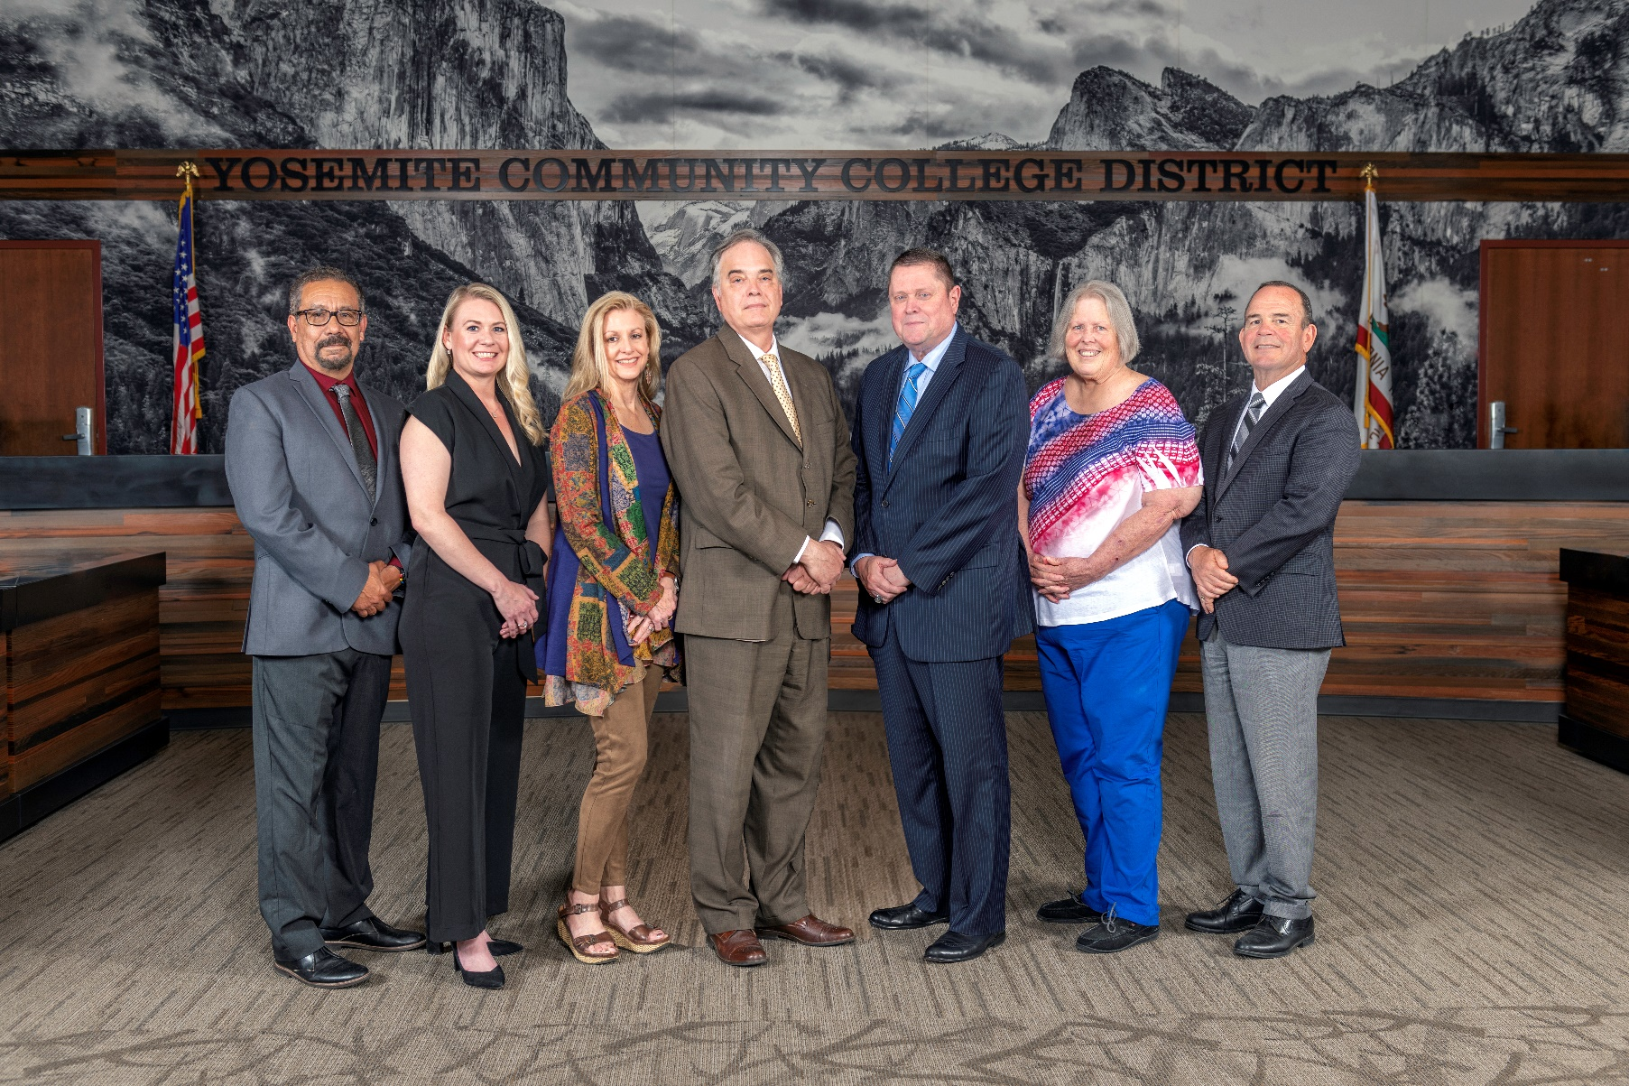

**Board Meeting Highlights**

**August 13, 2025**

**Regular Board Meeting**

**Report Out from Closed Session**

There was no report out from Closed Session.

**Board Committee Report: Modesto Junior College Foundation Report**

Trustee Leslie Beggs provided the Board of Trustees with an update from the Modesto Junior College Foundation.

**Board Committee Report: Columbia College Foundation Report**

Trustee Don Davis provided the Board of Trustees with an update from the Columbia College Foundation.

**Board Committee Report: Association of Stanislaus County School Boards Report**

Trustee Don Davis provided the Board of Trustees with an update from the Association of Stanislaus County School Boards.

**Presentation: Facilities Planning, Maintenance & Transportation Update**

Yolanda Perregil, Senior Director of Facilities Planning, Maintenance & Transportation, provided the Board of Trustees with an update on the completed and budgeted planning projects, transportation, maintenance/ground/custodial, and facilities milestones.

**Interim Chancellor Update**

Interim Chancellor Tran congratulated Trustee Beggs on her 43rd wedding anniversary. Dr. Tran also expressed her heartfelt gratitude to everyone at the colleges and Central Services for their willingness to collaborate with her. Dr. Tran emphasized that the Chancellor’s Office is available to assist and welcomed suggestions on how they can help advance the District.

Finally, Dr. Tran invited Dr. Redwing and Dr. Sanders to provide the Board of Trustees with an update on their respective colleges.

**YCCD Personnel Transaction**

The Board of Trustees acknowledged and commended the following retiree(s) for their years of service to the District:

o   Kasey Fulkerson, Executive Assistant (16 years)

o   Rebecca Heinrich, Administrative Secretary (27 years)

       o   Martha Lee, Administrative Specialist (36 years)

**Modesto Junior College, College and Careers Pathways (CCAP) Partnership Agreements**

The Board of Trustees welcomed comments from the public and approved the College and Careers Access Pathways (CCAP) Partnership Agreement between Yosemite Community College District and Stanislaus County Office of Education.

**YCCD Resolution No. 25-26.01 – Trustee Hinton Absence from Board Meeting**

The Board of Trustees adopted YCCD Resolution No. 25-26.01 in the Matter of Trustee Absence from Board Special Meeting.

**YCCD Resolution No. 25-26.02 – Resolution Declaring Property Exempt Surplus Land**

The Board of Trustees adopted YCCD Resolution No. 25-26.02 – Resolution Declaring Property Exempt Surplus Land.

**Next Meetings**

The next regular meeting of the Board of Trustees will be held on September 10, 2025. Closed Session will begin at 3:00 p.m. and Open Session at 5:30 p.m. in the Yosemite Community College District Board Room, 2201 Blue Gum Avenue, Modesto, California.

***All Board action is available on BoardDocs following the meeting at this link:*** [https://go.boarddocs.com/ca/yosemite/Board.nsf/vpublic?open](https://nam02.safelinks.protection.outlook.com/?url=https%3A%2F%2Fgo.boarddocs.com%2Fca%2Fyosemite%2FBoard.nsf%2Fvpublic%3Fopen&data=05%7C02%7Cgibbsk%40yosemite.edu%7C04ab26527f6a495a1c8e08dce989f34c%7C3d35afe626ac437eb4b375b50d459e45%7C0%7C0%7C638642026033239352%7CUnknown%7CTWFpbGZsb3d8eyJWIjoiMC4wLjAwMDAiLCJQIjoiV2luMzIiLCJBTiI6Ik1haWwiLCJXVCI6Mn0%3D%7C0%7C%7C%7C&sdata=LemRImXBecA5B4HggjFShKy2x6iWsE3ViNf%2BdE6cGew%3D&reserved=0)