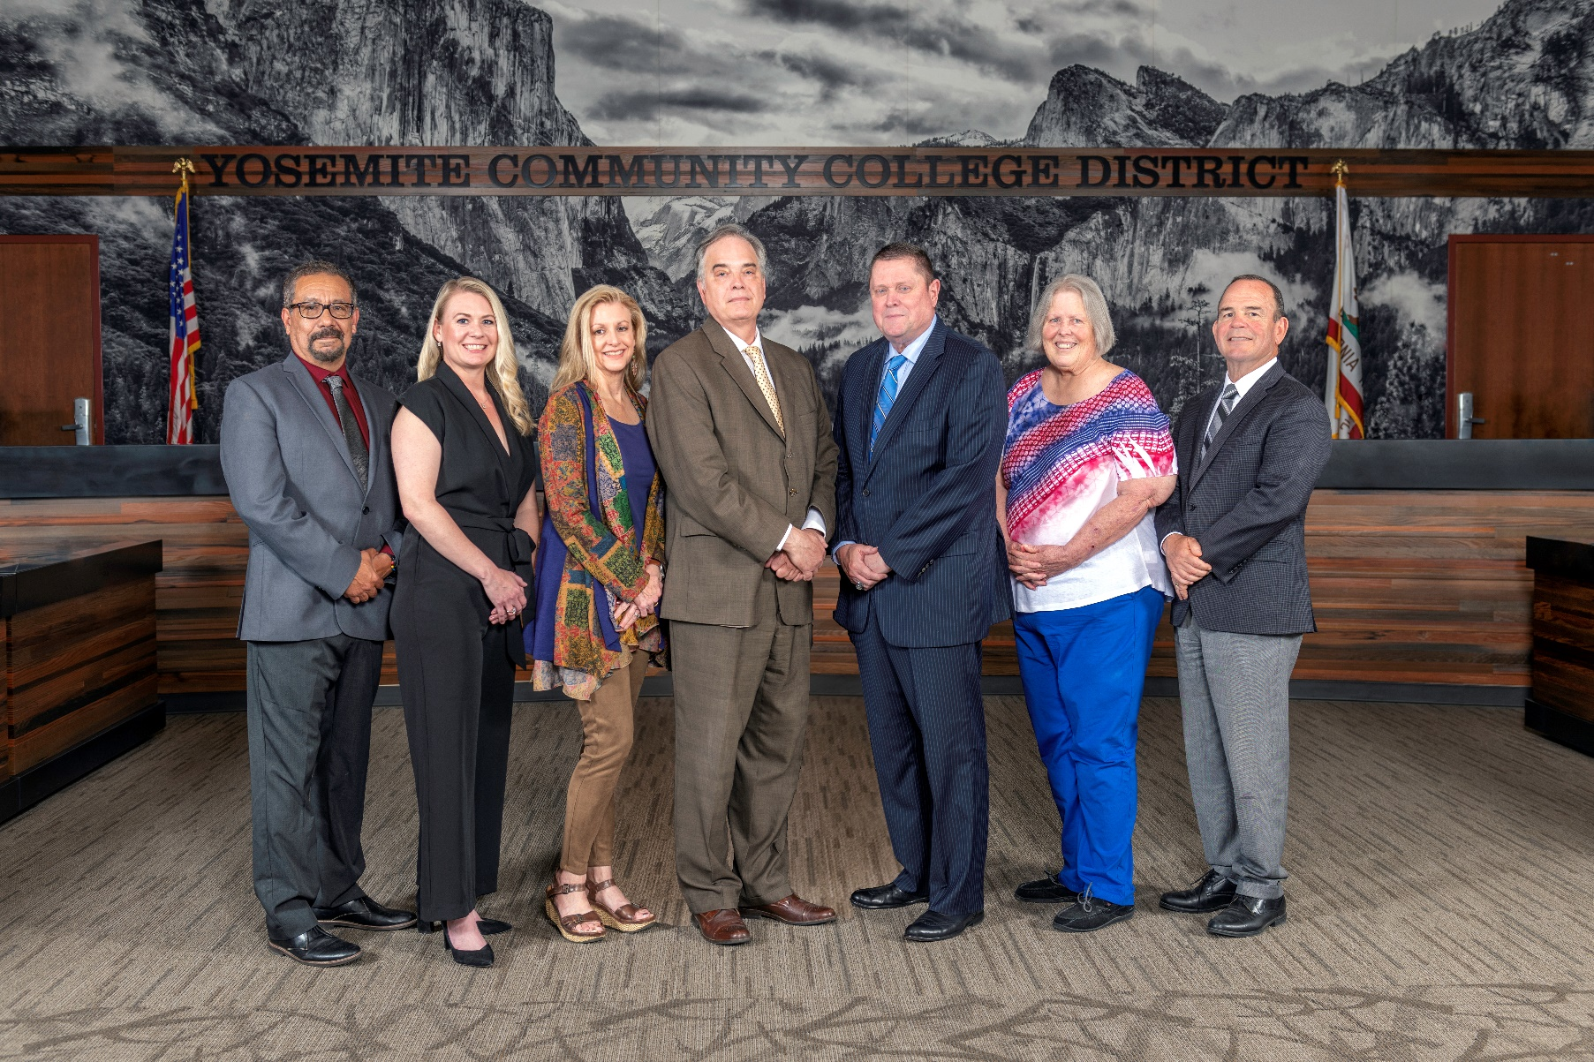

**Board Meeting Highlights**

**December 13, 2024**

**Regular Board Meeting**

**Election Results and Administration of Oath of Office**

Chancellor Yong gave a report of the results of the November 5th elections and congratulated the re-elected and seated Board members. Chancellor Yong administered the Oath of Office to re-elected Board member Leslie Beggs (Area 6) and seated Board members Dr. Milton Richards (Area 3) and Darin Gharat (Area 5). Chancellor Yong administered the Oath of Office to re-elected Board member Antonio Aguilar (Area 7) on Wednesday, December 11, 2024, per the trustee's request.

**Open Session – Annual Organizational Meeting**

Education Code Section 72000 requires that the annual organizational meeting of the Board of Trustees be conducted. In compliance with this code section, the Board of Trustees elected  Dr. Milton Richards (Area 3) as Board President and Jenny Nicolau (Area 4) as Vice-President.

Additionally, Dr. Don Davis was appointed as the member to serve on the Association of Stanislaus County School Boards and voting representative to attend the Stanislaus County annual meeting;  Darin Gharat was appointed as the member to serve on the Valley Insurance Program/Joint Powers Agency Board of Directors; Antonio Aguilar, Dr. Don Davis, and Darin Gharat were appointed to serve on the Finance Standing Committee; Leslie Beggs, Nancy Hinton, and Jenny Nicolau were appointed to serve on the Policy Standing Committee; Leslie Beggs was appointed as the member to serve on the Modesto Junior College Foundation Board; and Dr. Don Davis was appointed as the member to serve on the Columbia College Foundation Board.

**Report Out from Closed Session**

There was no report out from Closed Session.

**Adoption of Prior Versions of Board Policies 3433 and 3434**

The Board of Trustees adopted the versions of Board Policies 3433 (Prohibition of Sexual Harassment under Title IX) and 3434 (Responding to Harassment Based on Sex under Title IX) that were effective prior to August 1, 2024.

**Interim Chancellor Search Committee**

The Board of Trustees nominated Leslie Beggs to serve on the committee and Dr. Don Davis, to serve as the alternate.

**Board Recognition of 2023-2024 Board President**

Chancellor Yong recognized and thanked Trustee Dr. Milton Richards for serving as Board President in 2023-2024.

**Board Committee Report: Board Finance Committee Report**

Trustee Darin Gharat provided the Board of Trustees with an update from the Board Finance Committee.

**Board Committee Report: Board Policy Committee Report**

Vice-President Jenny Nicolau provided the Board of Trustees with an update from the Board Policy Committee.

**Board Committee Report: Modesto Junior College Foundation Report**

Trustee Leslie Beggs provided the Board of Trustees with an update from the Modesto Junior College Foundation.

**Board Committee Report: Columbia College Foundation Report**

Trustee Don Davis provided the Board of Trustees with an update from the Columbia College Foundation.

**Presentation: Modesto Junior College Athletic Training Staff**

David Voortman, MJC Dean and Athletic Director, shared various accomplishments from the MJC Athletic Training Staff with the Board of Trustees.

**Chancellor Update**

Chancellor Yong invited Dr. Tran and Dr. Sanders to provide the Board of Trustees with an update from their respective colleges.

Chancellor Yong also invited Yolanda Perregil, Senior Director of Facilities, Maintenance, and Transportation, to provide the Board of Trustees with an update on the solar panel installation on MJC East Campus and the gas line repair on MJC West Campus.

Chancellor Yong reported that both colleges had received good news from the Accreditation Team visits. The Chancellor thanked the faculty, staff, and administrators for their efforts and work. Additionally, the Chancellor announced that the District held a town hall discussion on the third college concept. The Chancellor stated that the town hall was very well attended and he has received lots of positive comments. Finally, Chancellor Yong reported that he attended the MJC Rise-up Scholars event and also the CCLC Annual Trustees Convention in Burlingame.

**Modesto Junior College Proposed Curriculum Changes**

The Board of Trustees approved the curriculum additions, deletions, and modifications as indicated on the Proposed Curriculum Changes Report as of the October 22, 2024 and November 12, 2024 Curriculum Committee meetings.

**Columbia College Proposed Curriculum Changes**

The Board of Trustees approved the curriculum additions, deletions, and modifications as indicated on the Proposed Curriculum Changes Reports for the period of October 22, 2024 to November 26, 2024.

**Columbia College Sabbatical Leave Requests**

The Board of Trustees approved the 2025-2026 Sabbatical Leave request from the following Columbia College faculty member:

       o   Nathan Rien – Fall 2025 and Spring 2026

**2025 Summer Schedule**

The Board of Trustees authorized the use of the 4/10 workweek for the Summer 2025 period beginning May 5, 2025, and ending August 15, 2025.

**YCCD Personnel Transaction**

The Board of Trustees acknowledged and commended the following retiree(s) for their years of service to the District:

o   Ljiljana Todd, Custodian (22 years)

       o   Sabino Vasconcelos, Grounds Maintenance Specialist (20 years)

**Annual District Audit Exit Report**

The Board of Trustees received the 2023-2024 audit report and authorized its filing with the appropriate state agency in accordance with Education Code Section 84040.

**Board Policy 2725 Board Member Compensation**

The Board of Trustees approved a 5% increase to the compensation of Board Members as specified in Education Code Section 72024 and adopted the new rate for Board Member compensation to be $510.51.

**Board Policy – 2nd Reading**

The Board of Trustees conducted a 2nd reading on the following YCCD policies and approved said policies, as amended.

o   3500 – Campus Safety

o   3501 – Campus Security and Access

o   3505 – Emergency Operations Plan

o   3515 – Reporting of Crimes

o   3520 – Local Law Enforcement

       o   7600 – Campus Safety Officers

**Board Policy – 1st Reading**

The Board of Trustees conducted a 1st reading on the following YCCD policies.  All of the policies will be presented to the Board for a 2nd reading at the February 13, 2025 Board Meeting, as amended.

o   2315 – Closed Sessions

o   2325 – Teleconferenced Meetings

       o   2-8075 – Parliamentary Procedure

**Acceptance of Administrative Procedures**

The Board of Trustees accepted the final recommendation from the Board Policy Committee and directed the Chancellor to revise the following administrative procedure(s) to align with the corresponding Board policy.

       o   2325 – Teleconferenced Meetings

**Personnel – Negotiations Reopeners, YCCD/CSEA #420**

The Board of Trustees acknowledged receipt of CSEA’s and YCCD’s collective bargaining proposal reopeners, scheduled public comment on the proposals, and Board approval of the District’s proposal for January 8, 2025, and referred the proposals to administrative staff for review.

**Personnel – Approval of Employment Contract for Vice Chancellor, District Administrative Services**

The Board of Trustees approved the employment contract for the Vice Chancellor, District Administrative Services.

**Personnel – Approval of Employment Contract for President, Modesto Junior College**

The Board of Trustees approved the employment contract for the President, Modesto Junior College.

**Next Meetings**

The next regular meeting of the Board of Trustees will be held on Wednesday, January 8, 2025. Closed Session will begin at 3:00 p.m. and Open Session at 5:30 p.m. in the Yosemite Community College District Board Room, 2201 Blue Gum Avenue, Modesto, California.

***All Board action is available on BoardDocs following the meeting at this link:*** [https://go.boarddocs.com/ca/yosemite/Board.nsf/vpublic?open](https://nam02.safelinks.protection.outlook.com/?url=https%3A%2F%2Fgo.boarddocs.com%2Fca%2Fyosemite%2FBoard.nsf%2Fvpublic%3Fopen&data=05%7C02%7Cgibbsk%40yosemite.edu%7C04ab26527f6a495a1c8e08dce989f34c%7C3d35afe626ac437eb4b375b50d459e45%7C0%7C0%7C638642026033239352%7CUnknown%7CTWFpbGZsb3d8eyJWIjoiMC4wLjAwMDAiLCJQIjoiV2luMzIiLCJBTiI6Ik1haWwiLCJXVCI6Mn0%3D%7C0%7C%7C%7C&sdata=LemRImXBecA5B4HggjFShKy2x6iWsE3ViNf%2BdE6cGew%3D&reserved=0)