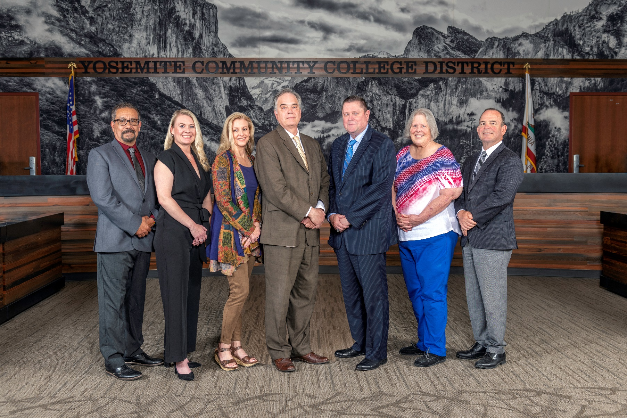

**Board Meeting Highlights**

**November 13, 2024**

**Regular Board Meeting**

**Report Out from Closed Session**

There was no report out from Closed Session.

**Chancellor Search**

The Board of Trustees took comments from the public on the item and directed Human Resources to initiate a recruitment for an Interim Chancellor.

**Chancellor Search Process**

The Board of Trustees took comments from the public on the item and approved the process for conducting the recruitment of the Interim Chancellor.

**Interim Chancellor Search Committee**

The Board of Trustees took comments from the public on the item and approved the establishment of a temporary Interim Chancellor Search Committee and the committee charter. The Board of Trustees approved the following trustees to serve on the Search Committee: Darin Gharat, Nancy Hinton, Milton Richards, and Leslie Beggs, as the alternate.

**Chancellor Search Firm**

The Board of Trustees took comments from the public on the item and determined that the Board would not like to use an executive search firm for the interim Chancellor recruitment. The Board of Trustees will use the District’s Human Resources Department for the interim Chancellor recruitment.

**Board Committee Report: Association of Stanislaus County School Boards Report**

Trustee Don Davis provided the Board of Trustees with an update from the Association of Stanislaus County School Boards.

**Presentation: Modesto Junior College Rising Scholars Network Program**

Glen Stovall, Director of Rise Up Center, Melanie Berru, Professor of Sociology, and David Lujan, Rising Scholar Network Peer Mentor, provided the Board of Trustees with an update on the Rising Scholars Network Program at Modesto Junior College.

**Chancellor Update**

Chancellor Yong invited Dr. Tran and Dr. Sanders to provide the Board of Trustees with an update from their respective colleges.

Chancellor Yong also invited Trevor Stewart, Vice Chancellor of District Administrative Services, to provide the Board of Trustees with the Annual Security Report for MJC and Columbia College.

Finally, Chancellor Yong reported that he attended the Faculty Spotlight event at MJC, where several faculty from the School of Language Arts and Education, showcased their work related to the theme “Cultural Wealth & Cultural Knowledge.”

**Modesto Junior College Proposed Curriculum Changes**

The Board of Trustees approved the curriculum additions, deletions, and modifications as indicated on the Proposed Curriculum Changes Report as of the September 24, 2024 and October 8, 2024 Curriculum Committee meetings.

**Columbia College Proposed Curriculum Changes**

The Board of Trustees approved the curriculum additions, deletions, and modifications as indicated on the Proposed Curriculum Changes Reports for the period of October 8, 2024 to October 8, 2024.

**YCCD Personnel Transaction**

The Board of Trustees acknowledged and commended the following retiree(s) for their years of service to the District:

o   Michael Bernal, Campus Safety Officer, Lead (36 years)

o   Micaela Gonzalez-Redding, Campus Safety Officer (36 years)

o   Gregory Hausmann, Professor of Administration of Justice (24 years)

o   Eric Ivory, Counselor/Coordinator (28 years)

o   Thomas Johnson, Professor of History (27 years)

o   Tanya Smith, Program Specialist (17 years)

       o   Kathryn Villafana, Accounting Analyst (28 years)

**Brown Act Modernization Letter**

The Board of Trustees approved the proposed draft letter to members of the Legislature related to Brown Act modernization and authorized the Chancellor to work with Townsend Public Affairs, LLC to raise the Brown Act issue with community college stakeholders, including CCLC, so that community colleges can sit at the table for Brown Act conversations.

**Quarterly Report on the District’s Financial Condition**

The Board of Trustees reviewed the District’s financial report for the quarter ended September 30, 2024, and directed staff to submit a copy of the required report to the California Community Colleges Chancellor’s Office.

**Columbia College Child Care Center-Continued Funding Application Fiscal Year 2025-2026**

The Board of Trustees authorized the Columbia College Child Care Program Director to submit the California Department of Education Early Education Division and the California Department of Social Services Continued Funding Applications for Fiscal Year 2025-2026 on behalf of the District.

**Academic Calendars for 2025-2026 and 2026-2027**

The Board of Trustees adopted the 2025-2026 Academic Calendar for Columbia College and Modesto Junior College and tentatively adopted the 2026-2027 Academic Calendar.

**Board Policy – 2nd Reading**

The Board of Trustees conducted a 2nd reading on the following YCCD policies and approved said policies, as amended.

o   3530 – Weapons on Campus

o   7-8006 – Citizen Complaints Concerning Employees

       o   7-8039 – Complaints Concerning Employees

**Board Policy – 1st Reading**

The Board of Trustees conducted a 1st reading on the following YCCD policies.  All of the policies will be presented to the Board for a 2nd reading at the December 11, 2024 Board Meeting, as amended.

o   3500 – Campus Safety

o   3501 – Campus Security and Access

o   3505 – Emergency Operations Plan

o   3515 – Reporting of Crimes

o   3520 – Local Law Enforcement

       o   7600 – Campus Safety Officers

**Acceptance of Administrative Procedures**

The Board of Trustees accepted the final recommendation from the Board Policy Committee and directed the Chancellor to revise the administrative procedures to align with the corresponding Board policy.

o   3500 – Campus Safety

o   3501 – Campus Security and Access

o   3505 – Emergency Operations Plan

o   3515 – Reporting of Crimes

o   3520 – Local Law Enforcement

o   3530 – Weapons on Campus

o   7600 – Campus Safety Officers

       o   7-8039 – Complaints Concerning Employees

**YCCD Resolution No. 24-25.08 – Native American Heritage Month**

The Board of Trustees adopted YCCD Resolution No. 24-25.08, recognizing November as Native American Heritage Month.

**Next Meetings**

The next regular meeting of the Board of Trustees will be held on Friday, December 13, 2024. Closed Session will begin at 3:00 p.m. and Open Session at 5:30 p.m. in the Yosemite Community College District Board Room, 2201 Blue Gum Avenue, Modesto, California.

***All Board action is available on BoardDocs following the meeting at this link:*** [https://go.boarddocs.com/ca/yosemite/Board.nsf/vpublic?open](https://nam02.safelinks.protection.outlook.com/?url=https%3A%2F%2Fgo.boarddocs.com%2Fca%2Fyosemite%2FBoard.nsf%2Fvpublic%3Fopen&data=05%7C02%7Cgibbsk%40yosemite.edu%7C0b2536e3bbdc43ee836708dc73a89a19%7C3d35afe626ac437eb4b375b50d459e45%7C0%7C0%7C638512415306890841%7CUnknown%7CTWFpbGZsb3d8eyJWIjoiMC4wLjAwMDAiLCJQIjoiV2luMzIiLCJBTiI6Ik1haWwiLCJXVCI6Mn0%3D%7C0%7C%7C%7C&sdata=GXp4wDhjmI%2FGDvsRN%2BEj6CHJlnA9v4e9PmubP5TJS9o%3D&reserved=0)