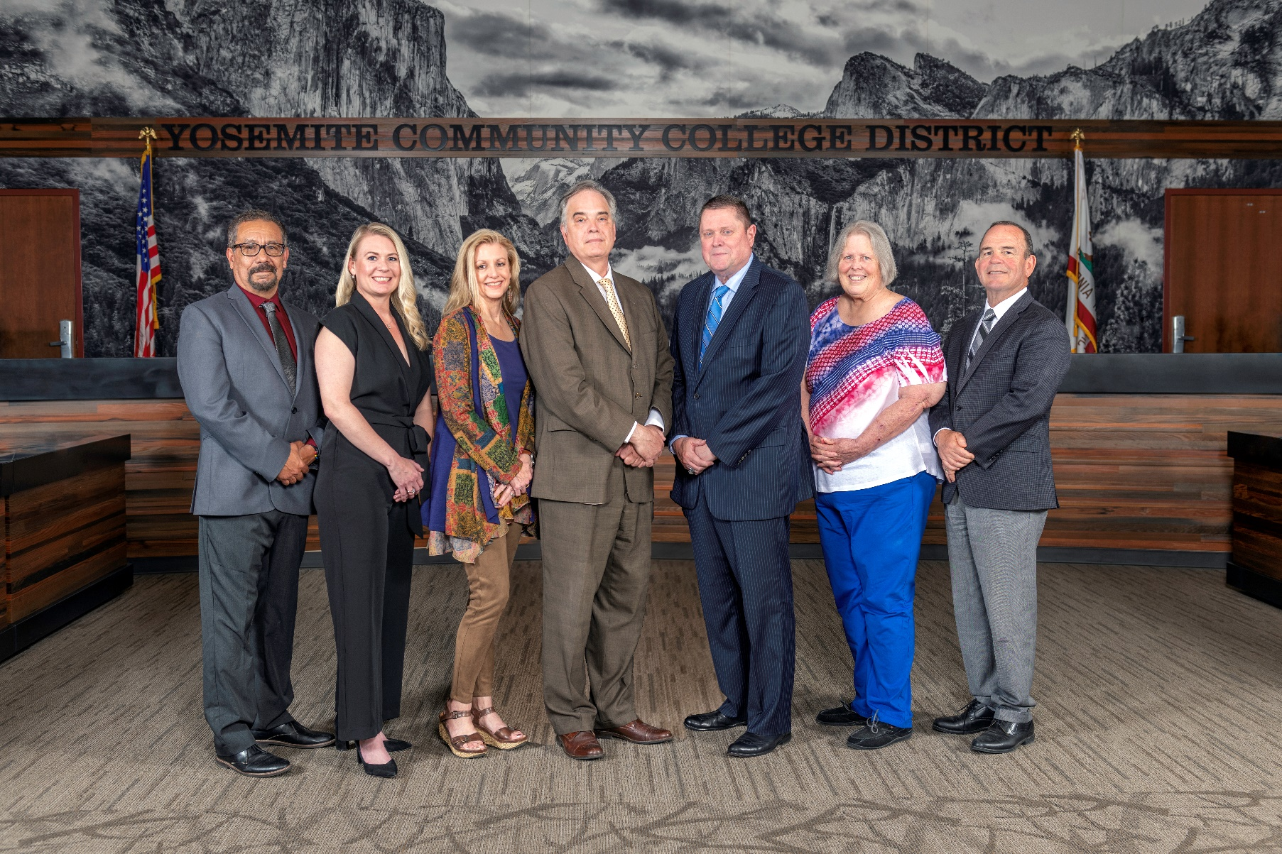

**Board Meeting Highlights**

**October 9, 2024**

**Regular Board Meeting**

**Report Out from Closed Session**

The Board of Trustees voted unanimously to approve an educational administrator’s request to rescind their resignation. Trustee Davis made a motion to approve, and Trustee Hinton seconded Trustee Davis’ motion.

**Board Committee Report: Modesto Junior College Foundation Report**

Trustee Leslie Beggs provided the Board of Trustees with an update from the Modesto Junior College Foundation.

**Board Committee Report: Columbia College Foundation Report**

Trustee Don Davis provided the Board of Trustees with an update from the Columbia College Foundation.

**Presentation: Career Technical Education (CTE), Columbia College**

Brandon Price, Columbia College Dean of CTE, Shane Warner, Columbia College Instructor of Fire Technology, and Emily Graham, Columbia College Director of Career Program Planning, provided the Board of Trustees with an update on Columbia College’s Fire, EMS, and Healthcare programs.

**Presentation: Analyzing Retention, Attrition, and Persistence**

Samantha Smith, Senior Director of Institutional Research, Planning and Accreditation, Caterina Grossi, MJC Director of College Research and Planning, and Jose Rocha, MJC Dean of Special Programs, provided the Board of Trustees with a review of retention, success, and persistence within the support programs at Modesto Junior College and Columbia College. In addition they provided the Board of Trustees with a review of the PowerBi Report which focused on retention, attrition, and persistence across various student populations within the District as well as a comparison of retention and success rates across all California Community Colleges.

**Chancellor Update**

Chancellor Yong invited Dr. Tran and Dr. Sanders to provide the Board of Trustees with an update from their respective colleges.

Chancellor Yong commended and thanked all faculty, staff, students, and administrators at both colleges for their efforts with the recent accreditation visits. In addition, Chancellor Yong reported that the District has been working with the lobbyist, Townsend Public Affairs, in response to Trustee Beggs’ position letter to request legislative changes for the Brown Act for trustee participation.

Chancellor Yong reported that both colleges are celebrating Hispanic Heritage Month with various events. Chancellor Yong extended a special invitation for everyone to attend the upcoming MJC Hispanic Education Conference. Finally, Chancellor Yong recognized and thanked all of the tutors in recognition of Tutor Appreciation week.

**Chancellor Recruitment Process**

Board President Milton Richards reported that the Tri-Chairs met and decided to wait until after the election to begin discussing the Chancellor’s recruitment process. In response, Trustee Davis requested an agenda item for the next Board meeting to discuss and take action on the possibility of sending out a Request for Proposal (RFP) seeking search consultants.

**Modesto Junior College Proposed Curriculum Changes**

The Board of Trustees approved the curriculum additions, deletions, and modifications as indicated on the Proposed Curriculum Changes Report as of the September 10, 2024 Curriculum Committee meeting.

**YCCD Personnel Transaction**

The Board of Trustees acknowledged and commended the following retiree(s) for their years of service to the District:

o   Shirley Buzbee, Professor of Medical Assisting (31 years)

o   Hector Duarte, Counselor (29 years)

o   Amy Duffy, Professor of Medical Assisting (12 years)

o   Dale Hubbard, Custodian Coordinator (13 years)

o   Cecilia Hudelson, Interim Dean, School of Business & Computing, Industry & Trades, and Public

Safety (28 years)

       o   Dale Phillips, Professor of Computer Science (20 years)

**Voting Delegates to the 2024 ACCT Leadership Congress**

The Board of Trustees appointed Trustee Leslie Beggs to serve as the voting delegate for the 2024 ACCT Leadership Congress in Seattle, WA.  The Board of Trustees also identified Dr. Milton Richards to serve as the alternate voting delegate should the voting delegate be unable to carry out the duties.

**Recordings of Board Meetings**

The Board of Trustees approved archiving the Board video recordings on YouTube for a period of one year.

**YCCD Resolution No. 24-25.07 – Support of AANAPISI Week 2024**

The Board of Trustees adopted YCCD Resolution No. 24-25.07 in support of Asian American Native American Pacific Islander Servin Institutions (AANAPISI) Week.

**YCCD Resolution No. 24-25.05 – Trustee Absence from Board Meeting**

The Board of Trustees adopted YCCD Resolution No. 24-25.05 in the Matter of Trustee Absence from Board Meeting.

**YCCD Resolution No. 24-25.0 6 – Trustee Absence from Board Meeting**

The Board of Trustees adopted YCCD Resolution No. 24-25.06 in the Matter of Trustee Absence from Board Meeting.

**Next Meetings**

The next regular meeting of the Board of Trustees will be held on November 13, 2024. Closed Session will begin at 3:00 p.m. and Open Session at 5:30 p.m. in the Yosemite Community College District Board Room, 2201 Blue Gum Avenue, Modesto, California.

***All Board action is available on BoardDocs following the meeting at this link:*** [https://go.boarddocs.com/ca/yosemite/Board.nsf/vpublic?open](https://nam02.safelinks.protection.outlook.com/?url=https%3A%2F%2Fgo.boarddocs.com%2Fca%2Fyosemite%2FBoard.nsf%2Fvpublic%3Fopen&data=05%7C02%7Cgibbsk%40yosemite.edu%7C0b2536e3bbdc43ee836708dc73a89a19%7C3d35afe626ac437eb4b375b50d459e45%7C0%7C0%7C638512415306890841%7CUnknown%7CTWFpbGZsb3d8eyJWIjoiMC4wLjAwMDAiLCJQIjoiV2luMzIiLCJBTiI6Ik1haWwiLCJXVCI6Mn0%3D%7C0%7C%7C%7C&sdata=GXp4wDhjmI%2FGDvsRN%2BEj6CHJlnA9v4e9PmubP5TJS9o%3D&reserved=0)