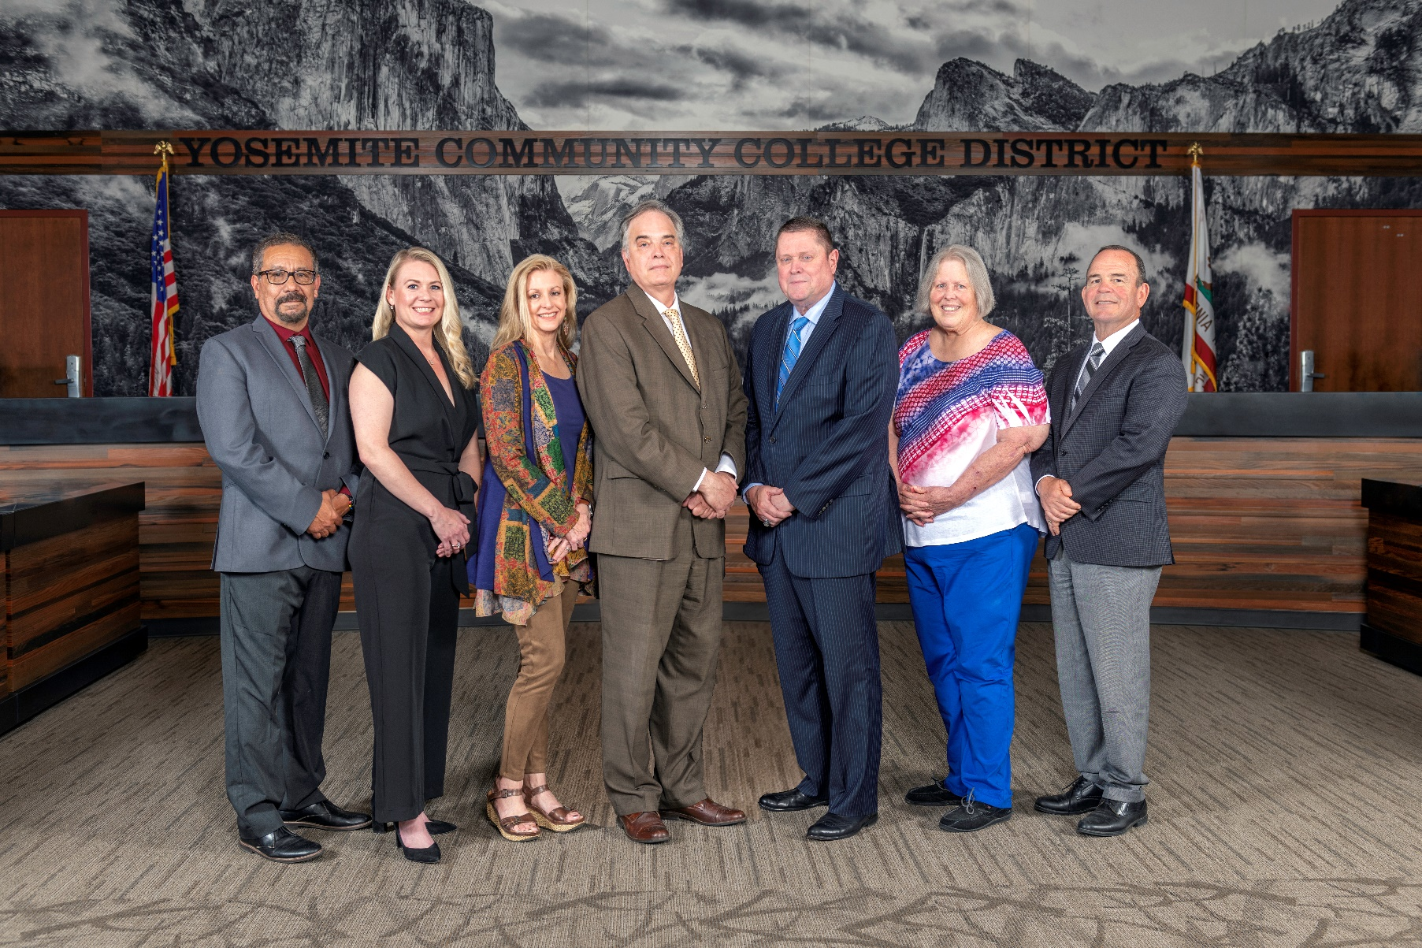

**Board Meeting Highlights**

**September 11, 2024**

**Regular Board Meeting**

**Report Out from Closed Session**

There was no report out from Closed Session.

**Board Committee Report: Board Finance Committee Report**

Trustee Darin Gharat provided the Board of Trustees with an update from the Board Finance Committee.

**Board Committee Report: Columbia College Foundation Report**

Trustee Don Davis provided the Board of Trustees with an update from the Columbia College Foundation.

**Board Committee Report: Association of Stanislaus County School Boards Report**

Trustee Don Davis provided the Board of Trustees with an update from the Association of Stanislaus County School Boards.

**Presentation: Modesto Junior College Communication Studies**

Taureanna Shimp, MJC Professor of Communication Studies, and Eve Dowdell, MJC Student, provided the Board of Trustees with highlights of the Speech and Debate team’s recent successes, their contributions to the college community, and benefits of participation.

**Presentation: Modesto Junior College’s 2023-2028 Strategic Plan Progress Report – August 2024 Update**

Caterina Grossi, MJC Director of College Research and Planning, and Jose Rocha, MJC Dean of Special Programs, provided the Board of Trustees with an update on MJC’s progress toward meeting the goals set out in the College’s Strategic Plan, Educational Master Plan, and Institution-Set Standards, with an emphasis on equity-related metrics.

**Chancellor Update**

Chancellor Yong invited Dr. Tran and Dr. Sanders to provide the Board of Trustees with an update from their respective colleges.

Chancellor Yong provided the Board of Trustees with an update on the following community meetings and events that he attended:

o   Welcome Reception for CSU Stanislaus President Britt Rios Ellis

       o     Modesto Sunrise Rotary Club Meeting

Chancellor Yong commended both colleges for having a successful start to the semester. Chancellor also reported that he attended the MJC Full-Time Faculty Orientation, the MJC Part-Time Faculty Orientation, and the MJC Nurse Assistant Summer Cohort Pinning Ceremony. Finally, Chancellor Yong reminded the Board that MJC’s Parking Lot 108 is offline due to solar panel installation.

**YCCD Personnel Transaction**

The Board of Trustees acknowledged and commended the following retiree(s) for their years of service to the District:

      o     Li Ching Accurso, Professor of Art (29 years)  
 o     Kevin Granados, Multimedia Specialist (10 years)

**2024-2025 Yosemite Community College District Final Budget**

The Board of Trustees conducted a public hearing regarding the 2024-2025 Final Budget for the Yosemite Community College District, adopted the District’s 2024-2025 Final Budget, and authorized staff to prepare and file the necessary annual Financial and Budget Report (CCFS 311) with the required agencies.

**Modesto Junior College, College and Careers Pathways (CCAP) Partnership Agreement – Keyes Union School District**

The Board of Trustees welcomed comments from the public and then approved the College and Careers Access Pathways (CCAP) Partnership Agreement between Yosemite Community College District and Keyes Union School District.

**Personnel – Negotiations, YCCD/CSEA, Chapter 420 Tentative Agreement**

The Board of Trustees approved the 2024-2025 Tentative Agreement regarding salary and benefits between the Yosemite Community College District (YCCD) and the California School Employees Association, Chapter 420 (CSEA), pending the successful completion of CSEA’s ratification process.

**Special Appointments to the VIP/JPA Board of Directors**

The Board of Trustees appointed Mr. Trevor Stewart to the management-level employee position and Ms. Kathren Pritchard to the alternate director position for two-year terms beginning October 1, 2024, and expiring on September 30, 2026.

**YCCD Resolution No. 24-25.04 – Trustee Absence from Board Meeting**

The Board of Trustees adopted YCCD Resolution No. 24-25.04 in the Matter of Trustee Absence from Board Meeting.

**Next Meetings**

The next regular meeting of the Board of Trustees will be held on October 9, 2024. Closed Session will begin at 3:00 p.m. and Open Session at 5:30 p.m. at Columbia College, 11600 Columbia College Drive, Sonora, California.

***All Board action is available on BoardDocs following the meeting at this link:*** [https://go.boarddocs.com/ca/yosemite/Board.nsf/vpublic?open](https://nam02.safelinks.protection.outlook.com/?url=https%3A%2F%2Fgo.boarddocs.com%2Fca%2Fyosemite%2FBoard.nsf%2Fvpublic%3Fopen&data=05%7C02%7Cgibbsk%40yosemite.edu%7C0b2536e3bbdc43ee836708dc73a89a19%7C3d35afe626ac437eb4b375b50d459e45%7C0%7C0%7C638512415306890841%7CUnknown%7CTWFpbGZsb3d8eyJWIjoiMC4wLjAwMDAiLCJQIjoiV2luMzIiLCJBTiI6Ik1haWwiLCJXVCI6Mn0%3D%7C0%7C%7C%7C&sdata=GXp4wDhjmI%2FGDvsRN%2BEj6CHJlnA9v4e9PmubP5TJS9o%3D&reserved=0)