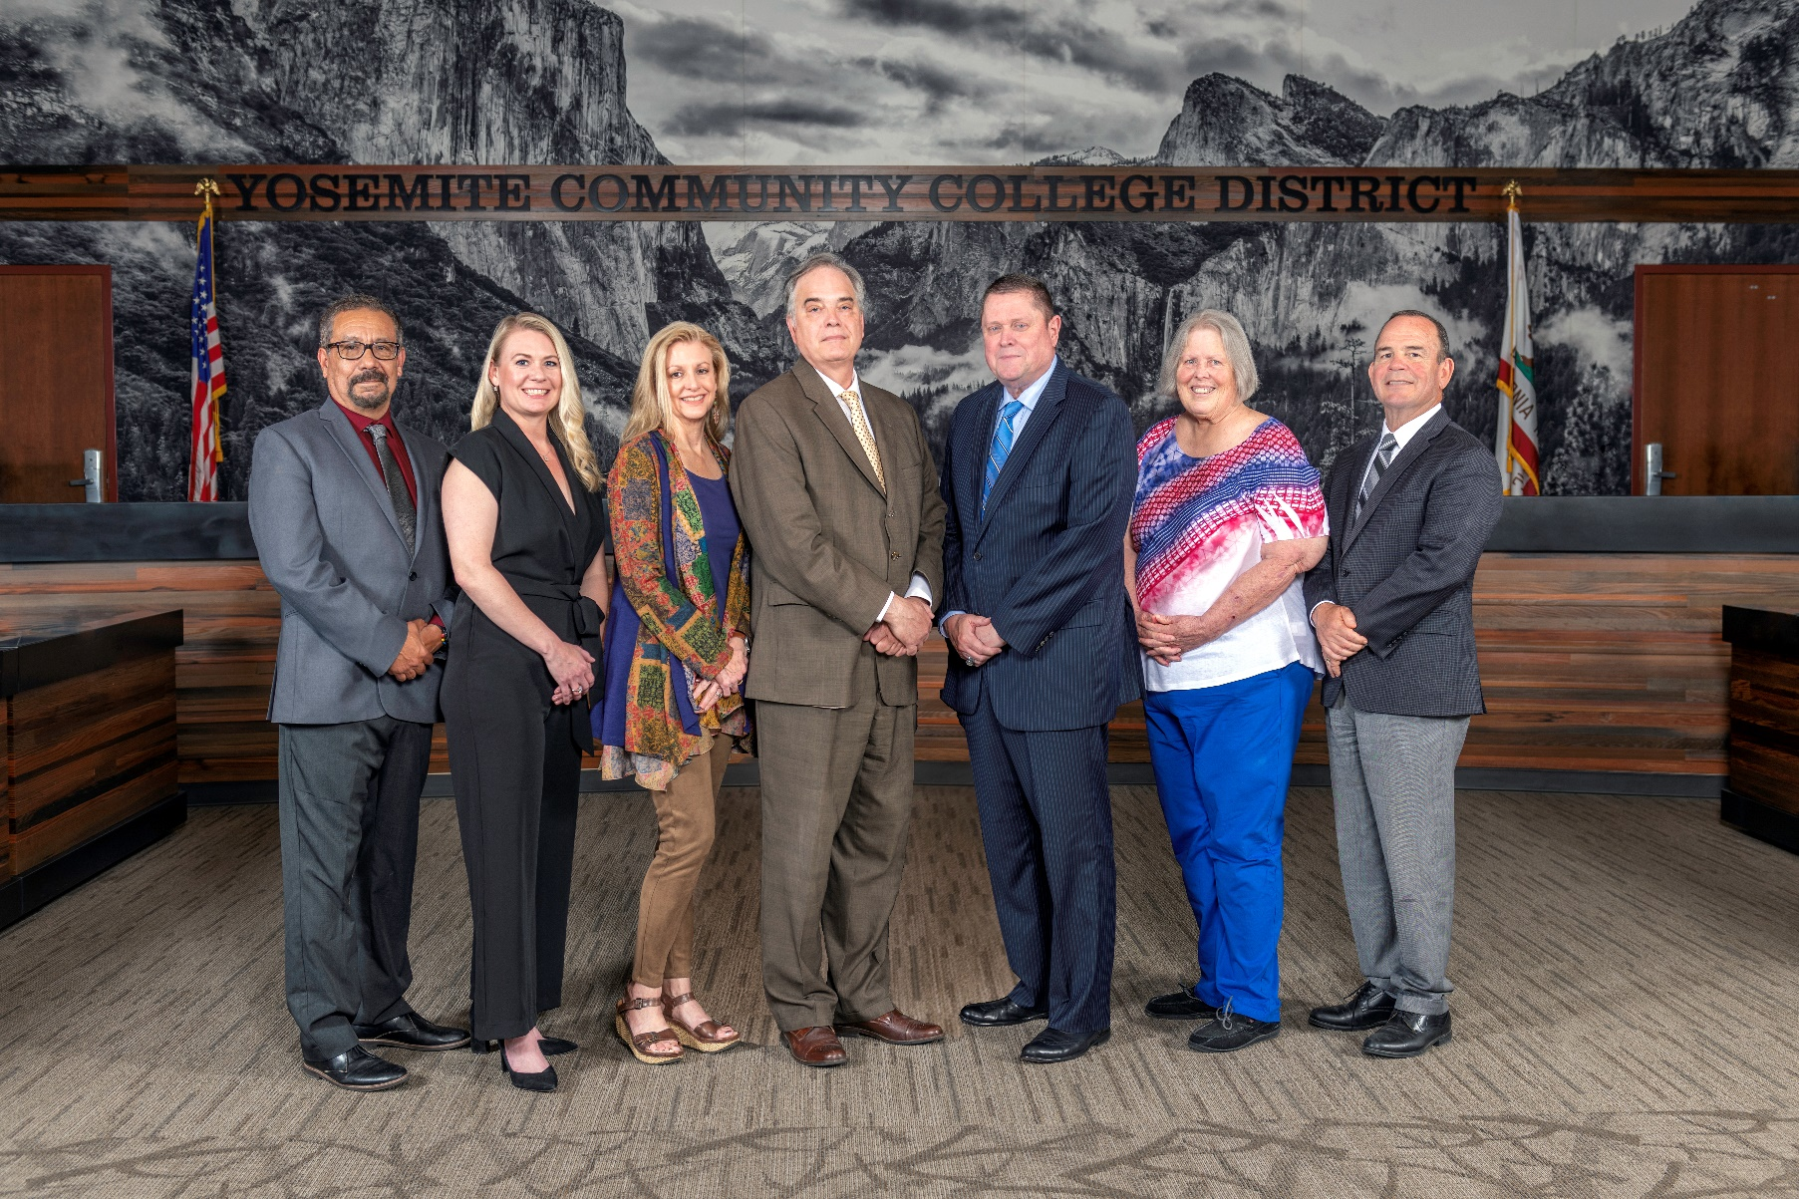

**Board Meeting Highlights**

**August 14, 2024**

**Regular Board Meeting**

**Report Out from Closed Session**

There was no report out from Closed Session.

**Board Committee Report: Columbia College Foundation Report**

Trustee Don Davis provided the Board of Trustees with an update from the Columbia College Foundation.

**Presentation: Modesto Junior College and Columbia College Enrollment Report**

Samantha Smith, Senior Director of Institutional Research, Planning and Accreditation, and Caterina Grossi, MJC Director of College Research and Planning, provided the Board of Trustees with information related to dual enrollment and CCAP at MJC and Columbia College. An overview of the enrollment and completion rates of MJC and Columbia College’s Fire Programs and MJC’s Nursing Programs was also provided to the Board.

**PRESENTATION: 2023-2024 Districtwide Enrollment Overview**

Samantha Smith, Senior Director of Institutional Research, Planning and Accreditation, provided the Board of Trustees with a comprehensive overview of districtwide enrollment for the 2023-2024 academic year. Also featured during the presentation was a district map by trustee area and aggregated data such as high school information, demographics, and special program participation.

**PRESENTATION: Accreditation Updates – Columbia College and Modesto Junior College**

Modesto Junior College and Columbia College Accreditation Team members, Patrick Bettencourt, Michael Smedshammer, and Melissa Raby provided the Board of Trustees with a status update on the progress of the upcoming accreditation.

**Chancellor Update**

Chancellor Yong invited Dr. Tran and Dr. Sanders to provide the Board of Trustees with an update from their respective colleges.

Chancellor Yong recognized and congratulated Modesto Junior College for its new contract education partnership with Adventist Health in Sonora.  Chancellor Yong is hopeful that contract education will continue to be utilized at both colleges to serve even more of the workforce training needs within the community.

Chancellor Yong provided the Board of Trustees with an update on the following community meetings that he attended:

o   State of the City of Turlock Address

o   Modesto Band of Stanislaus County – MoBand 105th Season

o   Madera College Visit

o   Ribbon Cutting Ceremony – Housing Project: The Village at Free Will Baptist Church

       o     National Night Out Event

Finally, Chancellor Yong recognized and thanked the Vice Chancellor of Information Technology & Institutional Research, Lucus Bogle, and his team for their work in protecting the District during the crowdstrike outage.

**Grants Annual Report and Activity Update**

The Board of Trustees received a report on grant activities for the fiscal year 2023-2024.  The report included grants obtained in 2023-2024 as well as grants submitted and pending for the future.

**YCCD Personnel Transaction**

The Board of Trustees acknowledged and commended the following retiree(s) for their years of service to the District:

       o     Gary DeBerry, Information Systems Specialist (21 years)

**Adoption of Interim Revisions to Board Policy 3433**

The Board of Trustees approved the interim revisions to BP 3433 – Prohibition of Sexual Harassment under Title IX, retroactive to August 1, 2024.

**Adoption of Interim Revisions to Board Policy 3434**

The Board of Trustees approved the interim revisions to BP 3434 – Responding to Harassment Based on Sex under Title IX, retroactive to August 1, 2024.

**YCCD Resolution No. 24-25.03 – Proposition 2: Public Education Facilities, Modernization, Repair, and Safety Bond Act of 2024**

The Board of Trustees adopted YCCD Resolution No. 24-25.03 Proposition 2: Public Education Facilities, Modernization, Repair, and Safety Bond Act of 2024.

**YCCD Resolution No. 24-25.01 – Trustee Absence from Board Meeting**

The Board of Trustees adopted YCCD Resolution No. 24-25.01 in the Matter of Trustee Absence from Board Meeting.

**Next Meetings**

The next regular meeting of the Board of Trustees will be held on September 11, 2024. Closed Session will begin at 3:00 p.m. and Open Session at 5:30 p.m.

***All Board action is available on BoardDocs following the meeting at this link:*** [https://go.boarddocs.com/ca/yosemite/Board.nsf/vpublic?open](https://nam02.safelinks.protection.outlook.com/?url=https%3A%2F%2Fgo.boarddocs.com%2Fca%2Fyosemite%2FBoard.nsf%2Fvpublic%3Fopen&data=05%7C02%7Cgibbsk%40yosemite.edu%7C0b2536e3bbdc43ee836708dc73a89a19%7C3d35afe626ac437eb4b375b50d459e45%7C0%7C0%7C638512415306890841%7CUnknown%7CTWFpbGZsb3d8eyJWIjoiMC4wLjAwMDAiLCJQIjoiV2luMzIiLCJBTiI6Ik1haWwiLCJXVCI6Mn0%3D%7C0%7C%7C%7C&sdata=GXp4wDhjmI%2FGDvsRN%2BEj6CHJlnA9v4e9PmubP5TJS9o%3D&reserved=0)