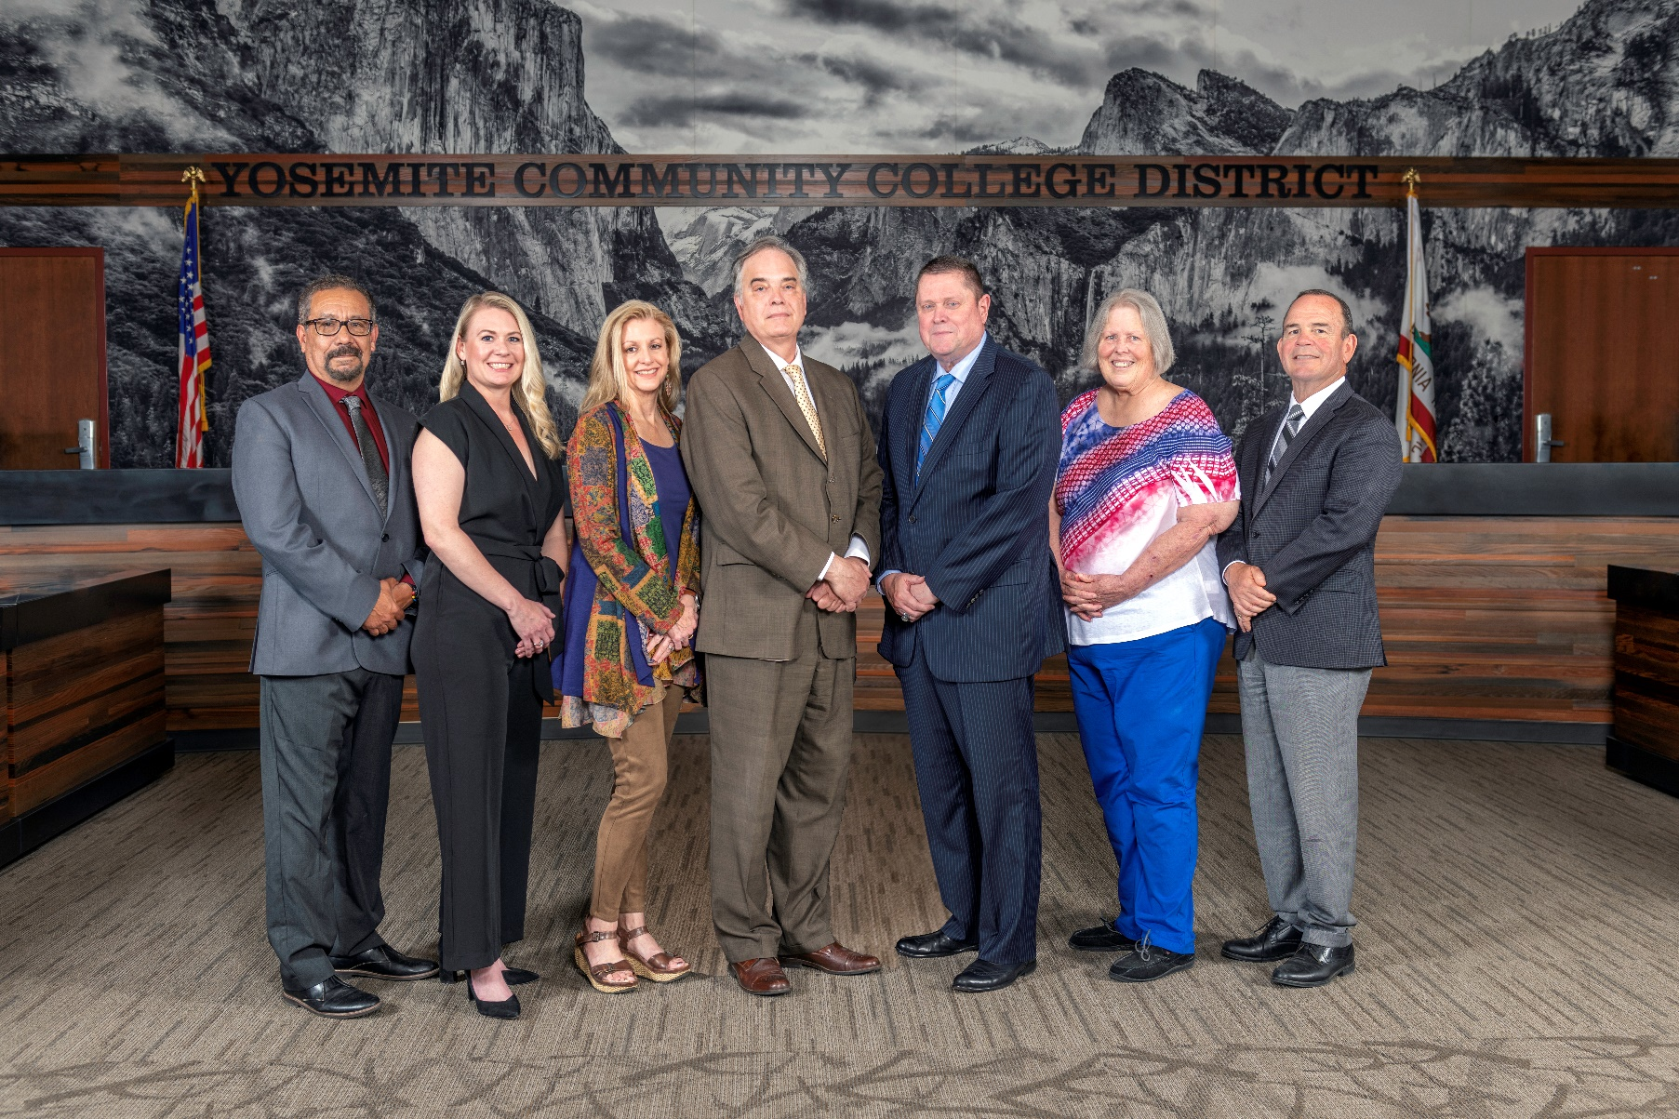

**Board Meeting Highlights**

**July 10, 2024**

**Regular Board Meeting**

**Report Out from Closed Session**

There was no report out from Closed Session.

**Board Committee Report: Board Policy Committee Report**

Trustee Nancy Hinton provided the Board of Trustees with an update from the Board Policy Committee.

**Board Committee Report: Columbia College Foundation Report**

Trustee Dr. Don Davis provided the Board of Trustees with an update from the Columbia College Foundation.

**Board Committee Report: Valley Insurance Program/Joint Powers Agency Board Report**

Trustee Nancy Hinton provided the Board of Trustees with an update from the Valley Insurance Program/Joint Powers Agency Board.

**Presentation: Columbia College Student Services Update**

The Board of Trustees was given an update on Student Services at Columbia College. The presenters included Melissa Raby, Vice President of Student Services, and five directors: Courtney Sutton, Director of Outreach and Retention; Michael Baldwin, Director of Dual Enrollment; Lesley Michtavy, Director of Admissions & Records and Veteran Benefits; Marnie Shively, Director of Student Financial Services; and Anneka Rogers Whitmer, Director of Special Programs.

**Chancellor Update**

Chancellor Yong invited Dr. Tran and Dr. Sanders to provide the Board of Trustees with an update from their respective colleges. Lastly, he introduced Vice Chancellor of Information Technology & Institutional Research Lucus Bogle.

**YCCD Personnel Transaction**

The Board of Trustees acknowledged and commended the following retirees for their years of service to the District:

       o   Steve Harmon, Maintenance Specialist, Carpenter (19 years)  
       o   Amy Nilson, Director of Development (11 years)

**Personnel - Negotiations YFA/YCCD - Opportunity for Members of the Public to Comment on the Mutually-Agreed Initial Proposal from the District and YFA, initially "sunshined" on June 12, 2024**

The Board of Trustees held a public comment period to receive comments on the initial proposal. No comments were received.

**Personnel - Negotiations YFA/YCCD - Adoption of the Mutually-Agreed Initial Proposal from the District and YFA**

The Board of Trustees adopted the mutually-agreed Initial Proposal from the District and YFA, attached to the July 10, 2024, Agenda.

**Next Meetings**

The next regular meeting of the Board of Trustees will be held on August 14, 2024. Open Session will begin at 3:00 p.m. Closed Session will follow at 3:05 p.m. The Board will reconvene to Open Session at 5:30 p.m. in the Yosemite Community College District Board Room, 2201 Blue Gum Avenue, Modesto, California.

***All Board action is available on BoardDocs following the meeting at this link:*** [https://go.boarddocs.com/ca/yosemite/Board.nsf/vpublic?open](https://na01.safelinks.protection.outlook.com/?url=https%3A%2F%2Fgo.boarddocs.com%2Fca%2Fyosemite%2FBoard.nsf%2Fvpublic%3Fopen&data=05%7C01%7Cgibbsk%40yosemite.edu%7Cdafdba40f9044726145608dbe4af4732%7C3d35afe626ac437eb4b375b50d459e45%7C0%7C0%7C638355213694252526%7CUnknown%7CTWFpbGZsb3d8eyJWIjoiMC4wLjAwMDAiLCJQIjoiV2luMzIiLCJBTiI6Ik1haWwiLCJXVCI6Mn0%3D%7C3000%7C%7C%7C&sdata=7UEPB9CWhETYn5eDl5v2kNE4GVtqxMX4oHYJQ5xq8bk%3D&reserved=0)