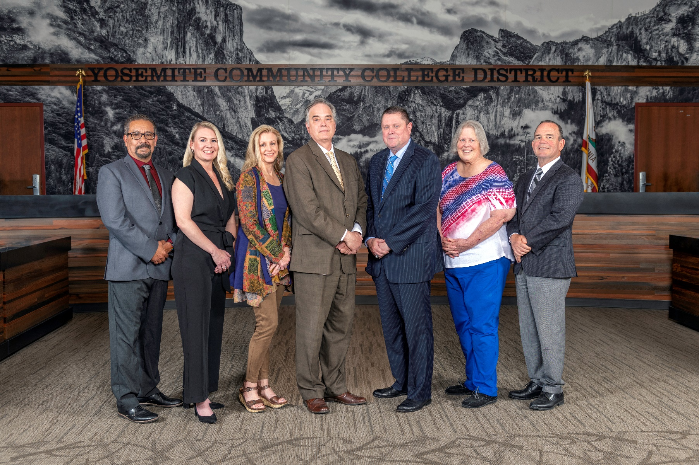

**Board Meeting Highlights**

**June 12, 2024**

**Regular Board Meeting**

**Report Out from Closed Session**

There was no report out from Closed Session.

**New YCCD Student Trustee**

Gustavo Castrejon, of Modesto Junior College, was sworn in as the new 2024-2025 YCCD Student Trustee.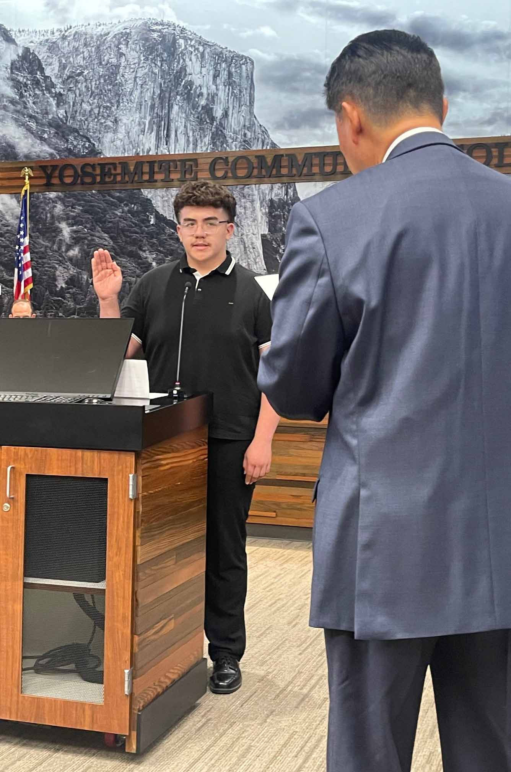

**Board Committee Report: Board Finance Committee Report**

Trustee Darin Gharat provided the Board of Trustees with an update from the Board Finance Committee.

**Board Committee Report: Valley Insurance Program/Joint Powers Agency Board Report**

Trustee Nancy Hinton provided the Board of Trustees with an update from the Valley Insurance Program/Joint Powers Agency Board.

**Presentation: FUN with FON, Round 3**

Dr. Brian Sanders, MJC President, provided the Board of Trustees with an update on the District’s Faculty Obligation Number (FON).

**Chancellor Update**

Chancellor Yong invited Dr. Tran and Dr. Sanders to provide the Board of Trustees with an update from their respective colleges.

Chancellor Yong also read a statement to acknowledge his retirement, in which he expressed his gratitude and thanks to YCCD and stated that he looks forward to future accomplishments in his last 383 days of service.

**Modesto Junior College Proposed Curriculum Changes**

The Board of Trustees approved the curriculum additions, deletions, and modifications as indicated on the Proposed Curriculum Changes Report as of the April 23, 2024 Curriculum Committee meeting.

**Columbia College Proposed Curriculum Changes**

The Board of Trustees approved the curriculum additions, deletions, and modifications as indicated on the Proposed Curriculum Changes Report for the period of April 16, 2024 to April 16, 2024.

**YCCD Personnel Transaction**

The Board of Trustees acknowledged and commended the following retirees for their years of service to the District:

o   Sue Hobby, Instructional Support Technician (12 years)

o   Alicia Kolstad, Counselor (24 years)

o   Anca Husher, Instructor of Physics (8 years)

o   David Todd, Photography Graphic Arts Production Specialist (20 years)

       o     Henry Yong, Chancellor (9 years)

**YCCD General Fund Tentative Budget 2024-2025**

The Board of Trustees adopted the 2024-2025 General Fund Tentative Budget for the Yosemite Community College District, and directed staff to file the budget with the Stanislaus County Superintendent of Schools by July 1, 2024.

**YCCD Resolution No. 23-14.16 Establish the 2024-2025 Appropriations Limit (GANN Limit)**

The Board of Trustees adopted YCCD Resolution No. 23-14.16 Establishing the Appropriations Limit for Fiscal Year 2024-2025 (GANN Limit) of $134,697,053.

**Proposition 30 Education Protection Account (EPA)**

The Board of Trustees approved the expenditure of EPA funds as instructional salaries and benefits. It is important to note that this is not new or increased revenue, but rather a new source of revenue towards total apportionment.

**Five-Year Construction Plan**

The Board of Trustees received the plan and approved it for submission to the California Community Colleges Chancellor’s Office per Board Policy 3600 – Capital Construction.

**Personnel – Approval of Employment Contract for Vice President of Instruction, Modesto Junior College**

The Board of Trustees approved the employment contract for the Vice President of Instruction, Modesto Junior College.

**Personnel – Approval of Employment Contract for Vice President of Instruction, Columbia College**

The Board of Trustees approved the employment contract for the Vice President of Instruction, Columbia College.

**Personnel – Approval of Employment Contract for Vice Chancellor, Information Technology & Institutional Research**

The Board of Trustees approved the employment contract for the Vice Chancellor, Information Technology & Institutional Research.

**Personnel – Approval of Employment Contract for President of Columbia College**

The Board of Trustees approved the employment contract for the President of Columbia College.

**Governing Board Member Election - YCCD Resolution No. 23-24.19**

The Board of Trustees adopted YCCD Resolution No. 23-24.19 ordering an election to be conducted on November 5, 2024, in the Yosemite Community College District and directed that the adopted resolution be filed with the Stanislaus Superintendent of Schools prior to July 8, 2024.

**Notice of Board Member Election, Merced County - YCCD Resolution No. 23-24.20**

The Board of Trustees adopted YCCD Resolution No. 23-24.20, Notice of Election to be conducted on November 5, 2024, in the Yosemite Community College District and directed that the adopted resolution be filed with the Merced County Registrar of Voters by July 3, 2024.

**Declaring an Election, San Joaquin County - YCCD Resolution No. 23-24.21**

The Board of Trustees adopted YCCD Resolution No. 23-24.21, Declaring an Election to be conducted on November 5, 2024, in the Yosemite Community College District and directed that the adopted resolution be filed with the San Joaquin County Registrar of Voters by July 3, 2024.

**Personnel – Negotiations YFA/YCCD – Presentation of the Initial Proposal Mutually Agreed to by the District and YFA**

The Board of Trustees acknowledged receipt of YFA’s and YCCD’s mutually agreed upon initial proposal; scheduled public comment on the proposal and Board adoption of the initial proposal for July 10, 2024, and referred the proposal to administrative staff for review.

**Personnel – Negotiations YFA/YCCD – Approval of the tentative agreements reached during negotiations for the 2023-2026 Successor Collective Bargaining Agreement**

The Board of Trustees approved the tentative agreements reached during negotiations for the 2023-2026 Successor Collective Bargaining Agreement.

**Letter of Support – Presentation Proposal for the ACCT Leadership Congress – Community Colleges as Catalysts: Cultivating Skills for the Future**

The Board of Trustees approved the letter of support for the DEI Challenges at Rural Community Colleges: Unique Obstacles and Creative Solutions presentation proposal for the ACCT Leadership Congress in Seattle, Washington on October 23-26, 2024.

**Next Meetings**

The next regular meeting of the Board of Trustees will be held on July 10, 2024.  Closed Session will begin at 3:00 p.m. and Open Session at 5:30 p.m. in the Manzanita Conference Room at Columbia College, 11600 Columbia College Drive, Sonora.

***All Board action is available on BoardDocs following the meeting at this link:*** [https://go.boarddocs.com/ca/yosemite/Board.nsf/vpublic?open](https://na01.safelinks.protection.outlook.com/?url=https%3A%2F%2Fgo.boarddocs.com%2Fca%2Fyosemite%2FBoard.nsf%2Fvpublic%3Fopen&data=05%7C01%7Cgibbsk%40yosemite.edu%7Cdafdba40f9044726145608dbe4af4732%7C3d35afe626ac437eb4b375b50d459e45%7C0%7C0%7C638355213694252526%7CUnknown%7CTWFpbGZsb3d8eyJWIjoiMC4wLjAwMDAiLCJQIjoiV2luMzIiLCJBTiI6Ik1haWwiLCJXVCI6Mn0%3D%7C3000%7C%7C%7C&sdata=7UEPB9CWhETYn5eDl5v2kNE4GVtqxMX4oHYJQ5xq8bk%3D&reserved=0)