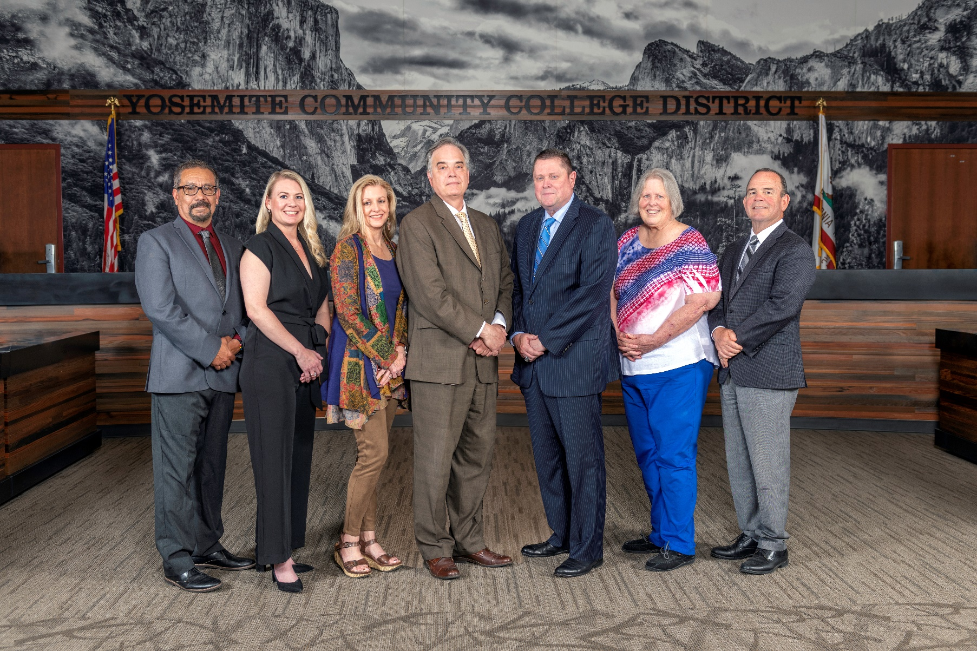

**Board Meeting Highlights**

**June 11, 2025**

**Regular Board Meeting**

**Report Out from Closed Session**

There was no report out from Closed Session.

**Board Committee Report: Modesto Junior College Foundation Report**

Trustee Leslie Beggs provided the Board of Trustees with an update from the Modesto Junior College Foundation.

**Board Committee Report: Columbia College Foundation Report**

Trustee Don Davis provided the Board of Trustees with an update from the Columbia College Foundation.

**Board Committee Report: Valley Insurance Program/Joint Powers Agency Report**

Trustee Darin Gharat provided the Board of Trustees with an update from the Valley Insurance Program/Joint Powers Agency.

**Interim Chancellor Update**

Interim Chancellor Dr. Lena Tran expressed her gratitude to the members of the public who shared their comments earlier in the meeting. Dr. Tran assured the students and community members in attendance that the District has listened to their concerns and is fully committed to taking the necessary actions to address their requests.

Interim Chancellor Tran also expressed appreciation to her Cabinet and her two assistants.  Dr. Tran then invited Dr. Sanders to provide the Board of Trustees with an update from Modesto Junior College.  In addition to his college update, Dr. Sanders also provided the Board of Trustees with an update on enrollment.

**Columbia College Proposed Curriculum Changes**

The Board of Trustees approved the curriculum additions, deletions, and modifications as indicated on the Proposed Curriculum Changes Report for the period of April 15, 2025, to April 22, 2025.

**YCCD Personnel Transaction**

The Board of Trustees acknowledged and commended the following retiree(s) for their years of service to the District:

       o     Glen Stovall, Director of Rise Up Center (25 years)

**YCCD General Fund Tentative Budget 2025-2026**

The Board of Trustees adopted the 2025-2026 General Fund Tentative Budget for the Yosemite Community College District, and directed staff to file the budget with the Stanislaus County Superintendent of Schools by July 1, 2025.

**YCCD Resolution No. 24-25.20 Establish the 2025-2026 Appropriations Limit (GANN Limit)**

The Board of Trustees adopted YCCD Resolution No. 24-25.20 Establishing the Appropriations Limit for Fiscal Year 2025-2026 (GANN Limit) of $132,400,486.

**Proposition 30 Education Protection Account (EPA)**

The Board of Trustees approved the expenditure of EPA funds as instructional salaries and benefits. It is important to note that this is not new or increased revenue, but rather a new source of revenue towards total apportionment.

**Five-Year Construction Plan**

The Board of Trustees received the plan and approved it for submission to the California Community Colleges Chancellor’s Office per Board Policy 3600 – Capital Construction.

**YCCD Resolution No. 24-25.23 Declare and Authorize Disposition of Surplus Property**

The Board of Trustees adopted YCCD Resolution No. 24-25.23 declaring the listed property in Exhibit A as surplus and directs staff to take appropriate action as per Education Code Section 81450.

**Modesto Junior College, College and Careers Access Pathway (CCAP) Partnership Agreement**

The Board of Trustees welcomed comments from the public and approved the College and Careers Access Pathways (CCAP) Partnership Agreement between Yosemite Community College District and Newman-Crows Landing Unified School District.

**Out of Country Travel – Modesto Junior College – National Geographic Society, Johannesburg, South Africa**

The Board of Trustees approved the out of country travel for Professor Debra Bolter to serve as lead scientists to study newly excavated fossils in collaboration with the National Geographic Society and the University of Witwatersrand in Johannesburg, South Africa from June 16, 2025 to July 17, 2025.

**Next Meetings**

The next regular meeting of the Board of Trustees will be held on July 9, 2025.  Closed Session will begin at 3:00 p.m. and Open Session at 5:30 p.m. in the Yosemite Community College District Board Room, 2201 Blue Gum Avenue, Modesto, California.

***All Board action is available on BoardDocs following the meeting at this link:*** [https://go.boarddocs.com/ca/yosemite/Board.nsf/vpublic?open](https://nam02.safelinks.protection.outlook.com/?url=https%3A%2F%2Fgo.boarddocs.com%2Fca%2Fyosemite%2FBoard.nsf%2Fvpublic%3Fopen&data=05%7C02%7Cgibbsk%40yosemite.edu%7C04ab26527f6a495a1c8e08dce989f34c%7C3d35afe626ac437eb4b375b50d459e45%7C0%7C0%7C638642026033239352%7CUnknown%7CTWFpbGZsb3d8eyJWIjoiMC4wLjAwMDAiLCJQIjoiV2luMzIiLCJBTiI6Ik1haWwiLCJXVCI6Mn0%3D%7C0%7C%7C%7C&sdata=LemRImXBecA5B4HggjFShKy2x6iWsE3ViNf%2BdE6cGew%3D&reserved=0)