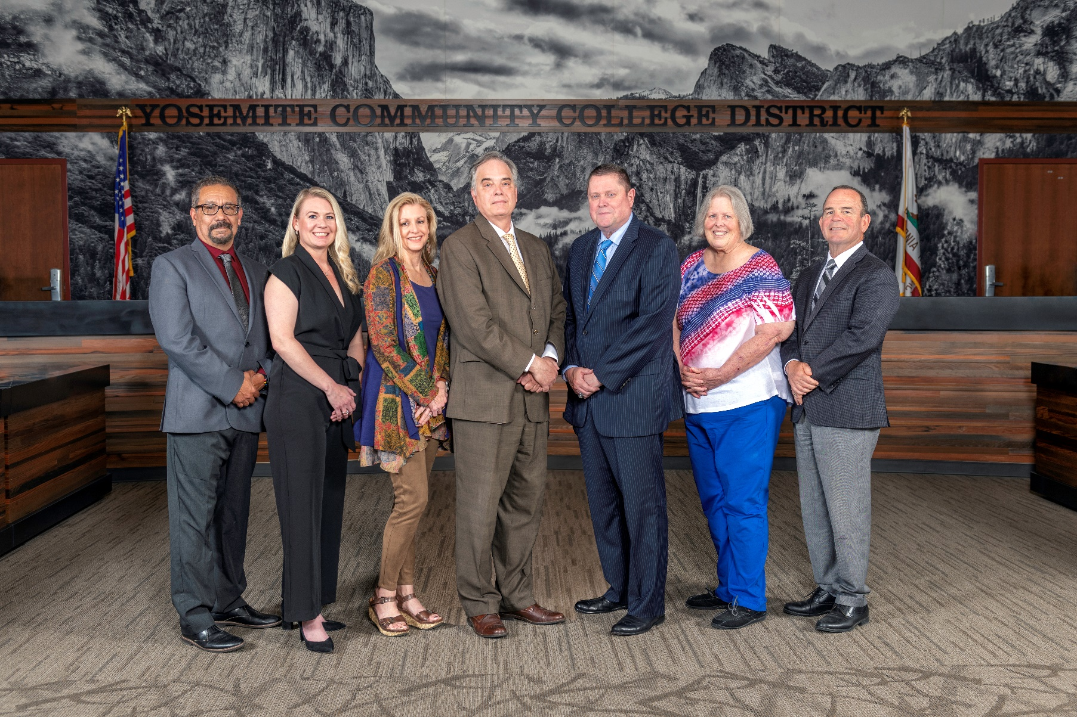

**Board Meeting Highlights**

**May 8, 2024**

**Regular Board Meeting**

**Report Out from Closed Session**

There was no report out from Closed Session.

**Board Committee Report: Board Finance Committee Report**

Trustee Darin Gharat provided the Board of Trustees with an update from the Board Finance Committee.

**Board Committee Report: Board Policy Committee Report**

Trustee Nancy Hinton provided the Board of Trustees with an update from the Board Policy Committee.

**Board Committee Report: Modesto Junior College Foundation Report**

Trustee Leslie Beggs provided the Board of Trustees with an update from the Modesto Junior College Foundation.

**Board Committee Report: Columbia College Foundation Report**

Trustee Dr. Don Davis provided the Board of Trustees with an update from the Columbia College Foundation.

**Presentation: Columbia College Outreach and Retention**

Courtney Sutton, Director of Outreach and Retention, provided the Board of Trustees with an update on the Starfish program at Columbia College.

**Presentation: Columbia College Student Housing Update**

Trevor Stewart, Vice Chancellor of District Administrative Services, provided the Board of Trustees with an update on Columbia College’s Student Housing transitioning to District ownership.

**Chancellor Update**

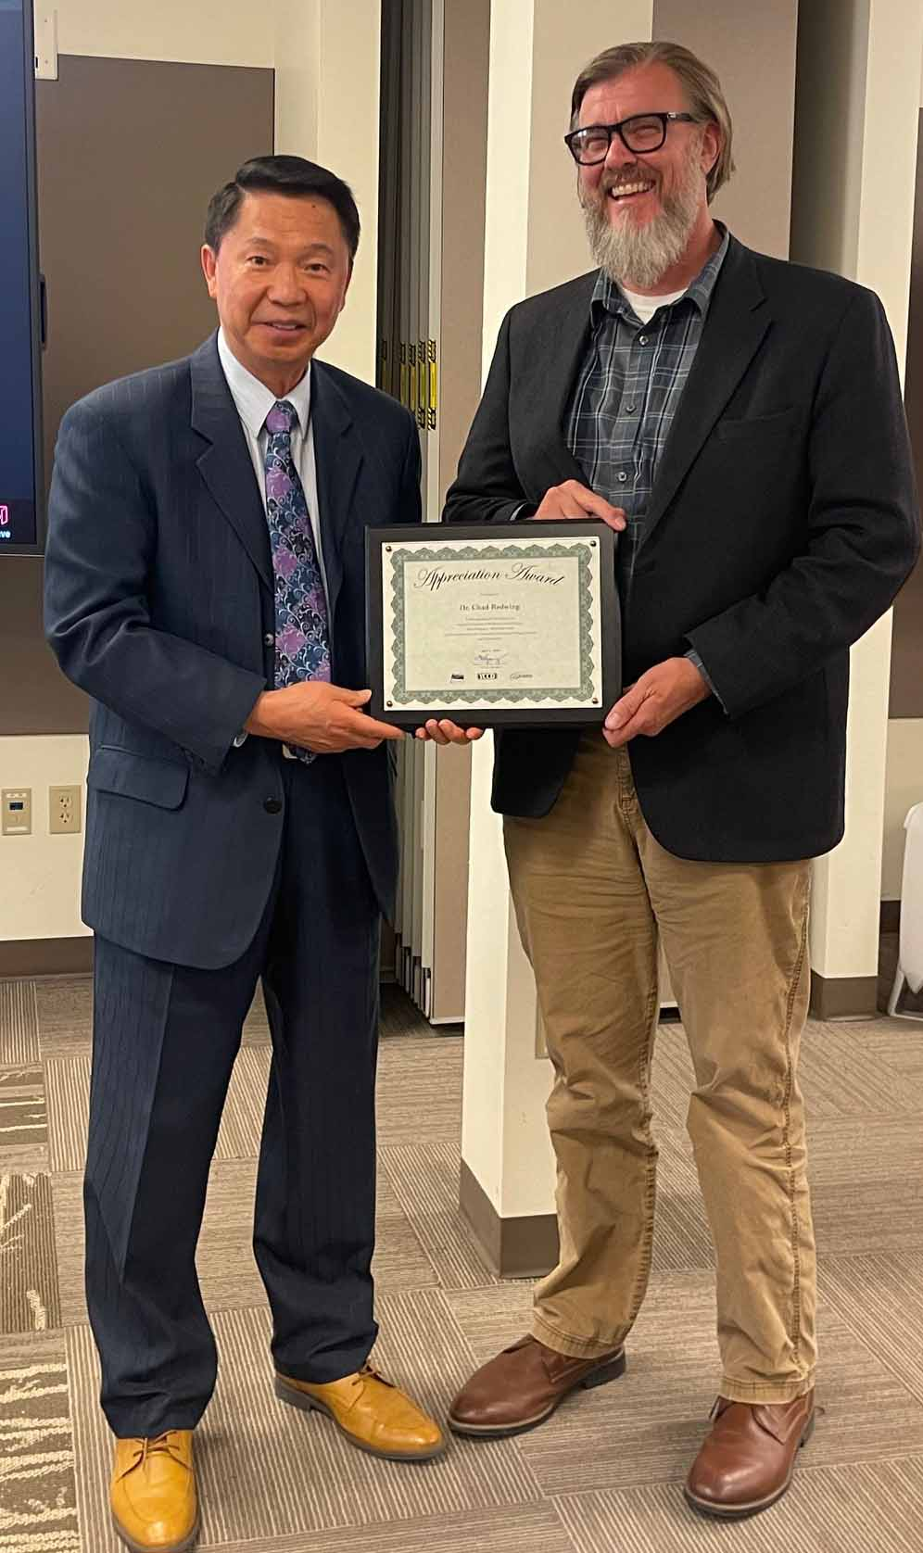  
Earlier in the meeting, Chancellor Yong presented Dr. Chad Redwing with an appreciation award in recognition of his service as Interim President of Modesto Junior College.

There were no college reports provided during the Chancellor’s update. However, the Board was provided a written report from both Presidents who were unable to attend the Board meeting. Chancellor Yong recognized the Columbia College accreditation team, who will be one of the presenters at the ACCJC Conference in Garden Grove.

Chancellor Yong announced that the new Senior Director of Institutional Research started on May 1st. Additionally, Chancellor Yong reported that the new Director of Information Security and the new Vice Chancellor of IT & IR will begin very soon.

Chancellor Yong acknowledged this week, May 6-10, as Faculty Appreciation Week. Chancellor Yong recognized and thanked all of the faculty within the District for their service. Chancellor Yong also announced that in appreciation of Classified School Employees’ Week, May 19-25, the District will be providing celebrations in honor of our classified professionals on the following dates and times:

o   Tuesday, May 21, 2024, between 8pm (*MJC East Campus – Custodial Break Room & Security Break Room*)

o   Tuesday, May 21, 2024, between 9:30pm (*MJC West Campus – Custodial Break Room & Security Break Room*)

o   Wednesday, May 22, 2024, between 9am-11am (*MJC East Campus – Staff Dining Room*)

o   Thursday, May 23, 2024, between 10am-11am (*Columbia College – Upper Manzanita Staff Lounge*)

o   Thursday, May 23, 2024, between 1pm-2pm (*MJC West Campus – YCCD District Office Break Room*)

**Modesto Junior College Proposed Curriculum Changes**

The Board of Trustees approved the curriculum additions, deletions, and modifications as indicated on the Proposed Curriculum Changes Report as of the April 9, 2024 Curriculum Committee meeting.

**Columbia College Proposed Curriculum Changes**

The Board of Trustees approved the curriculum additions, deletions, and modifications as indicated on the Proposed Curriculum Changes Report for the period of March 19, 2024 to April 9, 2024.

**YCCD Personnel Transaction**

The Board of Trustees acknowledged and commended the following retirees for their years of service to the District:

        o   Raelene Juarez, Dean of Arts, Sciences, and Human Performance (19 years)  
        o   Miriam Medina, Program Specialist (25 years)  
 o   Nora Seronello, Director of Center of Excellence (15.5 years)  
 o   Shelley Stevens, Food Service Coordinator (28 years)  
        o   Raquel Tiscareno, Auxiliary Services Manager (23 years)

**Modesto Junior College, College and Careers Access Pathway (CCAP) Partnership Agreement**

The Board of Trustees welcomed comments from the public and approved the College and Careers Access Pathways (CCAP) Partnership Agreement between Yosemite Community College District and Riverbank Unified School District.

**Board Policy – 2nd Reading**

The Board of Trustees conducted a 2nd reading on the following YCCD policies and approved all policies, with the exception of Policy 3530.  Policy 3530 was pulled and will be brought back as a 2nd Reading in the fall.

o   2410 – Board Policies and Administrative Procedures

o   3530 – Weapons on Campus

o   3-8032 – Privately Owned Transportation

o   4300 – Field Trips and Excursions

       o     6250 – Budget Adoption and Administration

**YCCD Resolution No. 23-24.14 – Faculty Appreciation Week 2024**

The Board of Trustees adopted Resolution No. 23-24.14, proclaiming May 7, 2024, as Faculty Appreciation Day and May 6-10, 2024, as Faculty Appreciation Week in the Yosemite Community College District, and thanked the YCCD faculty for their commitment and contribution to the District.

**Personnel – Approval of Employment Contract for Vice President of Student Services, Columbia College**

The Board of Trustees approved the employment contract for the Vice President of Student Services, Columbia College.

**Personnel – Approval of Employment Contract for Vice President of College Administrative Services, Modesto Junior College**

The Board of Trustees approved the employment contract for the Vice President of College Administrative Services, Modesto Junior College.

**Personnel – Approval of Employment Contract for Vice President of Student Services, Modesto Junior College**

The Board of Trustees approved the employment contract for the Vice President of Student Services, Modesto Junior College.

**YCCD Resolution No. 23-24.15 – Trustee Absence from Board Meeting**

The Board of Trustees adopted Resolution No. 23-24.15 in the Matter of Trustee Absence from Board Meeting.

**Next Meetings**

The next regular meeting of the Board of Trustees will be held on June 12, 2024. Closed Session will begin at 3:00 p.m. and Open Session at 5:30 p.m. in the Yosemite Community College District Board Room, 2201 Blue Gum Avenue, Modesto.

***All Board action is available on BoardDocs following the meeting at this link:*** [https://go.boarddocs.com/ca/yosemite/Board.nsf/vpublic?open](https://na01.safelinks.protection.outlook.com/?url=https%3A%2F%2Fgo.boarddocs.com%2Fca%2Fyosemite%2FBoard.nsf%2Fvpublic%3Fopen&data=05%7C01%7Cgibbsk%40yosemite.edu%7Cdafdba40f9044726145608dbe4af4732%7C3d35afe626ac437eb4b375b50d459e45%7C0%7C0%7C638355213694252526%7CUnknown%7CTWFpbGZsb3d8eyJWIjoiMC4wLjAwMDAiLCJQIjoiV2luMzIiLCJBTiI6Ik1haWwiLCJXVCI6Mn0%3D%7C3000%7C%7C%7C&sdata=7UEPB9CWhETYn5eDl5v2kNE4GVtqxMX4oHYJQ5xq8bk%3D&reserved=0)