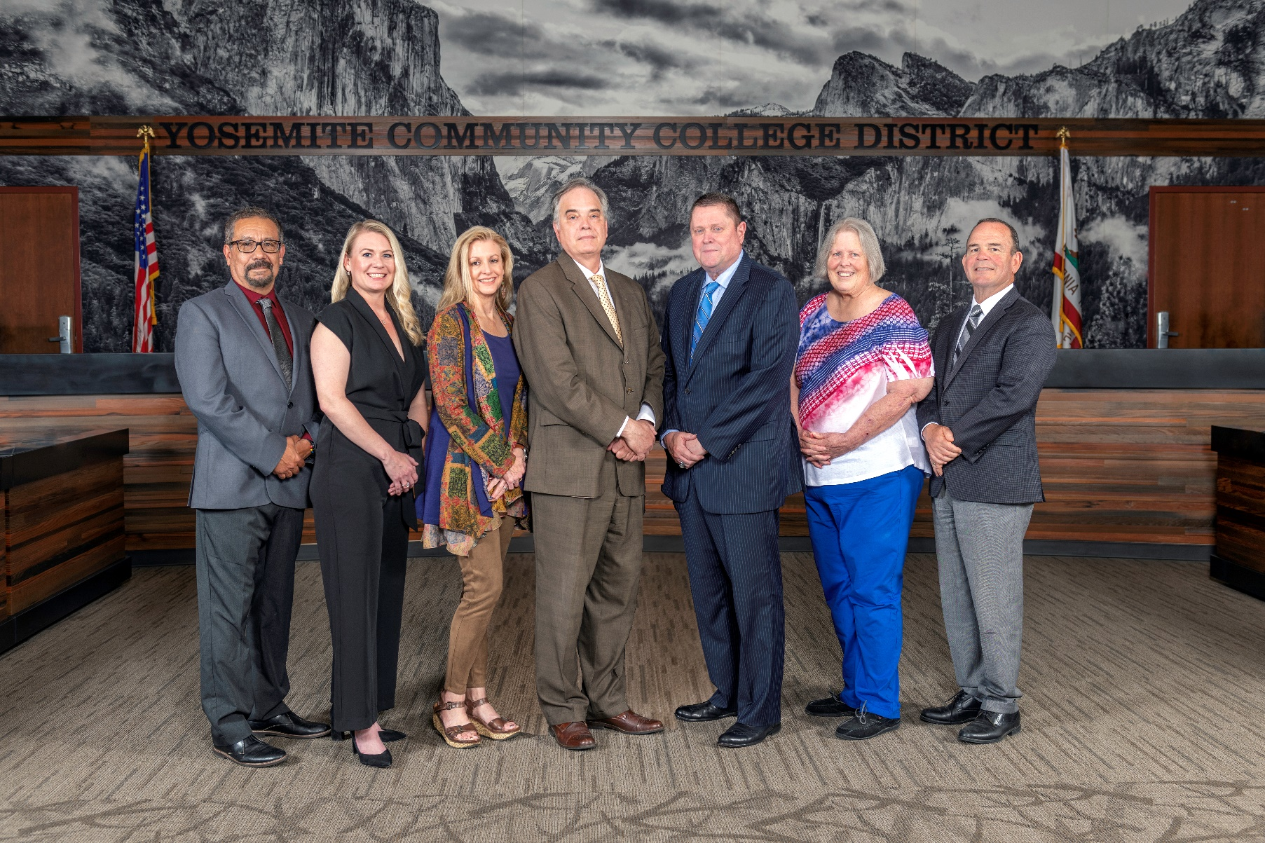

**Board Meeting Highlights**

**April 10, 2024**

**Regular Board Meeting**

**Report Out from Closed Session**

There was no report out from Closed Session.

**Board Committee Report: Modesto Junior College Foundation Report**

Trustee Leslie Beggs provided the Board of Trustees with an update from the Modesto Junior College Foundation.

**Board Committee Report: Columbia College Foundation Report**

Trustee Dr. Don Davis provided the Board of Trustees with an update from the Columbia College Foundation.

**Board Committee Report: Association of Stanislaus County School Boards Report**

Trustee Dr. Don Davis provided the Board of Trustees with an update from the Association of Stanislaus County School Boards.

**Board Committee Report: Valley Insurance Program/Joint Powers Agency Board Report**

Trustee Nancy Hinton provided the Board of Trustees with an update from the Valley Insurance Program/Joint Powers Agency Board.

**Presentation: MJC Regional Fire Training Center (RFTC) Update**

Deputy Chief Chris Jelinek provided the Board of Trustees with an update on the reaccreditation of the Modesto Junior College Fire Academy and the progress on the new partnership between MJC and Modesto-Stanislaus Consolidated-Turlock Fire in operating the Regional Fire Training Center.

After the presentation, Board President Dr. Milton Richards presented Chief Jelinek with an award in recognition of his service to the District.

Chief Jelinek with members from the District and Regional Fire Training Center posing for a photo.



**Presentation: MJC Student Services**

Dr. Andrea Wilson, MJC Vice President of Student Services; Angelica Guzman, MJC Dean of Enrollment Services; Jose Rocha, MJC Dean of Special Programs; and Dr. Matthew Lopez-Phillips, MJC Dean of Counseling, provided the Board of Trustees with an overview and update of services, activities, and various programs within the MJC Student Services Division. The presentation included an update on customer service enhancements, new technology usage, the growth of programs and services available for students, outreach activities, and student success initiatives. In addition, MJC students Oscar Tello, David Lujan, and Omar Abdulqadir shared personal Student Services program experiences with the Board of Trustees.

**Presentation: Accreditation Updates – Columbia College and Modesto Junior College**

Dr. Melissa Raby, Columbia College Vice President of Student Services and Accreditation Liaison Officer, and Dr. Brian Sanders, MJC President, provided the Board of Trustees with an accreditation update for their respective colleges.

**Chancellor Update**

Chancellor Yong invited Dr. Scott Siegel and Debra Hendricks, from Leaders 4ward Consultants, to provide the Board of Trustees with an update on the District Strategic Plan. Community members, Marian Kaanon and Joe Duran, also shared their input on the Strategic Plan from the community perspective.

Chancellor Yong also invited Trevor Stewart, Vice Chancellor of District Administrative Services, to provide the Board of Trustees with an update on the discussions surrounding transportation within the District. In addition, Chancellor Yong invited Dr. Brian Sanders, MJC President, and Dr. Melissa Raby, Columbia College Vice President of Student Services, to provide the Board of Trustees with a college update from their respective colleges.

Chancellor Yong announced that the Board of Trustees selected Mary Calderon, MJC Instructional Support Assistant in the Instructional Learning Center – English Second Language Services, as the YCCD nomination for the Classified Employee of the Year Award.  Mary’s name has been submitted to the California Community Colleges Board of Governors and the Foundation for California Community Colleges.  The Board honored Mary Calderon with an award presentation as the 2024 YCCD Classified Employee of the Year.

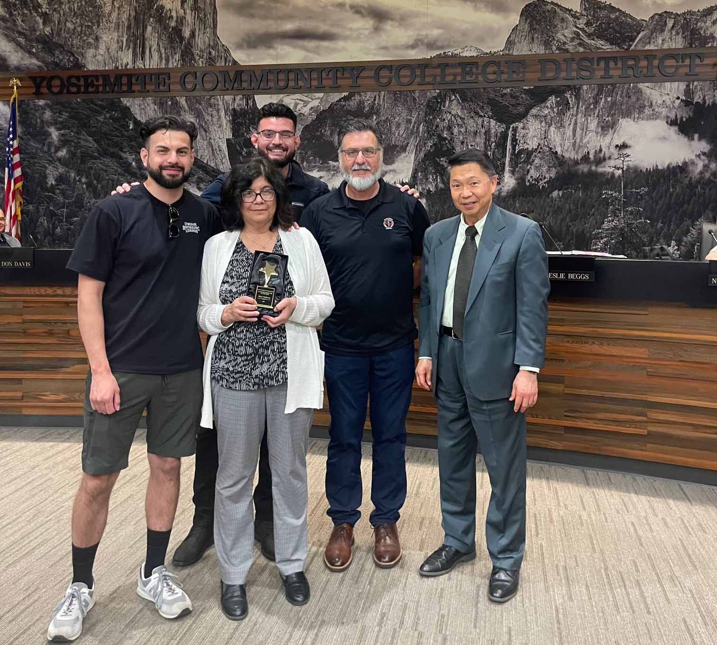

Finally, Chancellor Yong announced that the California Legislature recognizes the important contribution of classified school employees and named the third full week of May (May 19-25, 2024) “Classified School Employee Week” (CSEW) to honor their contributions. YCCD will honor all classified employees with a reception including refreshments during the week of May 19-25, 2024. The specific times and location of the receptions are currently in the process of being identified and will be shared at a later time.

**Modesto Junior College Proposed Curriculum Changes**

The Board of Trustees approved the curriculum additions, deletions, and modifications as indicated on the Proposed Curriculum Changes Report as of the March 12, 2024 Curriculum Committee meeting.

**Columbia College Proposed Curriculum Changes**

The Board of Trustees approved the curriculum additions, deletions, and modifications as indicated on the Proposed Curriculum Changes Report for the period of February 20, 2024 to March 12, 2024.

**Modesto Junior College Sabbatical Leave Report**

The Board of Trustees accepted the 2023-2024 sabbatical leave report for the following Modesto Junior College faculty member:

       o   Leslie Collins – Fall 2023

**YCCD Personnel Transaction**

The Board of Trustees acknowledged and commended the following retirees for their years of service to the District:

       o   Kelly Addington, Administrative Technician (17 years)  
 o   Robert Taylor, Custodian (22 years)

**Board Policy – 2nd Reading**

The Board of Trustees conducted a 2nd reading on the following YCCD policies and approved all policies, with the exception of Policy 2410. Policy 2410 was pulled and will be brought back as a 2nd Reading at the May 8, 2024 Board Meeting.

o   2015 – Student Member

o   2410 – Board Policies and Administrative Procedures

o   2716 – Political Activity

o   2717 – Personal Use of Public Resources

o   2720 – Communications Among Board Members

o   2730 – Board Member Health Benefits

o   2735 – Board Member Travel

o   5011 – Admission and Dual Enrollment of High School and Other Young Students

o   5130 – Financial Aid

o   5410 – Associated Students Election

       o   6400 – Financial Audits

**Board Policy – 1st Reading**

The Board of Trustees conducted a 1st reading on the following YCCD policies.  All of the policies, with the exception of Policies 3500, 3501, 3505, 3510, 3515, 3520, and 7600, will be presented to the Board for a 2nd reading at the May 8, 2024 Board Meeting.  Policies 3500, 3501, 3505, 3510, 3515, 3520, and 7600 were pulled and will be brought back as a 1st Reading in the fall.

o   3500 – Campus Safety

o   3501 – Campus Security and Access

o   3505 – Emergency Operations Plan

o   3510 – Workplace Violence

o   3515 – Reporting of Crimes

o   3520 – Local Law Enforcement

o   3530 – Weapons on Campus

o   3-8032 – Privately Owned Transportation

o   4300 – Field Trips and Excursions

       o   6250 – Budget Adoption and Administration

       o   7600 – Campus Safety Officers

**YCCD Resolution No. 23-24.13 – Classified School Employee Week 2024**

The Board of Trustees adopted Resolution No. 23-24.13 proclaiming May 19-25, 2024, as Classified School Employee Week in the Yosemite Community College District and thanked the YCCD classified staff for their commitment and contribution to the District.

**Next Meetings**

The next regular meeting of the Board of Trustees will be held on May 8, 2024. Closed Session will begin at 3:00 p.m. and Open Session at 5:30 p.m. in the Manzanita Conference Room at Columbia College, 11600 Columbia College Drive, Sonora.

***All Board action is available on BoardDocs following the meeting at this link:*** [https://go.boarddocs.com/ca/yosemite/Board.nsf/vpublic?open](https://na01.safelinks.protection.outlook.com/?url=https%3A%2F%2Fgo.boarddocs.com%2Fca%2Fyosemite%2FBoard.nsf%2Fvpublic%3Fopen&data=05%7C01%7Cgibbsk%40yosemite.edu%7Cdafdba40f9044726145608dbe4af4732%7C3d35afe626ac437eb4b375b50d459e45%7C0%7C0%7C638355213694252526%7CUnknown%7CTWFpbGZsb3d8eyJWIjoiMC4wLjAwMDAiLCJQIjoiV2luMzIiLCJBTiI6Ik1haWwiLCJXVCI6Mn0%3D%7C3000%7C%7C%7C&sdata=7UEPB9CWhETYn5eDl5v2kNE4GVtqxMX4oHYJQ5xq8bk%3D&reserved=0)