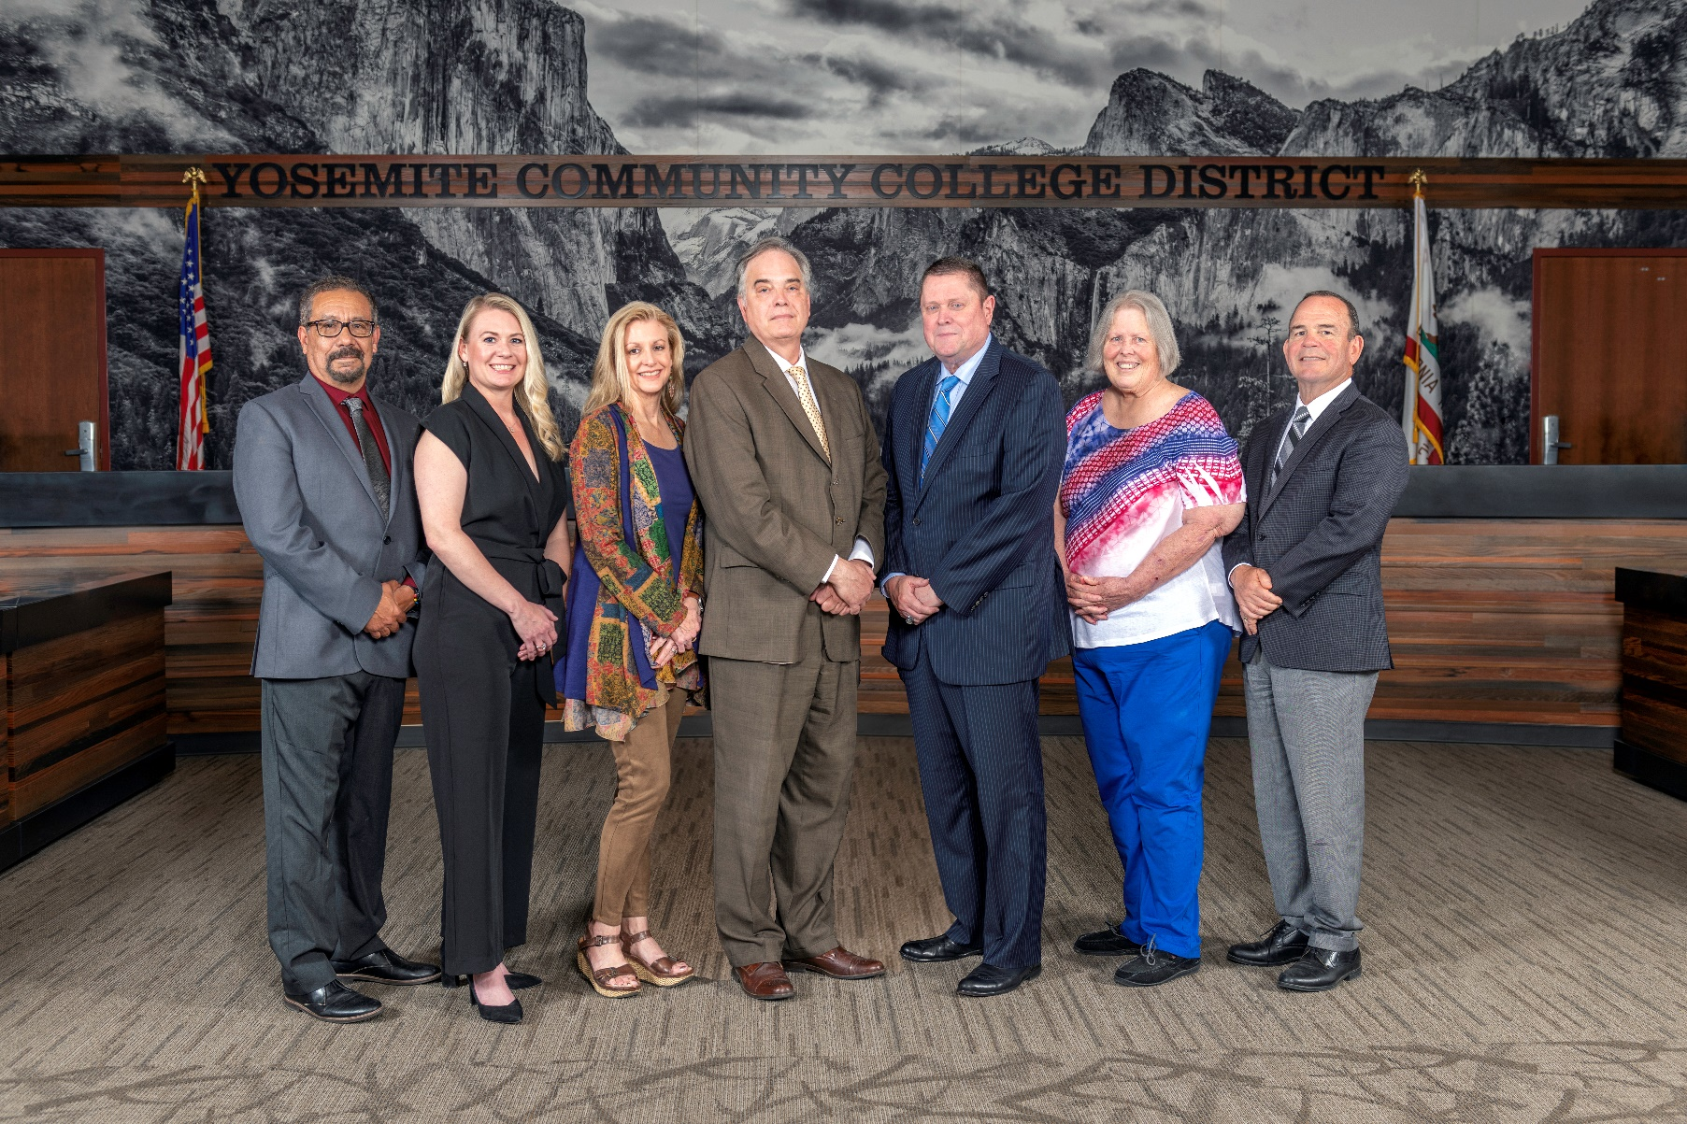

**Board Meeting Highlights**

**April 9, 2025**

**Regular Board Meeting**

**Report Out from Closed Session**

Board Stenographer Graciela Molina read the following:

1. In closed session, the Board took action to appoint an Interim Chancellor subject to completion of background and reference checks and agreement on an employment agreement. The name of the Interim Chancellor will be announced at the next Board meeting. The vote was:

o   Trustee Aguilar – Yes

o   Trustee Beggs – Yes

o   Trustee Gharat – No

o   Trustee Hinton – Yes

o   Trustee Nicolau – No

o   Trustee Richards – Yes

       o   Trustee Davis – Absent

**Board Committee Report: Board Finance Committee Report**

Trustee Darin Gharat provided the Board of Trustees with an update from the Board Finance Committee.

**Board Committee Report: Modesto Junior College Foundation Report**

Trustee Leslie Beggs provided the Board of Trustees with an update from the Modesto Junior College Foundation.

**Board Committee Report: Valley Insurance Program/Joint Powers Agency Report**

Trustee Darin Gharat provided the Board of Trustees with an update from the Valley Insurance Program/Joint Powers Agency.

**Chancellor Update**

Chancellor Yong invited Dr. Tran and Dr. Sanders to provide the Board of Trustees with an update from their respective colleges.

Chancellor Yong expressed gratitude to the classified professionals for their service to the District and announced that, during Classified School Employee Week, the District will honor classified employees with receptions on the specified dates and times below.

o   Monday, May 19, 11:30 am-12:30 pm, Columbia College

o   Tuesday, May 20, 8:30 am-9:30 am, Modesto Junior College, East Campus

o   Tuesday, May 20, 1:00 pm-2:00 pm, District Office/Modesto Junior College, West Campus

       o   Tuesday, May 20, 8:30 pm, Custodial Break Room and Security Break Room, East & West Campus

Finally, Chancellor Yong reported that the District has received a $200,000 Institutional Effectiveness Partnership Initiative (IEPI) grant. Chancellor Yong recognized and thanked Kathren Pritchard, Senior Director of Human Resources, and her HR team for their efforts in applying for the grant to fund professional development opportunities in the upcoming fiscal year.

**Presentation: Modesto Junior College School of Arts, Performance & the Humanities Dance Presentation**

Kim Davis, MJC Professor of Dance, and MJC students Erik Carbajal, Laurence Tabangcura, Eli Palmer, Daniel Snell, Keilani Cendejas, Natalee Coletti, Makayla Lugo, Berlin Kahl, Nora Knittel, and Signe Rodrigues presented a dance presentation to the Board of Trustees. The students, who are also members of the MJC Innovate Dance Company, directed by Professor Davis, have all been selected by the American College Dance Association (ACDA) to represent MJC and the ACDA Northwest Region in Washington, D.C., in May 2025. This marks the second time the MJC Dance program has received this prestigious invitation at the collegiate national level.

**Columbia College Proposed Curriculum Changes**

The Board of Trustees approved the curriculum additions, deletions, and modifications as indicated on the Proposed Curriculum Changes Reports for the periods of January 24, 2025, to February 11, 2025, and February 25, 2025, to March 11, 2025.

**Modesto Junior College Proposed Curriculum Changes**

The Board of Trustees approved the curriculum additions, deletions, and modifications as indicated on the Proposed Curriculum Changes Reports for the February 25, 2025, and March 11, 2025, Curriculum Committee meetings.

**Columbia College Faculty Tenure – 2025**

The Board of Trustees approved that the following Columbia College faculty member be granted tenure effective the beginning of the 2025-2026 academic year:

       o   Daniel Godsil

**Modesto Junior College Faculty Tenure – 2025**

The Board of Trustees approved that the following Modesto Junior College faculty members be granted tenure effective the beginning of the 2025-2026 academic year:

o   Ryan Patterson

o   Tim Traux

o   Dr. Zheng Huang

o   Allison Pieretti

       o   Danielle Hicks

**Board Policy – 2nd Reading**

The Board of Trustees conducted a 2nd reading on the following YCCD policies and approved said policies.

o   3420 – Equal Employment Opportunity

o   3510 – Workplace Violence

       o   3550 – Drug Free Environment and Drug Prevention Program

       o   3-8072 – Unattended Minors

**YCCD Resolution No. 24-25.17 – Classified School Employee Week 2025**

The Board of Trustees adopted Resolution No. 24-25.17 proclaiming May 18-24, 2025, as Classified School Employee Week in the Yosemite Community College District and thanked the YCCD classified staff for their commitment and contribution to the District.

**YCCD Resolution No. 24-25.18 – Faculty Appreciation Week 2025**

The Board of Trustees adopted Resolution No. 24-25.18 proclaiming May 6, 2025, to be Faculty Appreciation Day and the week of May 5-9, 2025, to be Faculty Appreciation Week in the Yosemite Community College District and thanked the YCCD faculty for their commitment and contribution to the District.

**YCCD Resolution No. 24-25.19 – 180-Day Wait Period Exception**

The Board of Trustees adopted Resolution No. 24-25.19 in the Matter of CalSTRS Certification of 180-Day Wait Period Exception.

**Board Meeting Locations**

The Board of Trustees reduced the number of meetings held at Columbia College to two per year during the months of April and October and directed the Board Policy Committee to address updating BP 2310 – Regular Meetings of the Board to hold two meetings at Columbia College rather than the four meetings currently listed.

**Next Meetings**

The next regular meeting of the Board of Trustees will be held on May 14, 2025. Closed Session will begin at 3:00 p.m. and Open Session at 5:30 p.m. This meeting was initially scheduled at Columbia College; however, following Board action on *Item 6.5 Board Meeting Locations*, the May 14th meeting will be held in the Yosemite Community College District Board Room, 2201 Blue Gum Avenue, Modesto, California.

***All Board action is available on BoardDocs following the meeting at this link:*** [https://go.boarddocs.com/ca/yosemite/Board.nsf/vpublic?open](https://nam02.safelinks.protection.outlook.com/?url=https%3A%2F%2Fgo.boarddocs.com%2Fca%2Fyosemite%2FBoard.nsf%2Fvpublic%3Fopen&data=05%7C02%7Cgibbsk%40yosemite.edu%7C04ab26527f6a495a1c8e08dce989f34c%7C3d35afe626ac437eb4b375b50d459e45%7C0%7C0%7C638642026033239352%7CUnknown%7CTWFpbGZsb3d8eyJWIjoiMC4wLjAwMDAiLCJQIjoiV2luMzIiLCJBTiI6Ik1haWwiLCJXVCI6Mn0%3D%7C0%7C%7C%7C&sdata=LemRImXBecA5B4HggjFShKy2x6iWsE3ViNf%2BdE6cGew%3D&reserved=0)