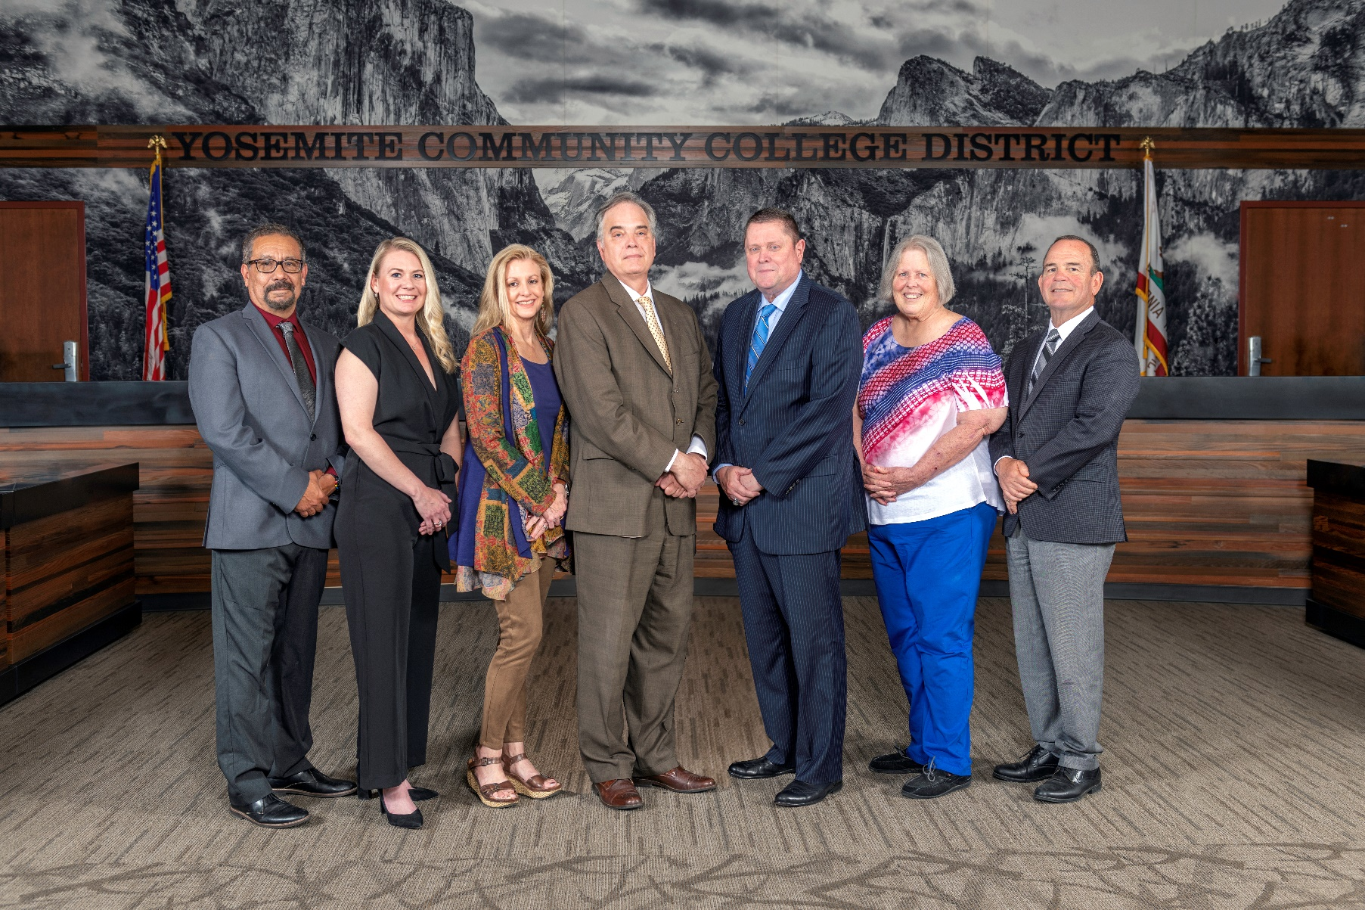

**Board Meeting Highlights**

**March 13, 2024**

**Regular Board Meeting**

**Report Out from Closed Session**

There was no report out from Closed Session.

**Board Committee Report: Association of Stanislaus County School Boards Report**

Trustee Don Davis provided the Board of Trustees with an update from the Association of Stanislaus County School Boards.

**Board Committee Report: Valley Insurance Program/Joint Powers Agency Board Report**

Trustee Nancy Hinton provided the Board of Trustees with an update from the Valley Insurance Program/Joint Powers Agency Board.

**Presentation: Columbia College Foundation**

Amy Nilson, Columbia College Foundation Director, and Charles Segerstrom, Columbia College Foundation Board President, provided the Board of Trustees with an update on the current Foundation activities.

**Presentation: Columbia College Culinary and Hospitality**

Chef Marcus Whisenant, Columbia College Instructor of Hospitality Management, provided the Board of Trustees with an update on the Columbia College Culinary and Hospitality program.

**Chancellor Update**

Chancellor Yong invited Dr. Tran and Dr. Sanders to provide the Board of Trustees with an update from their respective colleges.

Chancellor Yong recognized and congratulated Modesto Junior College for holding a very successful African Education Conference last month. Chancellor Yong reported that he was pleased to see so many high school students in attendance.

Chancellor Yong announced that the District’s Strategic Plan is moving forward with the District Council. Chancellor Yong reported that the District recently held two community town hall sessions, one at each college, to gather feedback on the goals and objectives from the community’s perspective. Finally, Chancellor Yong announced that each college had completed their first meeting with their respective Accreditation Team Chairs, Dr. Horan and Dr. Johnson. Chancellor Yong stated that he would be meeting with Dr. Horan, who is also serving as the Chair of Chairs.

**Modesto Junior College Proposed Curriculum Changes**

The Board of Trustees approved the curriculum additions, deletions, and modifications as indicated on the Proposed Curriculum Changes Report as of the January 23, 2024 Curriculum Committee meeting.

**Columbia College Proposed Curriculum Changes**

The Board of Trustees approved the curriculum additions, deletions, and modifications as indicated on the Proposed Curriculum Changes Report for the period of January 23, 2024 to February 13, 2024.

**Modesto Junior College Amended Sabbatical Leave Request**

The Board of Trustees approved the 2024-2025 amended sabbatical leave request for the following Modesto Junior College faculty member:

       o   Noah Wilson – Spring 2025

**YCCD Personnel Transaction**

The Board of Trustees acknowledged and commended the following retiree for their years of service to the District:

       o   Randy Moring, Maintenance Specialist – Painter (17 years)

**Board Policy – 2nd Reading**

The Board of Trustees conducted a 2nd reading on the following YCCD policies and approved said policies.

o   2365 – Recording

o   2710 – Conflict of Interest

o   2715 – Code of Ethics/Standards of Practice

o   4222 – Remedial Coursework

o   5015 – Residence Determination

o   5040 – Student Records, Directory Information, and Privacy

o   5055 – Enrollment Priorities

o   5700 – Intercollegiate Athletics

o   6350 – Contracts – Construction

       o   7340 – Leaves

**Board Policy – 1st Reading**

The Board of Trustees conducted a 1st reading on the following YCCD policies.  All of the policies, with the exception of Policies 6250, 7-8046, and 7-8056, will be presented to the Board for a 2nd reading at the April 10, 2024 Board Meeting.  Policies 6250, 7-8046, and 7-8056 were pulled and will be brought back as a 1st Reading at the April 10, 2024 Board Meeting.

o   2015 – Student Member

o   2410 – Board Policies and Administrative Procedures

o   2716 – Political Activity

o   2717 – Personal Use of Public Resources

o   2720 – Communications Among Board Members

o   2730 – Board Member Health Benefits

o   2735 – Board Member Travel

o   5011 – Admission and Dual Enrollment of High School and Other Young Students

o   5130 – Financial Aid

o   5410 – Associated Students Election

o   6250 – Budget Adoption and Administration

o   6400 – Financial Audits

o   7-8046 – Staff Course Fee Reimbursement

o   7-8056 – Educational Work Assignment Adjustment

**Bond Update**

Trevor Stewart, Vice Chancellor of District Administrative Services, provided an update to the Board of Trustees on going out for a potential bond.

**Student Health Fee Increase**

The Board of Trustees approved a health fee increase of $3/$2 per semester, effective summer 2024, for Modesto Junior College and Columbia College.

**Special Appointment to the VIP/JPA Board of Directors - Pritchard**

The Board of Trustees appointed Kathren Pritchard to the alternate director position to finish out the term expiring on September 30, 2024.

**Nomination for the State Board of Governors’ 2024 Classified Employee of the Year Award**

The Board of Trustees endorsed one YCCD Classified Staff member nomination for the State Board of Governors Classified Employee of the Year Award and directed staff to forward the nomination to the Board of Governors and the Foundation for California Community Colleges (FCCC) by the deadline.

**CCCT Board of Directors Election - 2024**

The Board of Trustees completed a ballot indicating their preferences for the CCCT Board of Directors and forwarded the ballot to the YCCD Chancellor’s Office for compilation and the completion of a single YCCD Board ballot will be submitted to the CCCT Board Elections Committee by the deadline.

**YCCD Resolution No. 23-24.12 – Trustee Absence from Board Meeting**

The Board of Trustees adopted Resolution No. 23-24.12 in the Matter of Trustee Absence from Board Meeting.

**Next Meetings**

The next regular meeting of the Board of Trustees will be held on April 10, 2024. Closed Session will begin at 3:00 p.m. and Open Session at 5:30 p.m. in the Yosemite Community College District Board Room, 2201 Blue Gum Avenue, Modesto, California.

***All Board action is available on BoardDocs following the meeting at this link:*** [https://go.boarddocs.com/ca/yosemite/Board.nsf/vpublic?open](https://na01.safelinks.protection.outlook.com/?url=https%3A%2F%2Fgo.boarddocs.com%2Fca%2Fyosemite%2FBoard.nsf%2Fvpublic%3Fopen&data=05%7C01%7Cgibbsk%40yosemite.edu%7Cdafdba40f9044726145608dbe4af4732%7C3d35afe626ac437eb4b375b50d459e45%7C0%7C0%7C638355213694252526%7CUnknown%7CTWFpbGZsb3d8eyJWIjoiMC4wLjAwMDAiLCJQIjoiV2luMzIiLCJBTiI6Ik1haWwiLCJXVCI6Mn0%3D%7C3000%7C%7C%7C&sdata=7UEPB9CWhETYn5eDl5v2kNE4GVtqxMX4oHYJQ5xq8bk%3D&reserved=0)