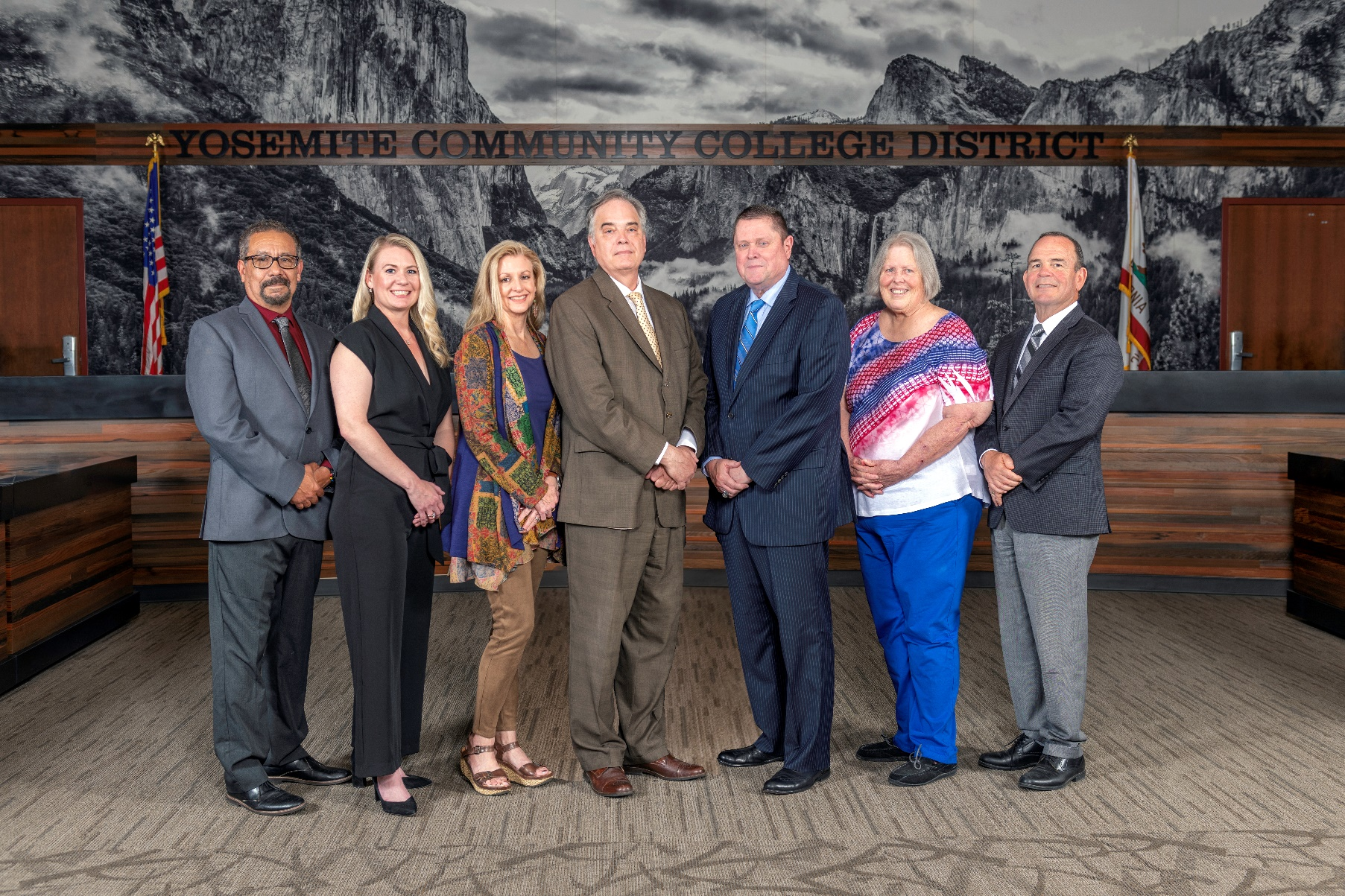

**Board Meeting Highlights**

**March 12, 2025**

**Regular Board Meeting**

**Report Out from Closed Session**

There was no report out from Closed Session.

**Board Committee Report: Board Policy Committee Report**

Trustee Leslie Beggs provided the Board of Trustees with an update from the Board Policy Committee.

**Board Committee Report: Modesto Junior College Foundation Report**

Trustee Leslie Beggs provided the Board of Trustees with an update from the Modesto Junior College Foundation.

**Board Committee Report: Columbia College Foundation Report**

Trustee Don Davis provided the Board of Trustees with an update from the Columbia College Foundation.

**Board Committee Report: Association of Stanislaus County School Boards Report**

Trustee Don Davis provided the Board of Trustees with an update from the Association of Stanislaus County School Boards.

**Chancellor Update**

Chancellor Yong invited Dr. Tran to provide the Board of Trustees with an update from Columbia College. There was no report from Modesto Junior College as Dr. Sanders was unable to attend the Board Meeting due to a previously scheduled conference.

Chancellor Yong reminded everyone to submit nominations for the 2025 Classified Employee of the Year award. Nominations are due by close of business on Thursday, March 13, 2025.

Chancellor Yong reported that the District has been working with StanRTA and the City of Modesto to improve the lighting at the bus stops on MJC West Campus. Chancellor Yong recognized and thanked Yolanda Perregil, Senior Director of Facilities Planning, Maintenance, & Transportation, for all of her efforts to ensure the lighting improvements were completed.

Finally, Chancellor Yong announced that the District’s Strategic Plan has been pulled from the Board agenda for further review and conversations. Chancellor Yong stated that the plan will be brought back to the Board for acceptance at a later time.

**Modesto Junior College Proposed Curriculum Changes**

The Board of Trustees approved the curriculum additions, deletions, and modifications as indicated on the Proposed Curriculum Changes Reports for the January 21, 2025, and February 11, 2025, Curriculum Committee meetings.

**YCCD Personnel Transaction**

The Board of Trustees acknowledged and commended the following retiree(s) for their years of service to the District:

o   Rhonda Mizuno, Admissions and Records Specialist (11 years)

       o   Lawrence Scheg, Professor of Reading (25 years)

**YCCD Strategic Plan 2024-2030**

No action was taken on this item. The item will be brought back to the Board at a later time.

**Board Policy – 2nd Reading**

The Board of Trustees conducted a 2nd reading on the following YCCD policies and approved said policies, as amended.

o   2015 – Student Member

o   3516 – Registered Sex Offender Information

o   3518 – Child Abuse Reporting

o   3820 – Gifts/Donations to the District

o   3-8024 – Energy Management

o   3-8025 – Maintenance of Buildings and Property

       o   3-8035 – Display of Flags

**Board Policy – 1st Reading**

The Board of Trustees conducted a 1st reading on the following YCCD policies.  All of the policies, with the exception of Policies 7120, 7210, 7230, 7240, 7250, and 7260, will be presented to the Board for a 2nd reading at the April 9, 2025 Board Meeting.  Policies 7120, 7210, 7230, 7240, 7250, and 7260 were pulled for legal review.

o   3420 – Equal Employment Opportunity

o   3510 – Workplace Violence

o   3550 – Drug Free Environment and Drug Prevention Program

o   3-8072 – Unattended Minors

o   7120 – Recruitment and Hiring

o   7210 – Academic Employees

o   7230 – Classified Professionals

o   7240 – Confidential Employees

       o   7250 – Educational Administrators

       o   7260 – Classified Supervisors and Managers

**Acceptance of Administrative Procedures**

The Board of Trustees accepted the final recommendation from the Board Policy Committee and directed the Chancellor to revise the following administrative procedure(s) to align with the corresponding Board policy. Administrative Procedures 7120 and 7240 were pulled to ensure alignment with their corresponding Board policies, which will undergo legal review.

o   3550 – Drug Free Environment and Drug Prevention Program

o   7120 – Recruitment and Hiring

       o   7240 – Confidential Employees

**Nomination for the State Board of Governors’ 2025 Classified Employee of the Year Award**

The Board of Trustees endorsed one YCCD Classified Staff member nomination for the State Board of Governors Classified Employee of the Year Award and directed staff to forward the nomination to the Board of Governors and the Foundation for California Community Colleges (FCCC) by the deadline.

**CCCT Board of Directors Election - 2025**

The Board of Trustees completed a ballot indicating their preferences for the CCCT Board of Directors and forwarded the ballot to the YCCD Chancellor’s Office for compilation and the completion of a single YCCD Board ballot will be submitted to the CCCT Board Elections Committee by the deadline.

**Next Meetings**

The next regular meeting of the Board of Trustees will be held on April 9, 2025. Closed Session will begin at 3:00 p.m. and Open Session at 5:30 p.m. in the Yosemite Community College District Board Room, 2201 Blue Gum Avenue, Modesto, California.

***All Board action is available on BoardDocs following the meeting at this link:*** [https://go.boarddocs.com/ca/yosemite/Board.nsf/vpublic?open](https://nam02.safelinks.protection.outlook.com/?url=https%3A%2F%2Fgo.boarddocs.com%2Fca%2Fyosemite%2FBoard.nsf%2Fvpublic%3Fopen&data=05%7C02%7Cgibbsk%40yosemite.edu%7C04ab26527f6a495a1c8e08dce989f34c%7C3d35afe626ac437eb4b375b50d459e45%7C0%7C0%7C638642026033239352%7CUnknown%7CTWFpbGZsb3d8eyJWIjoiMC4wLjAwMDAiLCJQIjoiV2luMzIiLCJBTiI6Ik1haWwiLCJXVCI6Mn0%3D%7C0%7C%7C%7C&sdata=LemRImXBecA5B4HggjFShKy2x6iWsE3ViNf%2BdE6cGew%3D&reserved=0)