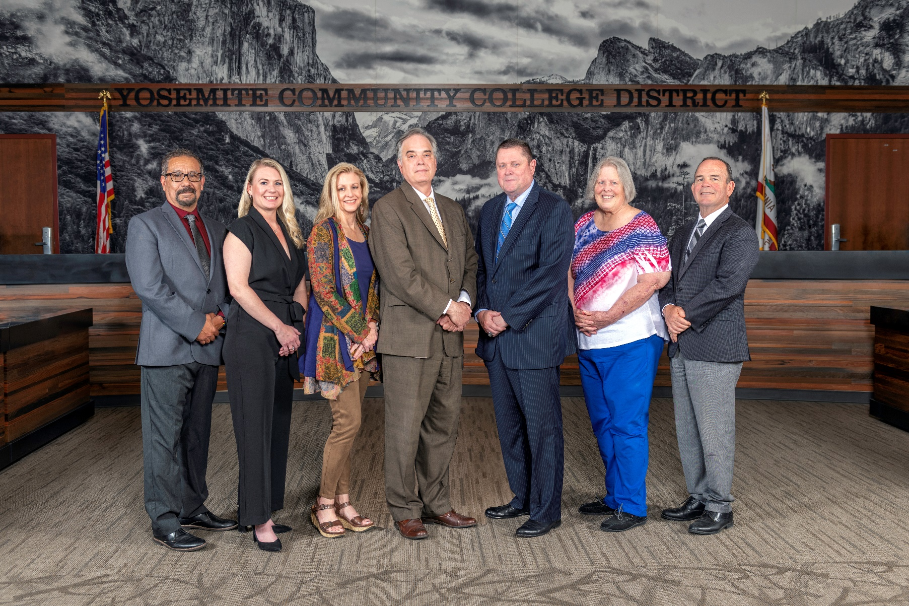

**Board Meeting Highlights**

**February 14, 2024**

**Regular Board Meeting**

**Report Out from Closed Session**

There was no report out from Closed Session.

**Board Committee Report: Modesto Junior College Foundation Report**

Trustee Leslie Beggs provided the Board of Trustees with an update from the Modesto Junior College Foundation.

**Board Committee Report: Association of Stanislaus County School Boards Report**

Trustee Don Davis provided the Board of Trustees with an update from the Association of Stanislaus County School Boards.

**Chancellor Update**

Chancellor Yong invited Dr. Tran and Dr. Sanders to provide the Board of Trustees with an update from their respective colleges.

Chancellor Yong announced that the District is currently accepting nominations for the YCCD Classified Employee of the Year Award. Chancellor Yong reminded everyone that the deadline to submit nominations is February 29th.

**Nonresident Tuition Fee**

The Board of Trustees adopted the 2024-2025 nonresident student tuition fee based on the statewide computed rate of $307 per unit.

**Columbia College Sabbatical Leave Requests**

The Board of Trustees approved the 2024-2025 sabbatical leave requests for the following Columbia College faculty members:

o   Rebecca Slate – Spring 2025

       o   Colin Thomas – Spring 2025

**Modesto Junior College Sabbatical Leave Requests**

The Board of Trustees approved the 2024-2025 sabbatical leave requests for the following Modesto Junior College faculty members:

o   Debra Bolter – Fall 2024 and Spring 2025

o   Shaila Christofferson – Fall 2024

o   Kwei-Yu Chu – Fall 2024 and Spring 2025

o   Angelica Cortes – Fall 2024

o   Cece Hudelson – Fall 2024

o   Caroline Miller – Fall 2024 and Spring 2025

o   Alejandro Sabre – Spring 2025

o   Aishah Saleh – Spring 2025

o   Timothy Vaughan – Fall 2024

       o   Noah Wilson – Fall 2024 and Spring 2025

**YCCD Personnel Transaction**

The Board of Trustees acknowledged and commended the following retirees for their years of service to the District:

o   Gerald ‘Jerry’ Baldwin, Transportation Services Operator, Senior (22 years)

o   Colleen Lemburg, Senior Administrative Secretary (16 years)

       o   Dorothy Pimentel, Director of Risk Management, Purchasing & Receiving (29 years)

**Board Policy – 3rd Reading**

The Board of Trustees conducted a 3rd reading on the following YCCD policy and approved said policy.

       o   2745 – Board Self-Evaluation

**Board Policy – 2nd Reading**

The Board of Trustees conducted a 2nd reading on the following YCCD policies and approved said policies, with the exception of Policy 2710. Policy 2710 was pulled and will be brought back as a 2nd Reading at the March 13, 2024 Board Meeting.

o   2430.1 – Delegation of Authority to the Presidents

o   2432 – District Chief Executive Officer (CEO) Succession

o   2435 – Evaluation of the Chancellor

o   2510 – Participation in Local Decision-Making

o   2610 – Presentation of Initial Collective Bargaining Proposals

o   2710 – Conflict of Interest

       o   2714 – Distribution of Tickets or Passes

**Board Policy – 1st Reading**

The Board of Trustees conducted a 1st reading on the following YCCD policies.  All of the policies, with the exception of Policy 5011, will be presented to the Board for a 2nd reading at the March 13, 2024 Board Meeting. Policy 5011 was pulled and will be brought back as a 1st Reading at the March 13, 2024 Board Meeting.

o   2715 – Code of Ethics/Standards of Practice

o   4222 – Remedial Coursework

o   5011 – Admission and Dual Enrollment of High School and Other Young Students

o   5015 – Residence Determination

o   5040 – Student Records, Directory Information, and Privacy

o   5055 – Enrollment Priorities

o   5700 – Intercollegiate Athletics

       o   6350 – Contracts – Construction

**Next Meetings**

The next regular meeting of the Board of Trustees will be held on March 13, 2024. Closed Session will begin at 3:00 p.m. and Open Session at 5:30 p.m. in the Manzanita Conference Room at Columbia College, 11600 Columbia College Drive, Sonora, California.

***All Board action is available on BoardDocs following the meeting at this link:*** [https://go.boarddocs.com/ca/yosemite/Board.nsf/vpublic?open](https://na01.safelinks.protection.outlook.com/?url=https%3A%2F%2Fgo.boarddocs.com%2Fca%2Fyosemite%2FBoard.nsf%2Fvpublic%3Fopen&data=05%7C01%7Cgibbsk%40yosemite.edu%7Cdafdba40f9044726145608dbe4af4732%7C3d35afe626ac437eb4b375b50d459e45%7C0%7C0%7C638355213694252526%7CUnknown%7CTWFpbGZsb3d8eyJWIjoiMC4wLjAwMDAiLCJQIjoiV2luMzIiLCJBTiI6Ik1haWwiLCJXVCI6Mn0%3D%7C3000%7C%7C%7C&sdata=7UEPB9CWhETYn5eDl5v2kNE4GVtqxMX4oHYJQ5xq8bk%3D&reserved=0)