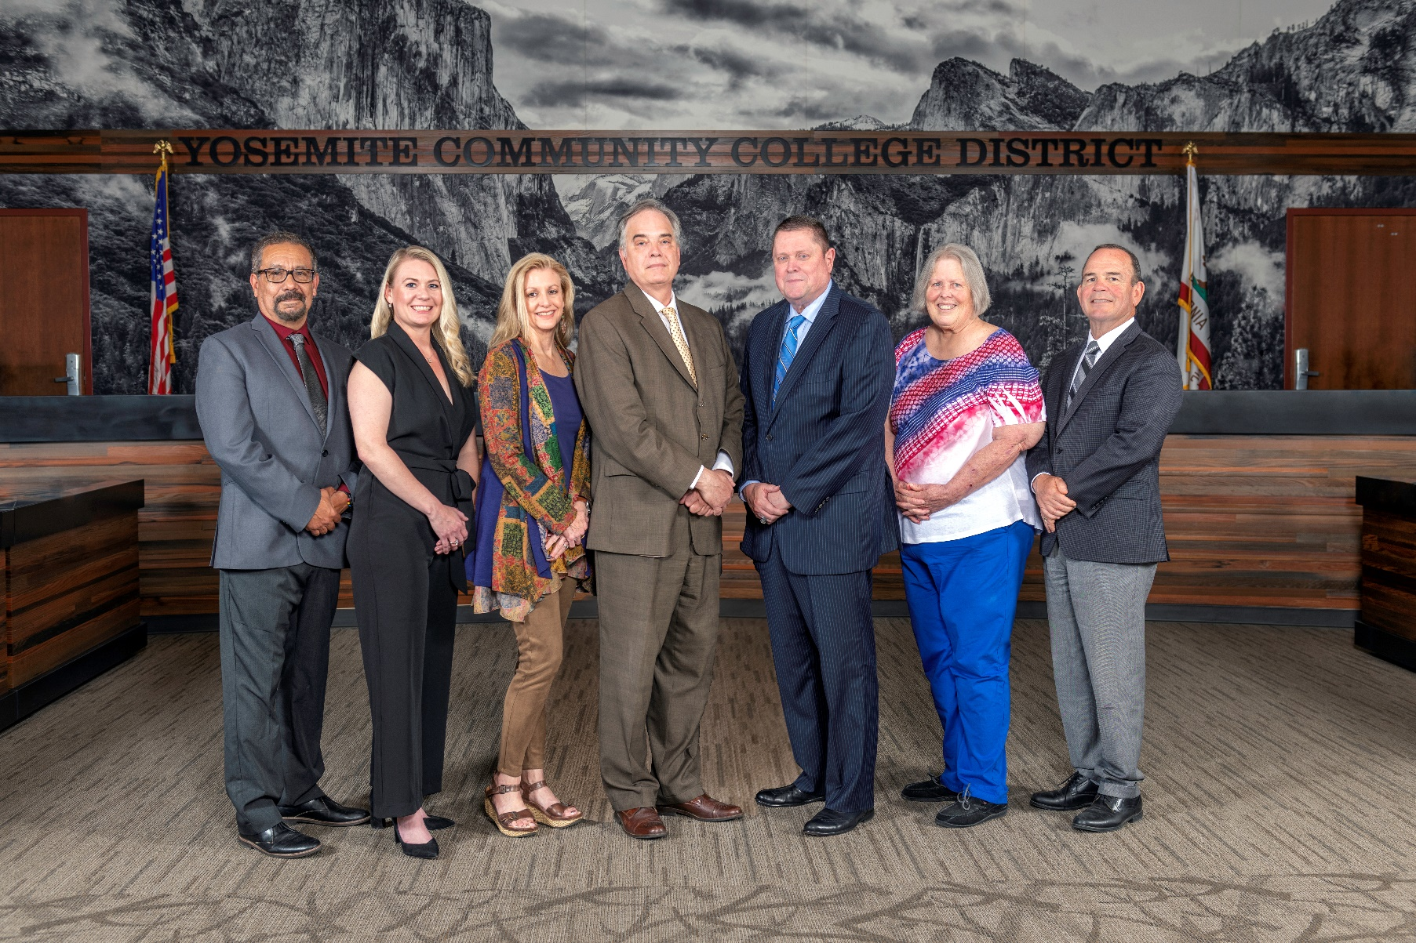

**Board Meeting Highlights**

**February 13, 2025**

**Regular Board Meeting**

**Report Out from Closed Session**

There was no report out from Closed Session.

**Board Committee Report: Board Policy Committee**

Vice President Jenny Nicolau provided the Board of Trustees with an update from the Board Policy Committee.

**Board Committee Report: Modesto Junior College Foundation Report**

Trustee Leslie Beggs provided the Board of Trustees with an update from the Modesto Junior College Foundation.

**Board Committee Report: Columbia College Foundation Report**

Trustee Don Davis provided the Board of Trustees with an update from the Columbia College Foundation.

**Board Committee Report: Association of Stanislaus County School Boards Report**

Trustee Don Davis provided the Board of Trustees with an update from the Association of Stanislaus County School Boards.

**Presentation: Happenings Within the MJC School of Agriculture, Animal Science Program**

Troy Gravatt, MJC Dean of the School of Agriculture; Nicole Morris, MJC Instructor of Animal Science/Dairy; Dr. Joel Speiller, MJC Instructor of Agriculture, Veterinary Technology; and Aiden Alberto, MJC student, provided the Board of Trustees with highlights of the MJC Animal Science program.

**Chancellor Update**

Chancellor Yong invited Dr. Tran and Dr. Sanders to provide the Board of Trustees with an update from their respective colleges.

Chancellor Yong reported that he recently attended the ACCT National Legislative Summit in Washington, DC with Dr. Sanders, Dr. Tran, Trustee Aguilar, Trustee Beggs, and Trustee Richards. In addition, Chancellor Yong reported that he attended Central Valley Higher Education Consortium’s Dual Enrollment in the Central Valley Conference in Fresno.

**Nonresident Tuition Fee**

The Board of Trustees adopted the 2025-2026 nonresident student tuition fee based on the statewide computed rate of $322 per unit.

**Modesto Junior College Sabbatical Leave Requests**

The Board of Trustees approved the 2025-2026 sabbatical leave requests for the following Modesto Junior College faculty members:

o   Marc Anaya – Fall 2025 and Spring 2026

o   Dimitri Keriotis – Spring 2026

       o   Daniel Schmidt – Spring 2026

**YCCD Personnel Transaction**

The Board of Trustees acknowledged and commended the following retiree(s) for their years of service to the District:

o   Monika Schortner, Graphic Arts and Marketing Specialist (21 years)

       o   Vicki Vander Veen, Community Lifelong Learning Specialist (20 years)

**Board Policy – 2nd Reading**

The Board of Trustees conducted a 2nd reading on the following YCCD policies and approved said policies.

o   2315 – Closed Sessions

o   2325 – Teleconferenced Meetings

       o   2-8075 – Parliamentary Procedure

**Board Policy – 1st Reading**

The Board of Trustees conducted a 1st reading on the following YCCD policies.  All of the policies will be presented to the Board for a 2nd reading at the March 12, 2025 Board Meeting, as amended.

o   2015 – Student Member

o   3516 – Registered Sex Offender Information

o   3518 – Child Abuse Reporting

o   3820 – Gifts/Donations to the District

o   3-8024 – Energy Management

o   3-8025 – Maintenance of Buildings and Property

       o   3-8035 – Display of Flags

**Acceptance of Administrative Procedures**

The Board of Trustees accepted the final recommendation from the Board Policy Committee and directed the Chancellor to revise the following administrative procedure(s) to align with the corresponding Board policy.

       o   3518 – Child Abuse Reporting

**YCCD Resolution No. 24-25.10 – Trustee Aguilar Absence from Board Meeting**

The Board of Trustees adopted YCCD Resolution No. 24-25.10 in the Matter of Trustee Absence from Board Regular Meeting.

**YCCD Resolution No. 24-25.11 – Trustee Hinton Absence from Board Meeting**

The Board of Trustees adopted YCCD Resolution No. 24-25.11 in the Matter of Trustee Absence from Board Regular Meeting.

**YCCD Resolution No. 24-25.12 – Trustee Beggs Absence from Board Meeting**

The Board of Trustees adopted YCCD Resolution No. 24-25.12 in the Matter of Trustee Absence from Board Special Meeting.

**YCCD Resolution No. 24-25.13 – Trustee Beggs Absence from Board Meeting**

The Board of Trustees adopted YCCD Resolution No. 24-25.13 in the Matter of Trustee Absence from Board Regular Meeting.

**Reasonable Accommodation Under the ADA for Continued Board Member Virtual Participation pursuant to AB 2449 Remote Teleconference Attendance for “Just Cause” or with a qualifying “Emergency Circumstance”**

The Board of Trustees approved Trustee Nancy Hinton’s request for continued participation in the Board meetings and standing committees virtually/remotely as a reasonable accommodation under the Americans with Disabilities Act following the “Just Cause” or “Emergency Circumstances” provision of AB 2449 specifying circumstance relating to the qualifying reason until such time as the trustee is medically able to attend the meetings in person.

**Next Meetings**

The next regular meeting of the Board of Trustees will be held on Wednesday, March 12, 2025. Closed Session will begin at 3:00 p.m. and Open Session at 5:30 p.m. in the Manzanita Conference Room at Columbia College, 11600 Columbia College Drive, Sonora, California.

***All Board action is available on BoardDocs following the meeting at this link:*** [https://go.boarddocs.com/ca/yosemite/Board.nsf/vpublic?open](https://nam02.safelinks.protection.outlook.com/?url=https%3A%2F%2Fgo.boarddocs.com%2Fca%2Fyosemite%2FBoard.nsf%2Fvpublic%3Fopen&data=05%7C02%7Cgibbsk%40yosemite.edu%7C04ab26527f6a495a1c8e08dce989f34c%7C3d35afe626ac437eb4b375b50d459e45%7C0%7C0%7C638642026033239352%7CUnknown%7CTWFpbGZsb3d8eyJWIjoiMC4wLjAwMDAiLCJQIjoiV2luMzIiLCJBTiI6Ik1haWwiLCJXVCI6Mn0%3D%7C0%7C%7C%7C&sdata=LemRImXBecA5B4HggjFShKy2x6iWsE3ViNf%2BdE6cGew%3D&reserved=0)