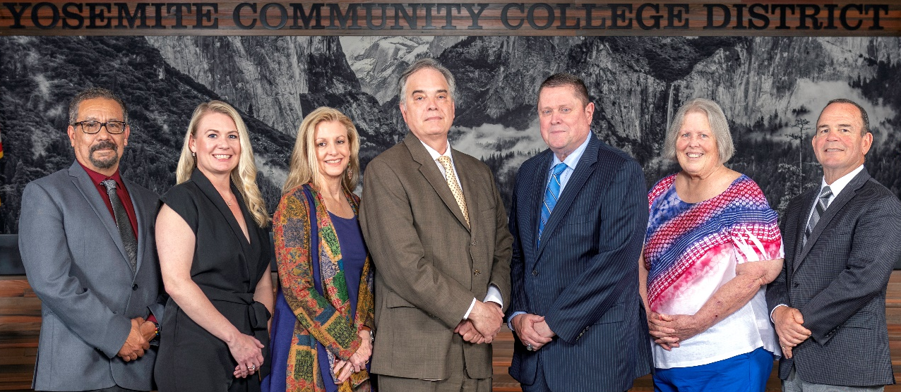
Board Meeting Highlights
February 12, 2026
Regular Board Meeting

Report Out from Closed Session
There was no report out from Closed Session.
Board Committee Report: Board Finance Committee Report
Trustee Darin Gharat provided the Board of Trustees with an update from the Board Finance Committee.
Board Committee Report: Modesto Junior College Foundation Report
Trustee Leslie Beggs provided the Board of Trustees with an update from the Modesto Junior College Foundation.
Board Committee Report: Columbia College Foundation Report
Trustee Don Davis provided the Board of Trustees with an update from the Columbia College Foundation.
Board Committee Report: Valley Insurance Program/Joint Powers Agency Board Report
Trustee Darin Gharat provided the Board of Trustees with an update from the Valley Insurance Program/Joint Powers Agency Board.
Presentation: Modesto Junior College Athletics Student Success Program
David Voortman, MJC Dean of the School of Kinesiology, Public Health & Athletics, introduced the MJC State Champion Women’s Track and Field Team and the newest sport to be added to the college, the MJC Women’s Wrestling Team.

Interim Chancellor Update
Interim Chancellor Tran reported that the Hearts United Gala was a highly successful District event. She expressed her sincere appreciation to the event sponsors, both internal and external, the planning committee led by Dr. Emily Lawrence, and everyone who attended and supported the evening.
Dr. Tran also announced that she will be traveling to Washington, DC with the trustees for an advocacy tour focused on securing support for growth funding for districts like ours that have experienced significant increases in FTES. She shared that she has received feedback regarding the YCCD Strategic Plan process, asked for everyone’s patience as the work continues, and expressed confidence that the plan will come together in the end. She reiterated that the Board of Trustees defines the “what,” while the colleges are responsible for determining the “how.”
Finally, Dr. Tran reported that the District will help sponsor a Lunar New Year celebration at Modesto Junior College on February 19. She noted that the Lunar New Year begins on February 17 and that this year marks the Year of the Horse. After wishing everyone a Happy New Year, Dr. Tran invited Dr. Redwing to provide the Board of Trustees with an update from Columbia College.
Nonresident Tuition Fee
The Board of Trustees adopted the 2026-2027 nonresident student tuition fee based on the statewide computed rate of $338 per unit.
Columbia College Sabbatical Leave Requests
The Board of Trustees accepted the 2026-2027 Sabbatical Leave Requests from the following Columbia College faculty members:
o Tamara Oxford – Spring 2027
o Vanessa Muro-Marai – Spring 2027
Columbia College Proposed Curriculum Changes
The Board of Trustees approved the curriculum additions, deletions, and modifications as indicated on the Proposed Curriculum Changes Reports for the period of November 25, 2025, to November 25, 2025.
YCCD Personnel Transaction
The Board of Trustees acknowledged and commended the following retiree(s) for their years of service to the District:
o Erik Andal, Professor of Automotive Technology (23 years)
o Scott Fernandes, Director of Enterprise Services (23.5 years)
o Luz ‘Lucy’ Munoz, Director of Human Resources (39 years)
District Administrative Services, Annual District Audit Exit Report
The Board of Trustees received the 2024-2025 audit report and authorized its filing with the appropriate state agency in accordance with Education Code Section 84040.

Board Policy 3750 – Use of Copyrighted Material
The Board of Trustees conducted a 1st reading of the following YCCD policy and approved it in a single reading due to a state-mandated implementation deadline.
o 3750 – Use of Copyrighted Material
Board Policy – 2nd Reading
The Board of Trustees conducted a 2nd reading on the following YCCD policies and approved said policies as presented in the agenda.
o 4010 – Academic Calendars
o 4020 – Program, Curriculum, and Course Development
o 4025 – Philosophy and Criteria for Associate Degree and General Education
o 4100 – Graduation Requirements for Degrees and Certificates
o 4103 – Work Experience
o 4105 – Distance Education
o 4227 – Repeatable Courses
o 5050 – Student Success and Support Program
o 7342 – Holidays
Board Policy – 1st Reading
The Board of Trustees conducted a 1st reading on the following YCCD policies. All of the policies will be presented to the Board for a 2nd reading at the March 11, 2026, Board Meeting.
o 3050 – Institutional Code of Ethics
o 3100 – Organizational Structure
o 3280 – Grants
o 3440 – Service Animals
o 3600 – Auxiliary Organizations
o 3810 – Claims Against the District
o 6-8015 – Grant Accounting
o 6-8064 – Special Purpose Grant Applications
Modesto Junior College Accreditation Follow-Up Report 2026
The Board of Trustees approved the 2026 Modesto Junior College Follow-up Report to the January 2025 Action Letter from the Accrediting Commission for Community and Junior Colleges (ACCJC) and directed staff to forward the report to ACCJC.
ASCSB Board Member of the Year 2026 – Nomination of Leslie Beggs
The Board of Trustees approved the submission of nomination material for Leslie Beggs for the 2026 ASCSB Board Member of the Year.

Special Appointment to the VIP/JPA Board of Directors - Guzman
The Board of Trustees appointed Saul Guzman to the alternate director position to finish out the term expiring on September 30, 2026.
YCCD Resolution No.25-26.09 – Trustee Absence from Board Meeting
The Board of Trustees adopted YCCD Resolution No. 25-26.09, in the matter of Trustee Aguilar’s absence from the Board Regular Meeting.
YCCD Resolution No.25-26.10 – Trustee Absence from Board Meeting
The Board of Trustees adopted YCCD Resolution No. 25-26.10, in the matter of Trustee Aguilar’s absence from the Board Special Meeting.
YCCD Resolution No.25-26.11 – Trustee Absence from Board Meeting
The Board of Trustees adopted YCCD Resolution No. 25-26.11, in the matter of Trustee Hinton’s absence from the Board Special Meeting.
Next Meetings
The next regular meeting of the Board of Trustees will be held on Wednesday, March 11, 2026. Closed Session will begin at 3:00 p.m. and Open Session at 5:30 p.m. in the Yosemite Community College District Board Room, 2201 Blue Gum Avenue, Modesto, California.

All Board action is available on BoardDocs following the meeting at this link: https://go.boarddocs.com/ca/yosemite/Board.nsf/vpublic?open

