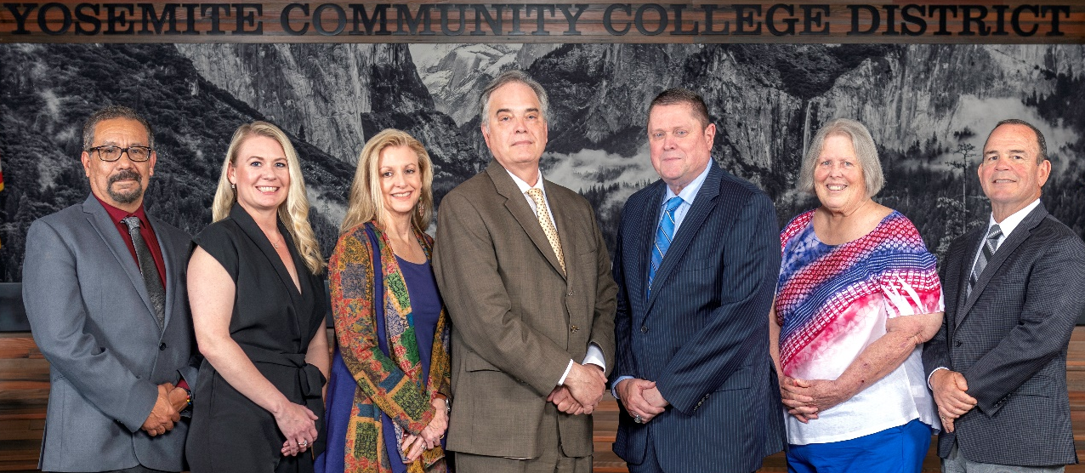
Board Meeting Highlights
January 14, 2026
Regular Board Meeting

Report Out from Closed Session
There was no report out from Closed Session.
Board Committee Report: Modesto Junior College Foundation Report
Trustee Leslie Beggs provided the Board of Trustees with an update from the Modesto Junior College Foundation.
Board Committee Report: Columbia College Foundation Report
Trustee Don Davis provided the Board of Trustees with an update from the Columbia College Foundation.
Presentation: Outcomes of Dr. Debi Bolter’s Research Work in Africa
Dr. Debi Bolter, Professor of Anthropology at Modesto Junior College, provided the Board of Trustees with a presentation that highlighted eight outcomes of her summer research in South Africa.
Presentation: Modesto Junior College Student Clubs
Dr. Matthew Lopez Phillips, MJC Dean of Counseling, and Lucy Hakimi, MJC Program Specialist, provided the Board of Trustees with an overview of the procedures for forming student clubs at Modesto Junior College.
Presentation: ASCC Club Presentation
Courtney Sutton, Columbia College Director of Student Access, Retention & Support, provided the Board of Trustees with an overview of the procedures for forming student clubs at Columbia College.

Interim Chancellor Update
Interim Chancellor Tran reported that she visited both colleges during the first week of the semester, walking the campuses and engaging with students and staff. She shared that it was a pleasure to meet new colleagues and connect with students.
Dr. Tran announced that the District will prioritize emergency preparedness at both colleges, including active-shooter training and enhanced data-security measures. She also shared that planning for the YCCD Strategic Plan will begin with the Board on January 22 and will subsequently move forward to the District Council.
In addition, Dr. Tran encouraged everyone to attend the Hearts United Gala on February 7 and expressed her appreciation to the Board for extending her contract. She concluded by inviting Dr. Sanders and Dr. Redwing to provide the Board of Trustees with updates from their respective colleges.
Modesto Junior College Sabbatical Leave Requests
The Board of Trustees accepted the 2026-2027 Sabbatical Leave Requests from the following Modesto Junior College faculty members:
o Stella Beratlis – Fall 2026 and Spring 2027
o Theresa Rojas – Spring 2027
o Dr. Theron Westrope – Fall 2026 and Spring 2027
Modesto Junior College Proposed Curriculum Changes
The Board of Trustees approved the curriculum additions, deletions, and modifications as indicated on the Proposed Curriculum Changes Report from the November 12, 2025, and November 25, 2025, Curriculum Committee meetings.
Columbia College Proposed Curriculum Changes
The Board of Trustees approved the curriculum additions, deletions, and modifications as indicated on the Proposed Curriculum Changes Reports for the period of November 18, 2025, to November 25, 2025.
Personnel – Extension to the Employment Contract for Interim Chancellor, Yosemite Community College District
The Board of Trustees approved an extension to the employment contract for the Interim Chancellor, Yosemite Community College District.
ASCSB Board Member of the Year 2026
The Board of Trustees expressed interest in submitting a nomination for the 2026 ASCSB Board Member of the Year award. Board President Milton Richards nominated Trustee Leslie Beggs for consideration. The nomination will be placed on the agenda for official Board action at the next Board Meeting.
CCCT Board of Directors Nominations for 2026
The Board of Trustees took no action on this item.
YCCD Resolution No.25-26.07 – Trustee Absence from Board Meeting
The Board of Trustees adopted YCCD Resolution No. 25-26.07, in the matter of Trustee Nicolau’s absence from the Board Special Meeting.

YCCD Resolution No.25-26.08 – Trustee Absence from Board Meeting
The Board of Trustees adopted YCCD Resolution No. 25-26.08, in the matter of Trustee Nicolau’s absence from the Board Regular Meeting.
Next Meetings
The next regular meeting of the Board of Trustees will be held on Thursday, February 12, 2026. Closed Session will begin at 3:00 p.m. and Open Session at 5:30 p.m. in the Yosemite Community College District Board Room, 2201 Blue Gum Avenue, Modesto, California.

All Board action is available on BoardDocs following the meeting at this link: https://go.boarddocs.com/ca/yosemite/Board.nsf/vpublic?open

