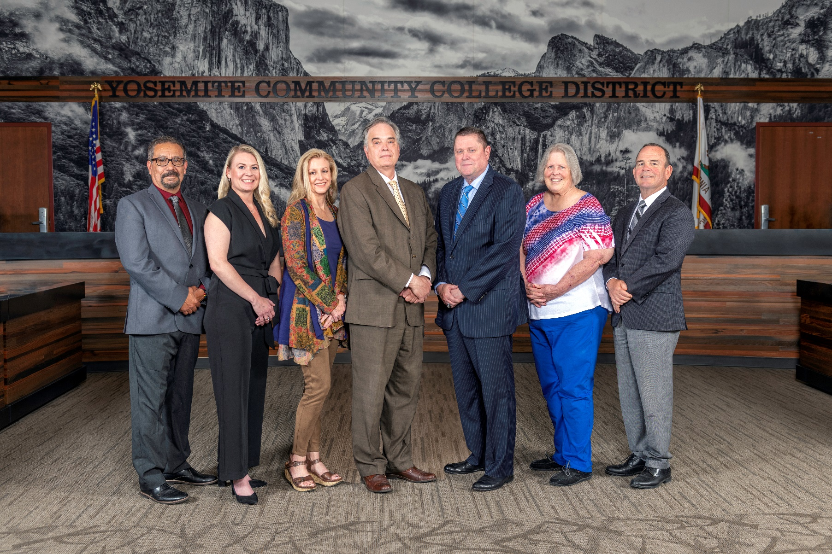

**Board Meeting Highlights**

**January 10, 2024**

**Regular Board Meeting**

**Report Out from Closed Session**

There was no report out from Closed Session.

**Presentation: Student Enrollment Data**

Gregory Stoup, Senior Director of Institutional Research, provided the Board of Trustees with an update on student enrollment data.

**Chancellor Update**

Chancellor Yong announced that January is School Board appreciation month and his expressed his thanks and appreciation to all local School Board Trustees and to those across the state. Chancellor invited Dr. Tran and Dr. Sanders to provide the Board of Trustees with an update from their respective colleges.

Chancellor Yong expressed his thanks to the faculty, staff, and administrators at both colleges for their preparation in getting the colleges ready for the start of the spring semester.  Chancellor Yong also thanked the Grounds and Custodial staff members for their efforts.

Chancellor Yong reported that the Interim Strategic Plan has been completed. The Interim Strategic Plan, which is an update from the previous plan, was shared with the District Council at the December Meeting. The next phase includes the District Council volunteers working with the consultants on the next plan. Chancellor Yong expressed his thanks to the District Council for their participation.

Finally, Chancellor Yong reminded everyone that the District will soon be accepting nominations for the upcoming State Board of Governor’s Annual Classified Employee of the Year Award.

**Modesto Junior College Proposed Curriculum Changes**

The Board of Trustees approved the curriculum additions, deletions, and modifications as indicated on the Proposed Curriculum Changes Report as of the November 28, 2023 Curriculum Committee meeting.

**Columbia College Proposed Curriculum Changes**

The Board of Trustees approved the curriculum additions, deletions, and modifications as indicated on the Proposed Curriculum Changes Report for the period of November 14, 2023 to November 28, 2023.

**Personnel – Negotiations - CSEA/YCCD/Public Hearing on Proposal Reopeners**

The Board of Trustees held a public comment period regarding the Bargaining Proposal Reopeners submitted by CSEA and the District.  The Board of Trustees approved the District reopeners.

**CCCT Board of Directors Nominations for 2024**

The Board of Trustees nominated Board President Milton Richards as a candidate for the CCCT Board of Directors.

**Personnel – Approval of Employment Contract for President, Modesto Junior College**

The Board of Trustees approved the employment contract for the President, Modesto Junior College.

**YCCD Resolution No.23-24.08 – Trustee Absence from Board Meeting, Alyssa Samaripa**

The Board of Trustees adopted YCCD Resolution No. 23-24.08, in the matter of Student Trustee Samaripa’s absence from Board Regular Meeting.

**YCCD Resolution No.23-24.09 – Trustee Absence from Board Meeting, Alyssa Samaripa**

The Board of Trustees adopted YCCD Resolution No. 23-24.09, in the matter of Student Trustee Samaripa’s absence from Board Regular Meeting.

**Next Meetings**

The next regular meeting of the Board of Trustees will be held on February 14, 2024. Closed Session will begin at 3:00 p.m. and Open Session at 5:30 p.m. in the Yosemite Community College District Board Room, 2201 Blue Gum Avenue, Modesto, California.

***All Board action is available on BoardDocs following the meeting at this link:*** [https://go.boarddocs.com/ca/yosemite/Board.nsf/vpublic?open](https://na01.safelinks.protection.outlook.com/?url=https%3A%2F%2Fgo.boarddocs.com%2Fca%2Fyosemite%2FBoard.nsf%2Fvpublic%3Fopen&data=05%7C01%7Cgibbsk%40yosemite.edu%7Cdafdba40f9044726145608dbe4af4732%7C3d35afe626ac437eb4b375b50d459e45%7C0%7C0%7C638355213694252526%7CUnknown%7CTWFpbGZsb3d8eyJWIjoiMC4wLjAwMDAiLCJQIjoiV2luMzIiLCJBTiI6Ik1haWwiLCJXVCI6Mn0%3D%7C3000%7C%7C%7C&sdata=7UEPB9CWhETYn5eDl5v2kNE4GVtqxMX4oHYJQ5xq8bk%3D&reserved=0)