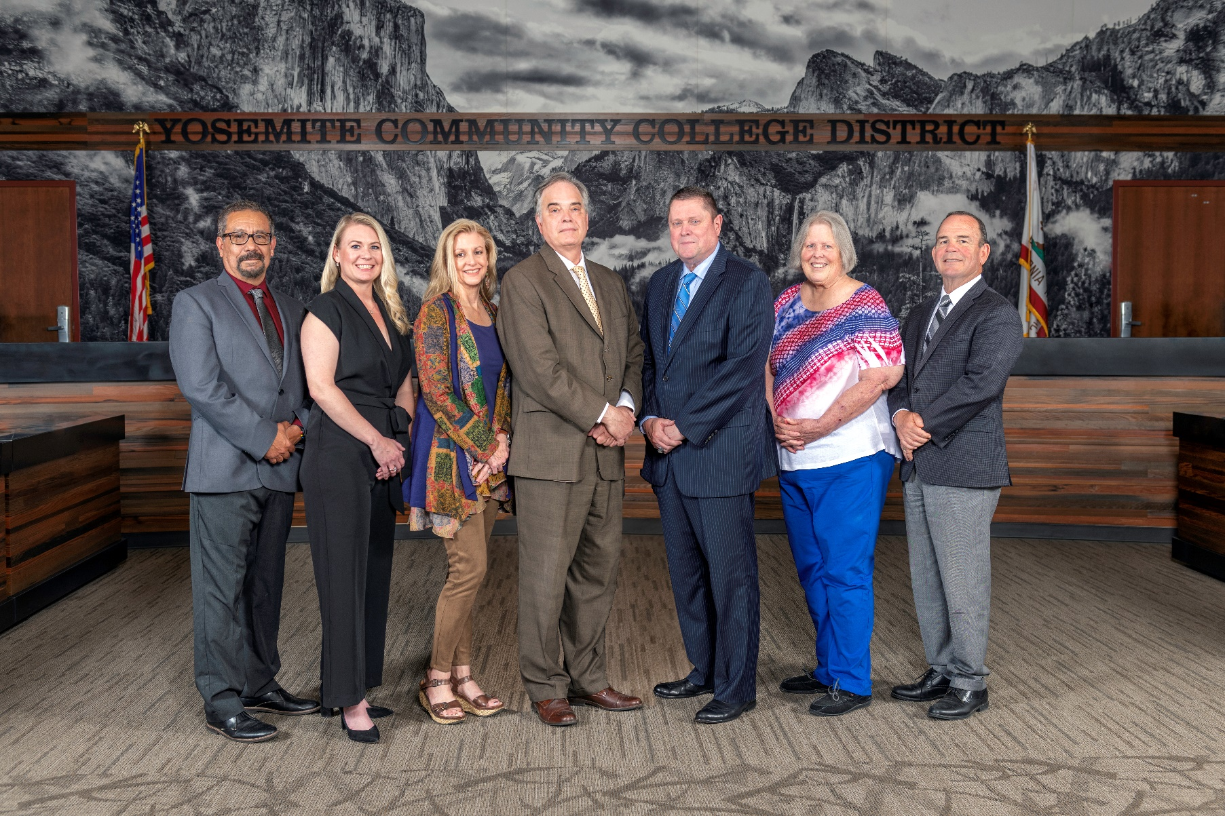

**Board Meeting Highlights**

**January 8, 2025**

**Regular Board Meeting**

**Report Out from Closed Session**

There was no report out from Closed Session.

**Presentation: MJC School of Industry & Trades**

Cece Hudelson, Interim Dean of MJC’s School of Industry & Trades, provided the Board of Trustees with highlights of the offerings within each department, including a broad overview of the number of sections, student demand, industry connections, and future needs of the school.

**Presentation: College-Level Transfer Data Trends**

Caterina Grossi, MJC Director of College Research & Planning; Melissa Raby, Columbia College Vice President of Student Services; and Teicia Downing, Columbia College Program Specialist with TRiO Transfer Services, provided the Board of Trustees with a presentation on college-level transfer data trends. The presentation focused on a cohort-based analysis of first-time students over a 6-year period and highlighted where students continued their education, completed programs, or stopped attending. Additional highlights included patterns among CTE (Career and Technical Education), STEM, and other programs offering context for student pathways.

**Chancellor Update**

In Chancellor Yong's absence, Board President Richards invited Dr. Tran and Dr. Sanders to provide the Board of Trustees with an update from their respective colleges.

Board President Richards also invited Trevor Stewart, Vice Chancellor of District Administrative Services, and Yolanda Perregil, Senior Director of Facilities Planning, Maintenance & Transportation, to update the Board of Trustees on the YCCD Facilities Planning projects.

**Modesto Junior College Proposed Curriculum Changes**

The Board of Trustees approved the curriculum additions, deletions, and modifications as indicated on the Proposed Curriculum Changes Report as of the November 26, 2024 Curriculum Committee meeting.

**YCCD Personnel Transaction**

The Board of Trustees acknowledged and commended the following retiree(s) for their years of service to the District:

       o   Gloria Ramirez, Accounting Analyst (21 years)

**CCCT Board of Directors Nominations for 2025**

The Board of Trustees nominated Board President Milton Richards as a candidate for the CCCT Board of Directors.

**Personnel – Negotiations - CSEA/YCCD/Public Hearing on Proposal Reopeners**

The Board of Trustees held a public comment period regarding the Bargaining Proposal Reopeners submitted by CSEA and the District.  The Board of Trustees approved the District reopeners.

**Next Meetings**

The next regular meeting of the Board of Trustees will be held on Thursday, February 13, 2025. Closed Session will begin at 3:00 p.m. and Open Session at 5:30 p.m. in the Yosemite Community College District Board Room, 2201 Blue Gum Avenue, Modesto, California.

***All Board action is available on BoardDocs following the meeting at this link:*** [https://go.boarddocs.com/ca/yosemite/Board.nsf/vpublic?open](https://nam02.safelinks.protection.outlook.com/?url=https%3A%2F%2Fgo.boarddocs.com%2Fca%2Fyosemite%2FBoard.nsf%2Fvpublic%3Fopen&data=05%7C02%7Cgibbsk%40yosemite.edu%7C04ab26527f6a495a1c8e08dce989f34c%7C3d35afe626ac437eb4b375b50d459e45%7C0%7C0%7C638642026033239352%7CUnknown%7CTWFpbGZsb3d8eyJWIjoiMC4wLjAwMDAiLCJQIjoiV2luMzIiLCJBTiI6Ik1haWwiLCJXVCI6Mn0%3D%7C0%7C%7C%7C&sdata=LemRImXBecA5B4HggjFShKy2x6iWsE3ViNf%2BdE6cGew%3D&reserved=0)