**Yosemite Community College District**



**SERVING**

**Modesto Junior College -- Columbia College**

**SALE OF PERSONAL PROPERTY**

**BID NO. 12-1686-S, Surplus Lathe and Farm Equipment**

**NO BIDS WILL BE RECEIVED AFTER**

**4:00 P.M., May 11, 2012**

WHERE TO SUBMIT YOUR BID:

OPTION 1; MAIL BID FORM TO:

DISTRICT PURCHASING OFFICE

ATTN: John Kane

P.O. BOX 4065

MODESTO, CA 95352

OPTION 2; DELIVER TO:

DISTRICT PURCHASING OFFICE

2201 BLUE GUM AVE

MODESTO, CA 95358

IMPORTANT NOTE!

PUBLIC OPENING AND READING WILL BE HELD AT THE YOSEMITE COMMUNITY COLLEGE

DISTRICT PURCHASING OFFICE, 2201 BLUE GUM AVENUE, MODESTO, CA 95358

PROMPTLY AT 4:00 P.M. ON THE ABOVE "DUE DATE."



*Printed on Recycled Paper*

**Sale of Personal Property**

The Yosemite Community College District gives notice that it will sell to the highest responsible bidder(s) for cash the following described personal property belonging to the District, but not required for school purposes. Please note that all items will be sold to the highest bidder for that line item.

**Bid No 12-1686-S, Surplus Lathe and Farm Equipment,**

Each bid shall be submitted on a form obtained from the Purchasing Department, Yosemite Community College District, P.O. Box 4065, 2201 Blue Gum Ave., Modesto, CA 95352, or can be picked up at the Purchasing Office, 2201 Blue Gum Avenue, Modesto, CA 95358, (209-575-6521). Bids must be submitted in a sealed envelope and filed with the Purchasing Office on or before 4:00 p.m. on **January 18, 2012**, and will be publicly opened and read aloud at that time and place. Bids may also be faxed to the Purchasing office by sending to phone #: 209-575-6516.

No bidder may withdraw his bid for a period of thirty (30) days after the date set for the opening of bids.

**Dated May 11, 2012**

Yosemite Community College District

by: John Kane

Director of Purchasing

**Yosemite Community College District**

**Bid No 12-1686-S, Surplus Lathe and Farm Equipment**

**Conditions of Sale**

The Board of Trustees of the Yosemite Community College District has declared the item(s) following hereafter as surplus and offers them for sale in accordance with State of California Education Code Section 81450. The property is offered for sale "as is" and "where is". The District makes no warranty, guarantee or representation of any kind, expressed or implied as to the condition, utility or usability of the property offered for sale. Furthermore, the District shall not be responsible for any accident or injury resulting from the purchase of the property on sale, or allow the return of any merchandise purchased. All sales are final.

**Description of Surplus Property Offered for Sale:** Please see the line items below for detailed descriptions of the equipment. However, the district makes no representation whatsoever as to condition, warranty, or suitability to task.  **See Description page for additional information and minimum bids accepted for this property. It is up to the bidder to determine the value of these items. The property offered for bid will be sold as individual units, with the highest bidder(s) offered the equipment. Or, if a bidder wishes to bid on more than one, so indicate on the bid form.**

Any loading, weighing or any other labor or expense involved in the transportation of the properties shall be borne by the successful bidder. Public weighmaster certificates, when required, shall be submitted by the successful bidder with his/her check. (Not required for this bid.)

Each bid must be in a separate sealed envelope with bid number on outside, and must be received in the **Yosemite Community College District Purchasing Office**, by the day and hour specified, at which time it will publicly opened and read aloud. As an alternative, bids may be faxed to: 209-575-6516.

The District reserves the right to reject any and all bids for any item(s) or waive any informality on the bid form. The bid is subject to acceptance at anytime within 30 days after opening of same, unless otherwise stipulated. Bids cannot be corrected, altered, signed or withdrawn after public opening.

The successful bidder(s) will be notified by the Director of Purchasing and Related Services of the acceptance of his/her bid. The successful bidder will be expected to make payment within **10** working days after notification of acceptance of bid. **Property must be removed within 15 days after notification of acceptance.** Payment must be in the form of cash, cashier's check or certified check, payable to the Yosemite Community College District, at the District Purchasing Office.

If the successful bidder fails or neglects to make payment or remove items within time specified, either partially or totally, the District reserves the right to otherwise sell or dispose of said item(s) without obligation to refund any amounts received from bidder.

Bidder(s) must remove the property during regular school hours only, Monday through Thursday, holidays excluded between the hours of 8:00 a.m. and 4:00 p.m.

By the act of submitting a bid, the successful bidder agrees to clear the site of surplus property and any refuse that may be mixed within the surplus property. The site is to be left clean and clear of all refuse.

This property is located at various areas. The lathe is located at Columbia College and the remaining items are on the MJC East and West campuses. The items are available for **inspection** prior to bid opening. For detailed information about how to inspect each of the items please contact John Kane, Director of Purchasing at (209)575-6536.

Late or unsigned bids will be rejected.

**Yosemite Community College District**

**Bid Form**

**Bid No. 12-1686-S**

**Surplus Property Sale – Lathe and Farm Equipment**

In accordance with the bid advertisement, and conditions of sale, I hereby submit my bid for the following item(s). All prices quoted are FOB point of locations.

**Item Quantity Description**

1. 1/ea Metal Lathe

1941, Boye & Emmes

4’ center

3 and 4 jaw chuck (8” to 12”)

220 Volt, 3-Phase

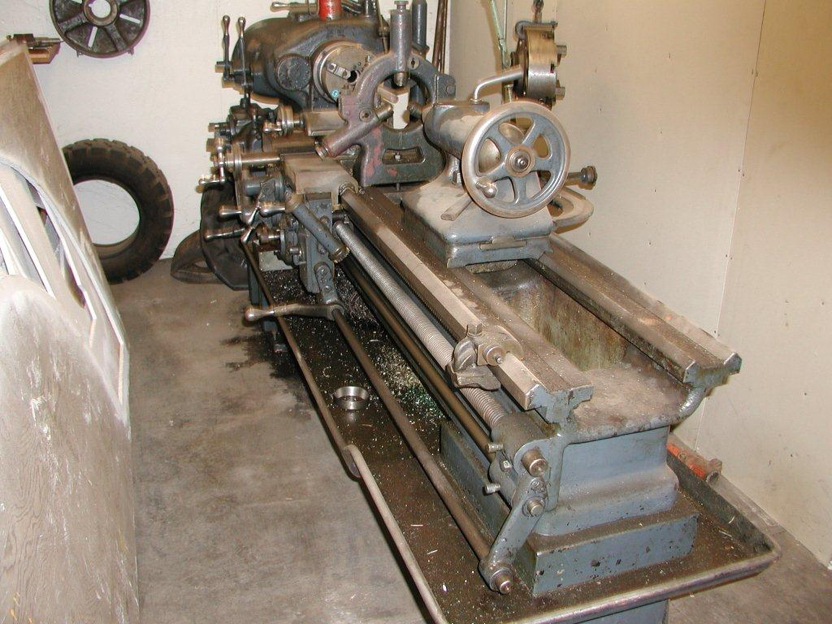

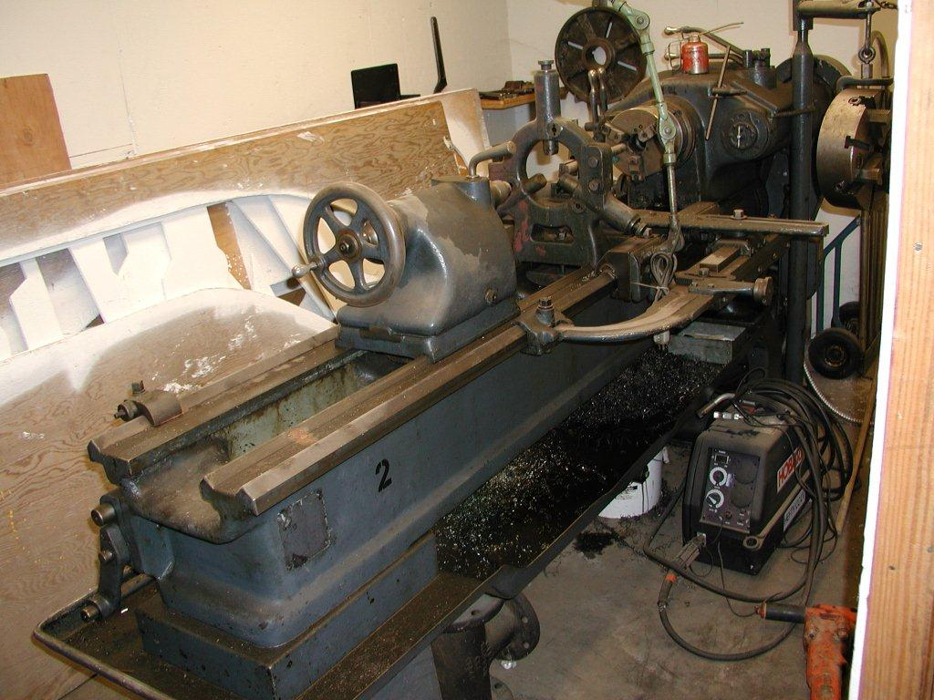

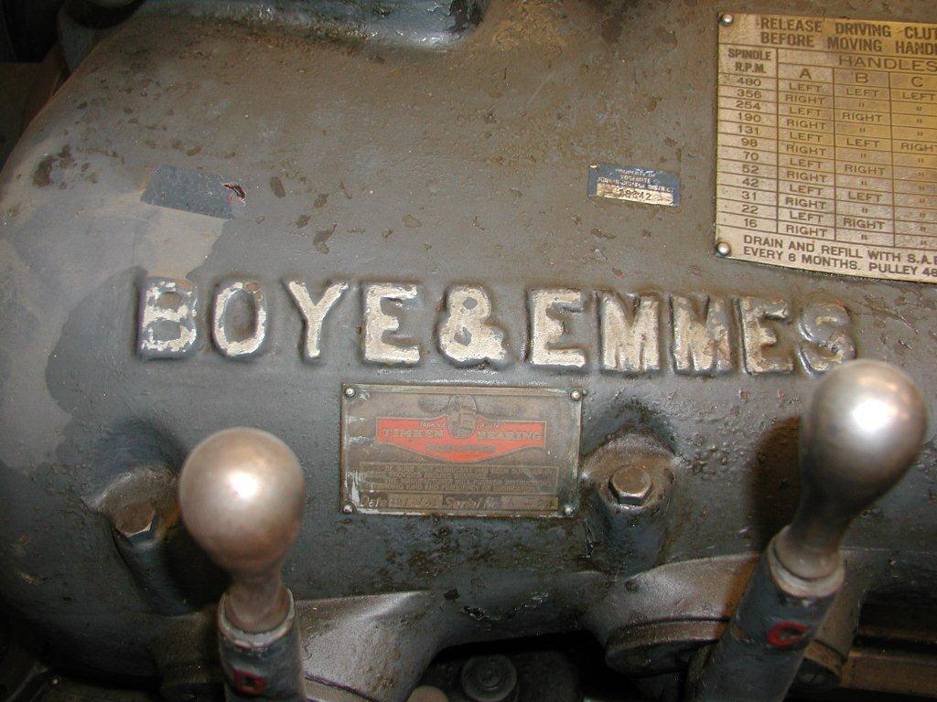

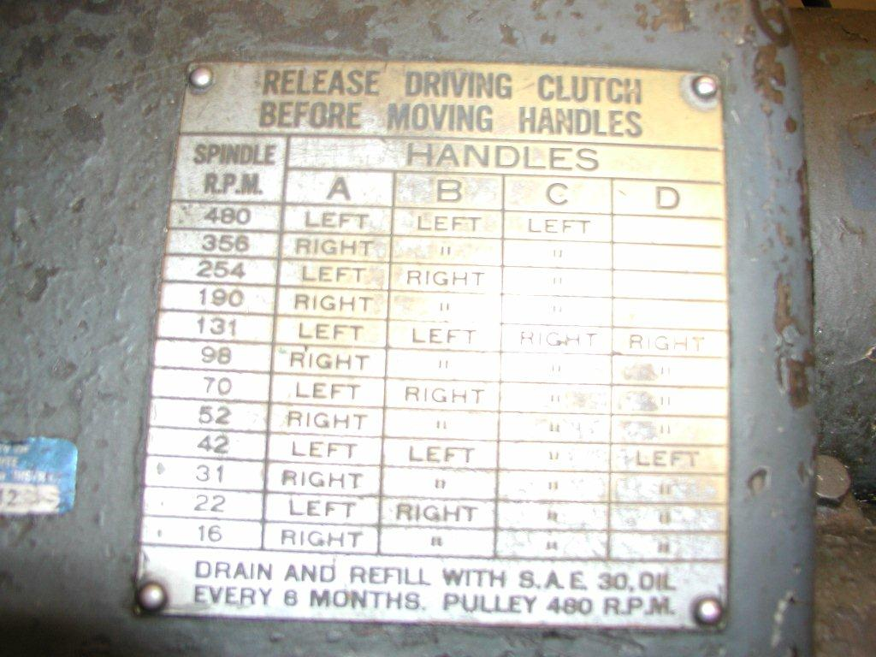

**Bid Amount (Minimum Acceptable Bid, $500.00) $**

1. 2/ea 2 nursery decks @ 4 pens each

Pens are 4 ft. X 7 ft.

Stainless steel 6-hole feeder for each pen

Tender foot flooring

2 Lixit waterers per pen

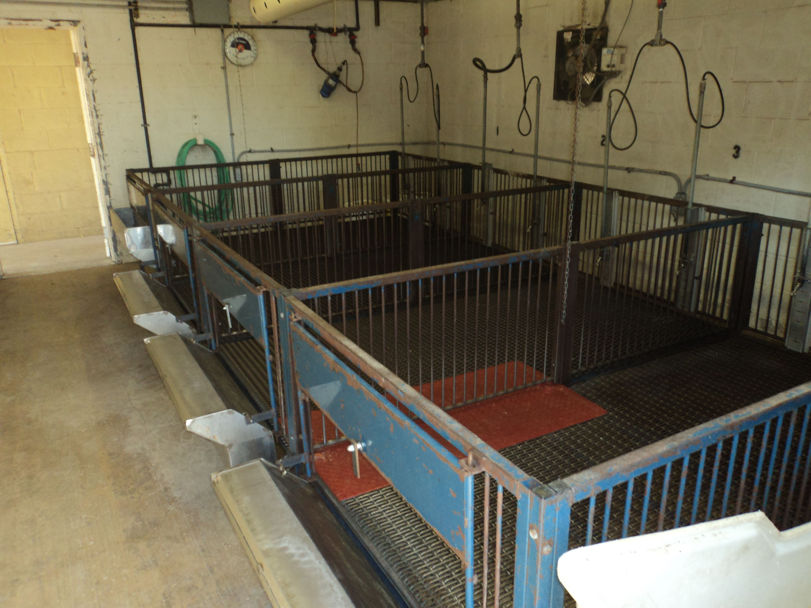

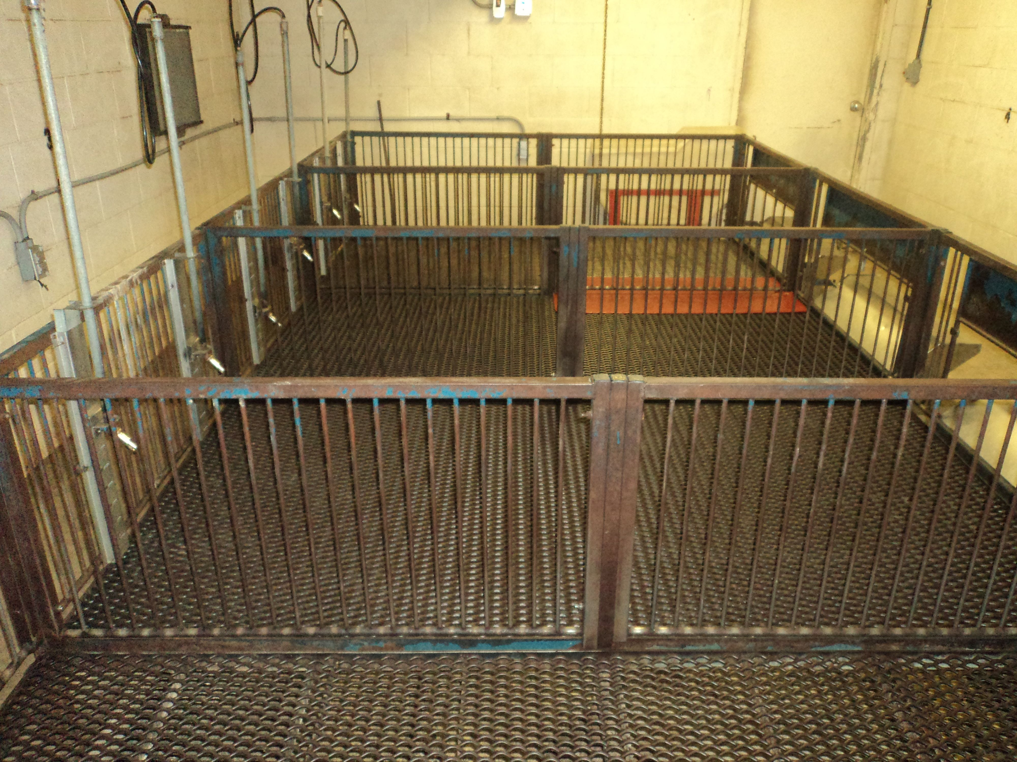

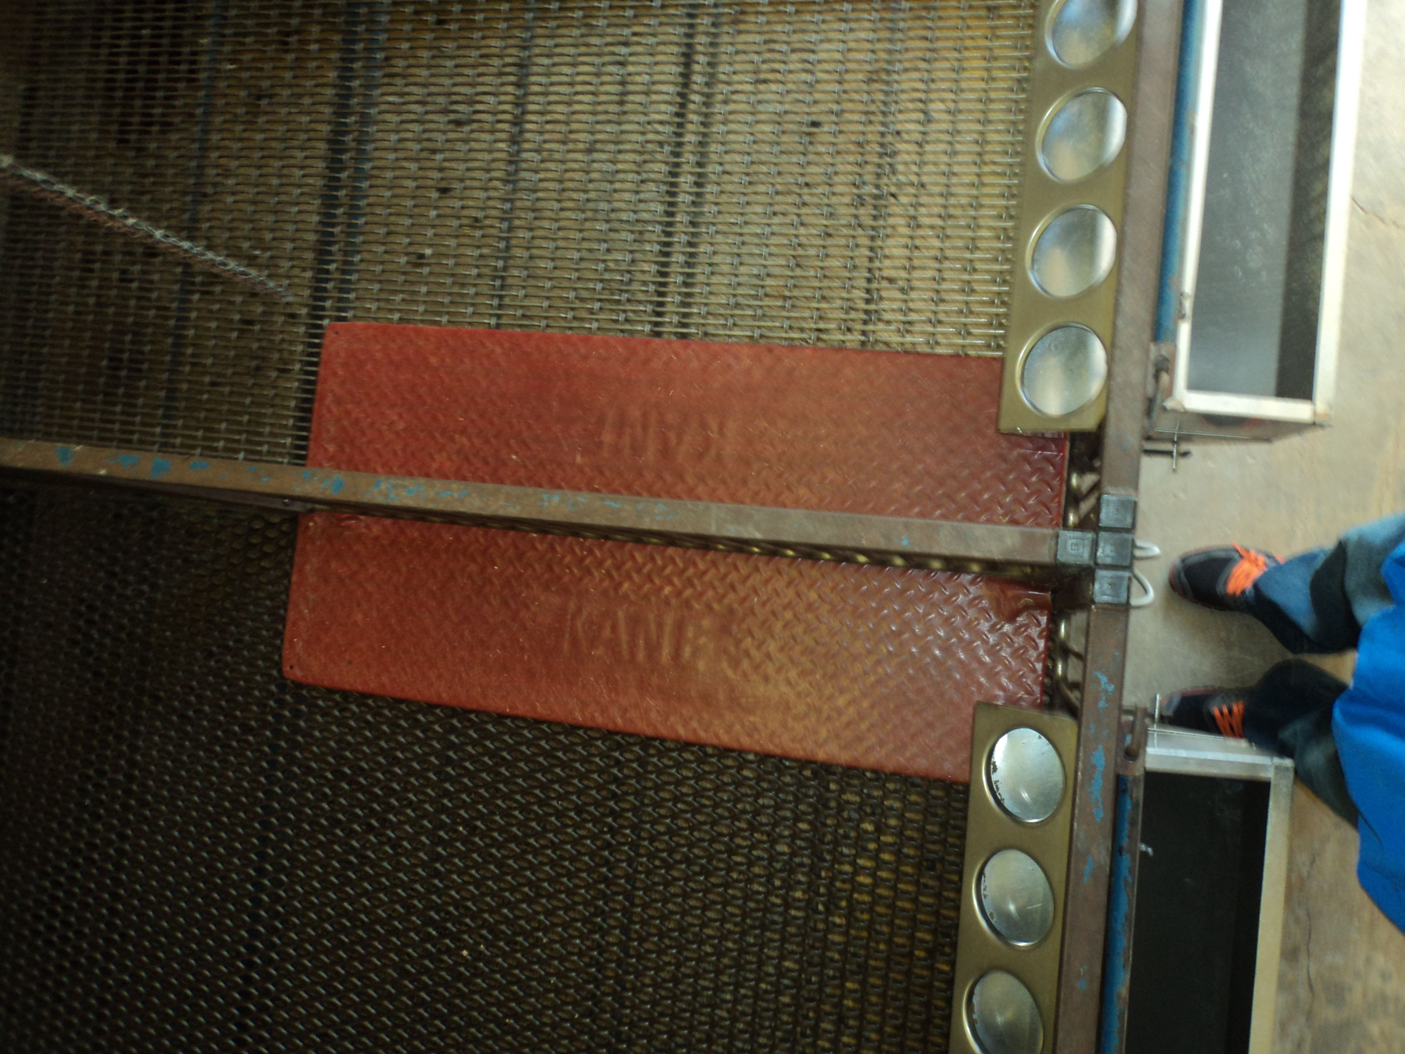

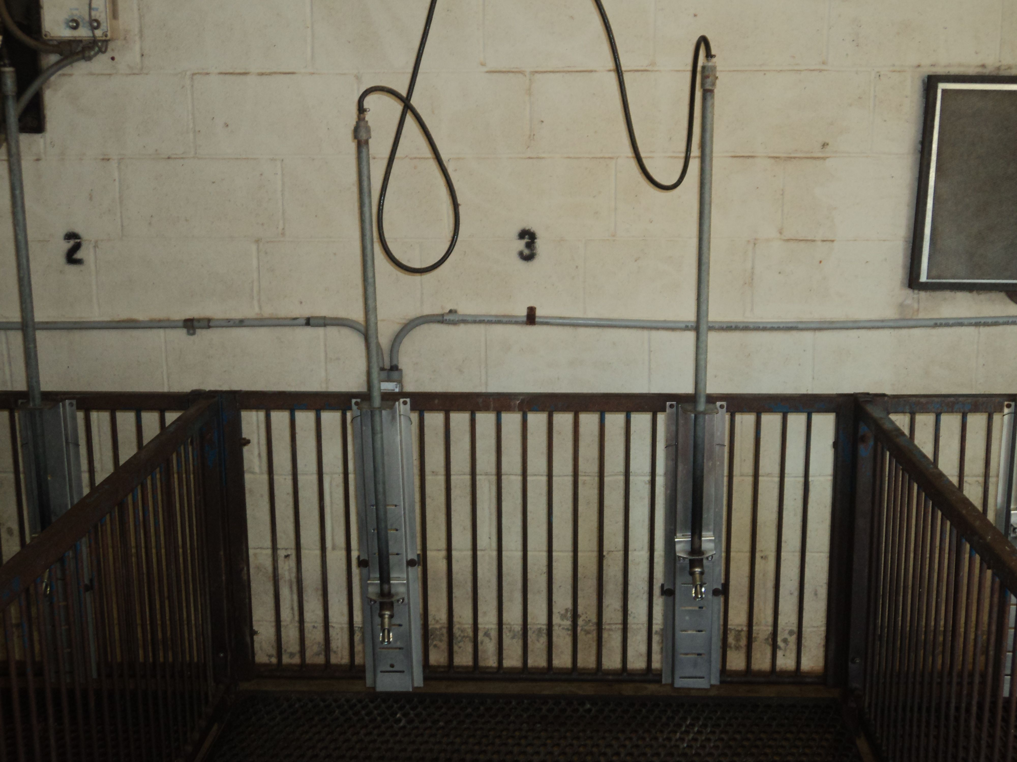

**Bid Unit 1(Minimum Acceptable Bid $800.00)$**

**Bid Unit 2(Minimum Acceptable Bid $800.00)$**

1. 1/ea Antique hay rake



**Bid Amount (Minimum Acceptable Bid $200.00)$**

1. 1/ea Antique Wheatland Plow



Bid Amount (Minimum Acceptable Bid $200.00)$

1. 1/ea 1978 Model Clark 500-25

Natural gas powered Forklift

2500lb

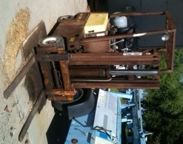

**Bid Amount (Minimum Acceptable Bid $800.00)$**

Machines will be sold to the highest bidder(s).

I hereby certify that I have read all bid conditions and will, upon notification of award, promptly pay for such property as awarded and will remove it from this District's premises within the time limit specified.

Sales Tax will be collected, when required, from successful bidder(s) at time of payment to the District unless property is being purchased for resale. If property is being purchased for resale, indicate your sales tax permit number.

__ __________________________

Individual or Firm Name Signature

Street Address City, State Zip

_____________

Title Printed Name

___________

Phone No. Contractor's License No. Sales Tax Permit No.

(If applicable)

Fax No.____________________ E-Mail Address:________________________